UNITED STATES
SECURITIES AND EXCHANGE COMMISSION
WASHINGTON, D.C. 20549
FORM 8-K
CURRENT REPORT PURSUANT TO
SECTION 13 OR 15(d) OF THE
SECURITIES EXCHANGE ACT OF 1934
Date of report (Date of earliest event reported): July 24, 2026
HBT FINANCIAL, INC.
(Exact name of registrant as specified in its charter)
Delaware |  |  | 001-39085 |  |  | 37-1117216
(State or other jurisdiction  of incorporation) |  |  | (Commission File Number) |  |  | (IRS Employer  Identification Number)
401 North Hershey Road  Bloomington, Illinois |  |  |  |  |  | 61704
(Address of principal executive  offices) |  |  |  |  |  | (Zip Code)
(309) 662-4444
(Registrant’s telephone number, including area code)
N/A
(Former name or former address, if changed since last report)
Check the appropriate box below if the Form 8-K filing is intended to simultaneously satisfy the filing obligation of the registrant under any of the following provisions (see General Instruction A.2. below):
☐ |  |  | Written communications pursuant to Rule 425 under the Securities Act (17 CFR 230.425)
☐ |  |  | Soliciting material pursuant to Rule 14a-12 under the Exchange Act (17 CFR 240.14a-12)
☐ |  |  | Pre-commencement communications pursuant to Rule 14d-2(b) under the Exchange Act (17 CFR 240.14d-2(b))
☐ |  |  | Pre-commencement communications pursuant to Rule 13e-4(c) under the Exchange Act (17 CFR 240.13e-4(c))
Securities registered pursuant to Section 12(b) of the Act:
Title of each class |  |  | Trading Symbol(s) |  |  | Name of each exchange on which registered
Common Stock, par value $0.01 per share |  |  | HBT |  |  | The Nasdaq Stock Market LLC
Indicate by check mark whether the registrant is an emerging growth company as defined in Rule 405 of the Securities Act of 1933 (§230.405 of this chapter) or Rule 12b-2 of the Securities Exchange Act of 1934 (§240.12b-2 of this chapter).
Emerging growth company ☐
If an emerging growth company, indicate by check mark if the registrant has elected not to use the extended transition period for complying with any new or revised financial accounting standards provided pursuant to Section 13(a) of the Exchange Act. ☐

Item 2.02. Results of Operations and Financial Condition.
On July 27, 2026, HBT Financial, Inc. (the “Company”) issued a press release announcing its financial results for the second quarter ended and six months ended June 30, 2026 (the “Earnings Release”). A copy of the Earnings Release is furnished as Exhibit 99.1 to this Current Report on Form 8-K (this “Report”) and is incorporated herein by reference.
The information contained in Item 2.02, including Exhibit 99.1 furnished herewith, shall not be deemed “filed” for purposes of Section 18 of the Securities Exchange Act of 1934, as amended (the “Exchange Act”), or otherwise subject to the liabilities under that section, nor shall it be deemed incorporated by reference into any registration statement or other document pursuant to the Securities Act of 1933, as amended (the “Securities Act”), or into any filing or other document pursuant to the Exchange Act, except to the extent required by applicable law or regulation.

Item 7.01. Regulation FD Disclosure.
The Company has prepared a presentation of its results for the second quarter ended and six months ended June 30, 2026 (the “Presentation”) to be used from time to time during meetings with members of the investment community. A copy of the Presentation is furnished as Exhibit 99.2 to this Report and is incorporated herein by reference. The Presentation will also be made available on the Company’s investor relations website at ir.hbtfinancial.com under the Presentations section.
The information contained in Item 7.01, including Exhibit 99.2 furnished herewith, shall not be deemed “filed” for purposes of Section 18 of the Exchange Act, or otherwise subject to the liabilities under that section, nor shall it be deemed incorporated by reference into any registration statement or other document pursuant to the Securities Act, or into any filing or other document pursuant to the Exchange Act, except to the extent required by applicable law or regulation.

Item 8.01 Other Events.
On July 24, 2026, the Board of Directors of the Company declared a quarterly cash dividend of $0.25 per share on the Company’s common stock (the “Dividend”). The Dividend is payable on August 18, 2026 to shareholders of record as of August 11, 2026. This represents an increase of $0.02 from the previous quarterly dividend of $0.23 per share.

Item 9.01. Financial Statements and Exhibits.
Exhibit Number |  |  | Description of Exhibit
99.1 |  |  | Earnings Release issued July 27, 2026 for the Second Quarter Ended and Six Months Ended June 30, 2026.
99.2 |  |  | Presentation of Results for the Second Quarter Ended June 30, 2026.
104 |  |  | Cover Page Interactive Data File (embedded within the Inline XBRL document).

SIGNATURES
Pursuant to the requirements of the Securities Exchange Act of 1934, the registrant has duly caused this report to be signed on its behalf by the undersigned thereunto duly authorized.
 |  |  | HBT FINANCIAL, INC.
 |  |  | By: |  |  | /s/ Peter R. Chapman
 |  |  |  |  |  | Name: Peter R. Chapman
 |  |  |  |  |  | Title: Chief Financial Officer
Date: July 27, 2026

EXHIBIT 99.1

HBT FINANCIAL, INC. ANNOUNCES
SECOND QUARTER 2026 FINANCIAL RESULTS

Quarterly Cash Dividend Increased to $0.25 per Share
Second Quarter Highlights
•Net income of $27.8 million, or $0.76 per diluted share; return on average assets (“ROAA”) of 1.66%; return on average stockholders' equity (“ROAE”) of 14.73%; and return on average tangible common equity (“ROATCE”)(1) of 17.69%
•Adjusted net income(1) of $28.5 million, or $0.78 per diluted share; adjusted ROAA(1) of 1.70%; adjusted ROAE(1) of 15.09%; and adjusted ROATCE(1) of 18.13%
•Asset quality remained strong with nonperforming assets to total assets of 0.15% and net recoveries to average loans of 0.01%, on an annualized basis
•Net interest margin increased 12 basis points to 4.32% and net interest margin (tax-equivalent basis)(1) increased 13 basis points to 4.38%
Bloomington, IL, July 27, 2026 – HBT Financial, Inc. (NASDAQ: HBT) (the “Company”, “HBT Financial” or “HBT”), the holding company for Heartland Bank and Trust Company, today reported net income of $27.8 million, or $0.76 diluted earnings per share, for the second quarter of 2026. This compares to net income of $11.2 million, or $0.34 diluted earnings per share, for the first quarter of 2026, and net income of $19.2 million, or $0.61 diluted earnings per share, for the second quarter of 2025.
J. Lance Carter, President and Chief Executive Officer of HBT Financial, said, “Our first full quarter after the closing of our acquisition of CNB Bank Shares, Inc. (“CNB”) and its wholly owned subsidiary, CNB Bank & Trust, N.A. (“CNB Bank”) delivered strong results. For the second quarter, we reported adjusted net income(1) of $28.5 million, or $0.78 per diluted share, adjusted ROAA(1) of 1.70% and adjusted ROATCE(1) of 18.13%. Our net interest margin on a tax equivalent basis(1) increased 13 basis points to 4.38% compared to the first quarter of 2026. While some of that increase was driven by higher than expected loan accretion income, net interest margin also increased as maturing fixed rate loans repriced higher and securities cash flows were reinvested at higher rates, which offset an increase in cost of funds related to the deposit base acquired from CNB Bank. Noninterest income and noninterest expense were both in line with expectations as we are now realizing the full benefit of our acquisition and all material cost savings.
Our tangible book value per share(1) increased 3.5% for the quarter to $17.60 while our balance sheet remains strong with good liquidity, solid capital ratios, and no material credit issues. That gives us confidence that we are prepared for a variety of economic environments. Our capital levels and operational structure support continued organic growth and attractive acquisition opportunities should the right opportunity arise.”
____________________________________
(1)See “Reconciliation of Non-GAAP Financial Measures” below for reconciliation of non-GAAP financial measures to their most closely comparable GAAP financial measures.

HBT Financial, Inc.

Page 2
Adjusted Net Income
In addition to reporting GAAP results, the Company believes non-GAAP measures such as adjusted net income and adjusted earnings per share, which adjust for acquisition expenses, branch closure expenses, net earnings (losses) on closed or sold operations, losses on extinguishment of debt, gains (losses) on closed branch premises, realized gains (losses) on sales of securities, mortgage servicing rights (“MSR”) fair value adjustments, and the tax effect of these pre-tax adjustments, provide investors with additional insight into its operational performance. The Company reported adjusted net income of $28.5 million, or $0.78 adjusted diluted earnings per share, for the second quarter of 2026. This compares to adjusted net income of $22.6 million, or $0.68 adjusted diluted earnings per share, for the first quarter of 2026, and adjusted net income of $19.8 million, or $0.63 adjusted diluted earnings per share, for the second quarter of 2025. See “Reconciliation of Non-GAAP Financial Measures” tables below for reconciliation of non-GAAP financial measures to their most closely comparable GAAP financial measures.
Cash Dividend
On July 24, 2026, the Company’s Board of Directors declared a quarterly cash dividend of $0.25 per share on the Company’s common stock (the “Dividend”). The Dividend is payable on August 18, 2026 to shareholders of record as of August 11, 2026. This represents an increase of $0.02 from the previous quarterly cash dividend of $0.23 per share.
Mr. Carter noted, “We are very pleased to announce that our strong financial performance and capital ratios have enabled us to further increase our quarterly cash dividend by $0.02 per share. This increased dividend reflects the increase in earnings from the successful acquisition and integration of CNB in the first quarter of 2026 while ensuring that capital levels remain strong and comfortably support our balance sheet and strategic objectives.”
Net Interest Income and Net Interest Margin
Net interest income for the second quarter of 2026 was $69.1 million, an increase of 22.5% from $56.4 million for the first quarter of 2026. The increase was primarily attributable to higher average interest-earning asset balances following the CNB merger completed on March 1, 2026 and higher yields on interest-earning assets. Additionally, acquired loan discount accretion was $2.1 million during the second quarter of 2026 compared to $1.0 million during the first quarter of 2026. Partially offsetting these increases were higher funding costs and a $0.3 million decrease in loan fees.
Relative to the second quarter of 2025, net interest income increased 39.1% from $49.7 million. The increase was primarily attributable to higher average interest-earning asset balances following the CNB merger and improved yields on debt securities. Additionally, a $1.1 million increase in acquired loan discount accretion contributed to the improvement and was partially offset by a $0.2 million decrease in loan fees.
Net interest margin for the second quarter of 2026 was 4.32%, compared to 4.20% for the first quarter of 2026, while net interest margin (tax-equivalent basis)(1) for the second quarter of 2026 was 4.38%, compared to 4.25% for the first quarter of 2026. These increases were primarily attributable to improved yields on loans, which increased 10 basis points to 6.38%, including an 8 basis point increase in acquired loan discount accretion, and improved yields on debt securities. Additionally, a more favorable interest-earning asset mix further contributed to the overall improvement. These increases were partially offset by higher funding costs, which increased 7 basis points to 1.32%, driven primarily by the first full quarter of interest expense on the subordinated notes and the higher cost deposit base acquired from CNB Bank.
Relative to the second quarter of 2025, net interest margin increased 18 basis points from 4.14% and net interest margin (tax-equivalent basis)(1) increased 19 basis points from 4.19%. These increases were primarily attributable to improved yields on debt securities and a more favorable interest-earning asset mix, which were partially offset by higher funding costs.
____________________________________
(1)See “Reconciliation of Non-GAAP Financial Measures” below for reconciliation of non-GAAP financial measures to their most closely comparable GAAP financial measures.
HBT Financial, Inc.

Page 3
Noninterest Income
Noninterest income for the second quarter of 2026 was $11.8 million, an increase from $10.9 million for the first quarter of 2026. The increase was primarily attributable to a $0.7 million increase in card income, a $0.3 million increase in service charges on deposit accounts, and a $0.2 million increase in wealth management fees, all primarily driven by a larger customer base following the CNB merger. These increases were partially offset by changes in the MSR fair value adjustment, with a $0.8 million negative MSR fair value adjustment included in the second quarter of 2026 results compared to a $0.2 million positive MSR fair value adjustment included in the first quarter of 2026 results.
Relative to the second quarter of 2025, noninterest income increased 29.6% from $9.1 million. The increase was primarily attributable to a $1.1 million increase in wealth management fees, a $0.6 million increase in card income, and a $0.6 million increase in service charges on deposit accounts, all primarily driven by a larger customer base following the CNB merger.
Noninterest Expense
Noninterest expense for the second quarter of 2026 was $42.4 million, a 19.1% decrease from the first quarter of 2026. Acquisition-related noninterest expenses totaled $0.3 million during the second quarter of 2026, compared to $15.7 million during the first quarter of 2026. Excluding acquisition-related expenses, the $5.4 million increase in noninterest expense was primarily attributable to higher base costs following the CNB merger, which primarily drove a $3.2 million increase in salaries and employee benefits as well as increases in data processing, occupancy, and marketing expenses.
Relative to the second quarter of 2025, noninterest expense increased 33.0% from $31.9 million. Excluding acquisition-related expenses, the $10.3 million increase in noninterest expense was primarily attributable to higher base costs following the CNB merger, including a $6.2 million increase in salaries and employee benefits, which were also driven higher by annual merit increases and higher medical benefits costs, as well as increases in occupancy, data processing, and marketing expenses.
Acquisition-related expenses during the first and second quarter of 2026 and during the six months ended June 30, 2026 are summarized below. There were no acquisition-related expenses during the second quarter of 2025 or during the six months ended June 30, 2025. We do not expect material acquisition-related expenses related to the CNB merger in subsequent quarters.
 |  |  | Three Months Ended |  |  |  |  |  |  |  |  |  |  |  |  |  |  |  |  |  | Six Months Ended
(dollars in thousands) |  |  | June 30,  2026 |  |  |  |  |  | March 31, 2026 |  |  |  |  |  | June 30,  2025 |  |  |  |  |  | 2026 |  |  |  |  |  | 2025
NONINTEREST EXPENSE
Salaries |  |  | $ | (44) |  |  |  |  | $ | 4,003 |  |  |  |  | $ | — |  |  |  |  | $ | 3,959 |  |  |  |  | $ | —
Occupancy of bank premises |  |  | 13 |  |  |  |  |  | 105 |  |  |  |  |  | — |  |  |  |  |  | 118 |  |  |  |  |  | —
Furniture and equipment |  |  | 9 |  |  |  |  |  | 63 |  |  |  |  |  | — |  |  |  |  |  | 72 |  |  |  |  |  | —
Data processing |  |  | 91 |  |  |  |  |  | 8,668 |  |  |  |  |  | — |  |  |  |  |  | 8,759 |  |  |  |  |  | —
Marketing and customer relations |  |  | 5 |  |  |  |  |  | 69 |  |  |  |  |  | — |  |  |  |  |  | 74 |  |  |  |  |  | —
Loan collection and servicing |  |  | 28 |  |  |  |  |  | 320 |  |  |  |  |  | — |  |  |  |  |  | 348 |  |  |  |  |  | —
Professional fees and other noninterest expense |  |  | 155 |  |  |  |  |  | 2,438 |  |  |  |  |  | — |  |  |  |  |  | 2,593 |  |  |  |  |  | —
Total acquisition-related expenses |  |  | $ | 257 |  |  |  |  | $ | 15,666 |  |  |  |  | $ | — |  |  |  |  | $ | 15,923 |  |  |  |  | $ | —

HBT Financial, Inc.

Page 4
Loan Portfolio
Total loans outstanding, before allowance for credit losses, were $4.75 billion at June 30, 2026, compared with $4.69 billion at March 31, 2026, and $3.35 billion at June 30, 2025. The $65.5 million increase from March 31, 2026 was primarily due to increases in multi-family loans and loans to nondepository institutions, included within the municipal, consumer, and other category. These increases were offset by seasonal reductions on grain elevator lines of $27.3 million and several large payoffs due to refinancings across multiple categories, including one condominium loan for $26.1 million within the one-to-four family residential category. In addition, $50.6 million in completed construction projects were transferred from the construction and land development to other categories, primarily in the commercial real estate – non-owner occupied category.
Deposits
Total deposits were $5.76 billion at June 30, 2026, compared with $5.80 billion at March 31, 2026, and $4.31 billion at June 30, 2025. The $45.5 million decrease from March 31, 2026 was primarily attributable to higher outflows for tax payments by depositors and lower balances maintained in existing retail accounts, which were partially offset by higher public funds balances. Additionally, $48.6 million of wealth management customer reciprocal deposits were moved on-balance sheet during the second quarter of 2026.
Asset Quality
Nonperforming assets totaled $9.9 million, or 0.15% of total assets, at June 30, 2026, compared with $14.4 million, or 0.21% of total assets, at March 31, 2026, and $6.5 million, or 0.13% of total assets, at June 30, 2025. The $4.5 million decrease in nonperforming assets from March 31, 2026 was primarily attributable to paydowns and payoffs in the one-to-four family residential and construction and land development categories. Additionally, of the $9.1 million of nonperforming loans held as of June 30, 2026, $2.4 million were either wholly or partially guaranteed by the U.S. government.
The Company recorded a provision for credit losses of $0.7 million for the second quarter of 2026. The provision for credit losses primarily reflects a $3.9 million increase in required reserves resulting from changes in qualitative factors; a $1.3 million decrease in specific reserves; a $1.0 million decrease in required reserves driven by changes in the economic forecast; and a $1.0 million decrease in required reserves driven by changes within the portfolio.
The Company had net recoveries of $0.1 million, or 0.01% of average loans on an annualized basis, for the second quarter of 2026, compared to net charge-offs of $0.8 million, or 0.08% of average loans on an annualized basis, for the first quarter of 2026, and net charge-offs of $1.0 million, or 0.12% of average loans on an annualized basis, for the second quarter of 2025.
The Company’s allowance for credit losses was 1.27% of total loans and 666% of nonperforming loans at June 30, 2026, compared with 1.29% of total loans and 457% of nonperforming loans at March 31, 2026. In addition, the allowance for credit losses on unfunded lending-related commitments totaled $6.6 million as of June 30, 2026, compared with $5.9 million as of March 31, 2026.
Capital
As of June 30, 2026, the Company exceeded all regulatory capital requirements under Basel III as summarized in the following table:
 |  |  |  |  |  | June 30, 2026 |  |  |  |  |  | For Capital  Adequacy Purposes  With Capital  Conservation Buffer
Total capital to risk-weighted assets |  |  |  |  |  | 16.20 |  | % |  |  |  | 10.50 |  | %
Tier 1 capital to risk-weighted assets |  |  |  |  |  | 13.59 |  |  |  |  |  | 8.50
Common equity tier 1 capital ratio |  |  |  |  |  | 12.64 |  |  |  |  |  | 7.00
Tier 1 leverage ratio |  |  |  |  |  | 11.01 |  |  |  |  |  | 4.00
HBT Financial, Inc.

Page 5
The ratio of tangible common equity to tangible assets(1) increased to 9.69% as of June 30, 2026, from 9.31% as of March 31, 2026, and tangible book value per share(1) increased by $0.59 to $17.60 as of June 30, 2026, when compared to March 31, 2026.
During the second quarter of 2026, the Company repurchased 15,466 shares of its common stock at a weighted average price of $27.53 under its stock repurchase program. The Company’s Board of Directors has authorized the repurchase of up to $30.0 million of HBT Financial common stock under its stock repurchase program, which is in effect until January 1, 2027. As of June 30, 2026, the Company had $14.0 million remaining under the stock repurchase program.
____________________________________
(1)See “Reconciliation of Non-GAAP Financial Measures” below for reconciliation of non-GAAP financial measures to their most closely comparable GAAP financial measures.
About HBT Financial, Inc.
HBT Financial, Inc., headquartered in Bloomington, Illinois, is the holding company for Heartland Bank and Trust Company, and has banking roots that can be traced back to 1920. HBT Financial provides a comprehensive suite of financial products and services to consumers, businesses, and municipal entities throughout Illinois, eastern Iowa, and suburban St. Louis through 83 full-service branches. As of June 30, 2026, HBT Financial had total assets of $6.7 billion, total loans of $4.8 billion, and total deposits of $5.8 billion.
Non-GAAP Financial Measures
Some of the financial measures included in this press release are not measures of financial performance recognized in accordance with GAAP. These non-GAAP financial measures include adjusted net income, adjusted earnings per share, adjusted ROAA, pre-provision net revenue, pre-provision net revenue less charge-offs (recoveries), adjusted pre-provision net revenue, adjusted pre-provision net revenue less charge-offs (recoveries), net interest income (tax-equivalent basis), net interest margin (tax-equivalent basis), efficiency ratio (tax-equivalent basis), adjusted efficiency ratio (tax-equivalent basis), the ratio of tangible common equity to tangible assets, tangible book value per share, adjusted ROAE, ROATCE, and adjusted ROATCE. Our management uses these non-GAAP financial measures, together with the related GAAP financial measures, in its analysis of our performance and in making business decisions. Management believes that it is a standard practice in the banking industry to present these non-GAAP financial measures, and accordingly believes that providing these measures may be useful for peer comparison purposes. These disclosures should not be viewed as substitutes for the results determined to be in accordance with GAAP; nor are they necessarily comparable to non-GAAP financial measures that may be presented by other companies. See our reconciliation of non-GAAP financial measures to their most directly comparable GAAP financial measures in the “Reconciliation of Non-GAAP Financial Measures” tables.

Forward-Looking Statements
Readers should note that in addition to the historical information contained herein, this press release contains, and future oral and written statements of the Company and its management may contain, “forward-looking statements” within the meanings of the Private Securities Litigation Reform Act of 1995, Section 27A of the Securities Act of 1933, as amended, and Section 21E of the Securities Exchange Act of 1934, as amended. Forward-looking statements generally can be identified by the use of forward-looking terminology such as “will,” “propose,” “may,” “plan,” “seek,” “expect,” “intend,” “estimate,” “anticipate,” “believe,” “continue,” or “should,” or similar terminology and the negative forms of such words. Any forward-looking statements presented herein are made only as of the date of this press release, and the Company does not undertake any obligation to update or revise any forward-looking statements to reflect changes in assumptions, the occurrence of unanticipated events, or otherwise.
Factors that could cause actual results to differ materially from these forward-looking statements include, but are not limited to: (1) the strength of the local, state, national and international economies and financial markets (including effects of inflationary pressures, global energy market conditions, the threat or implementation of tariffs, immigration enforcement and changes in foreign policy); (2) policy changes in, and the interpretation and prioritization of, local, state and federal laws, regulations and governmental policies, including executive orders; (3) the economic impact of any future terrorist threats and attacks, widespread disease or pandemics, acts of war or other threats thereof (including the Russian invasion of Ukraine, ongoing conflicts in the Middle East, and
HBT Financial, Inc.

Page 6
other international military conflicts that can increase levels of political and economic unpredictability, contribute to rising energy and commodity prices, affect global supply chains, increase the volatility of financial markets, and other matters beyond our control), and the response of the local, state and national governments to any such adverse external events; (4) new and revised accounting policies and practices, as may be adopted by state and federal regulatory banking agencies, the Financial Accounting Standards Board or the Public Company Accounting Oversight Board; (5) the imposition of tariffs or other governmental policies impacting the value of products produced by the Company's commercial borrowers; (6) changes in interest rates and prepayment rates of the Company’s assets; (7) increased competition in the financial services sector, including from non-bank competitors such as credit unions, private credit firms, fintech companies, and digital asset service providers, and the inability to attract new customers; (8) technological changes implemented by us and other parties, including our third-party vendors, which may have unforeseen consequences to us and our customers; (9) emerging issues related to the development and use of artificial intelligence that could give rise to legal or regulatory action, damage our reputation or otherwise materially harm our business or customers; (10) unexpected results of acquisitions, which may include failure to realize the anticipated benefits of acquisitions and the possibility that transaction costs may be greater than anticipated, including the acquisition of CNB; (11) the loss of key executives and employees, talent shortages and employee turnover; (12) changes in consumer spending; (13) unexpected outcomes or costs of existing or new litigation or other legal proceedings and regulatory actions involving the Company; (14) the economic impact on the Company and its customers of climate change, natural disasters and of exceptional weather occurrences such as tornadoes, floods and blizzards; (15) fluctuations in the value of securities held in our securities portfolio, including as a result of changes in interest rates; (16) credit risks and risks from concentrations (by type of borrower, geographic area, collateral and industry) within our loan portfolio (including commercial real estate loans) and large loans to certain borrowers; (17) the overall health of the local and national real estate market; (18) the ability to maintain an adequate level of allowance for credit losses on loans; (19) the concentration of large deposits from certain clients who have balances above current FDIC insurance limits and who may withdraw deposits to diversify their exposure; (20) the availability of future equity and debt issuances and other capital raising opportunities on favorable terms; (21) the ability to successfully manage liquidity risk, which may increase dependence on non-core funding sources such as brokered deposits, and may negatively impact the Company’s cost of funds; (22) the level of nonperforming assets on our balance sheet; (23) interruptions involving our information technology and communications systems or those of our third-party servicers; (24) the occurrence of fraudulent activity, breaches or failures of our third-party vendors’ information security controls or cybersecurity-related incidents, including as a result of sophisticated attacks using artificial intelligence and similar tools or as a result of insider fraud; (25) the effectiveness of the Company’s risk management framework; and (26) the ability of the Company to manage the risks associated with the foregoing as well as anticipated.
Readers should note that the forward-looking statements included in this press release are not a guarantee of future events, and that actual events may differ materially from those made in or suggested by the forward-looking statements. Additional information concerning the Company and its business, including additional factors that could materially affect the Company’s financial results, is included in the Company’s filings with the Securities and Exchange Commission.
CONTACT:
Peter Chapman
HBTIR@hbtbank.com
(309) 664-4556

HBT Financial, Inc.

Page 7
HBT Financial, Inc.
Unaudited Consolidated Financial Summary
 |  |  |  |  |  | As of or for the Three Months Ended |  |  |  |  |  |  |  |  |  |  |  |  |  |  |  |  |  | Six Months Ended June 30,
(dollars in thousands, except per share data) |  |  |  |  |  | June 30,  2026 |  |  |  |  |  | March 31,  2026 |  |  |  |  |  | June 30,  2025 |  |  |  |  |  | 2026 |  |  |  |  |  | 2025
Interest and dividend income |  |  |  |  |  | $ | 88,583 |  |  |  |  | $ | 71,839 |  |  |  |  | $ | 63,919 |  |  |  |  | $ | 160,422 |  |  |  |  | $ | 127,057
Interest expense |  |  |  |  |  | 19,527 |  |  |  |  |  | 15,452 |  |  |  |  |  | 14,261 |  |  |  |  |  | 34,979 |  |  |  |  |  | 28,691
Net interest income |  |  |  |  |  | 69,056 |  |  |  |  |  | 56,387 |  |  |  |  |  | 49,658 |  |  |  |  |  | 125,443 |  |  |  |  |  | 98,366
Provision for credit losses |  |  |  |  |  | 676 |  |  |  |  |  | (156) |  |  |  |  |  | 526 |  |  |  |  |  | 520 |  |  |  |  |  | 1,102
Net interest income after provision for credit losses |  |  |  |  |  | 68,380 |  |  |  |  |  | 56,543 |  |  |  |  |  | 49,132 |  |  |  |  |  | 124,923 |  |  |  |  |  | 97,264
Noninterest income |  |  |  |  |  | 11,841 |  |  |  |  |  | 10,944 |  |  |  |  |  | 9,140 |  |  |  |  |  | 22,785 |  |  |  |  |  | 18,446
Noninterest expense |  |  |  |  |  | 42,446 |  |  |  |  |  | 52,437 |  |  |  |  |  | 31,914 |  |  |  |  |  | 94,883 |  |  |  |  |  | 63,849
Income before income tax expense |  |  |  |  |  | 37,775 |  |  |  |  |  | 15,050 |  |  |  |  |  | 26,358 |  |  |  |  |  | 52,825 |  |  |  |  |  | 51,861
Income tax expense |  |  |  |  |  | 9,931 |  |  |  |  |  | 3,850 |  |  |  |  |  | 7,128 |  |  |  |  |  | 13,781 |  |  |  |  |  | 13,556
Net income |  |  |  |  |  | $ | 27,844 |  |  |  |  | $ | 11,200 |  |  |  |  | $ | 19,230 |  |  |  |  | $ | 39,044 |  |  |  |  | $ | 38,305
Earnings per share - diluted |  |  |  |  |  | $ | 0.76 |  |  |  |  | $ | 0.34 |  |  |  |  | $ | 0.61 |  |  |  |  | $ | 1.12 |  |  |  |  | $ | 1.21
Adjusted net income (1) |  |  |  |  |  | $ | 28,535 |  |  |  |  | $ | 22,610 |  |  |  |  | $ | 19,803 |  |  |  |  | $ | 51,145 |  |  |  |  | $ | 39,056
Adjusted earnings per share - diluted (1) |  |  |  |  |  | 0.78 |  |  |  |  |  | 0.68 |  |  |  |  |  | 0.63 |  |  |  |  |  | 1.47 |  |  |  |  |  | 1.23
Book value per share |  |  |  |  |  | $ | 21.03 |  |  |  |  | $ | 20.54 |  |  |  |  | $ | 18.44
Tangible book value per share (1) |  |  |  |  |  | 17.60 |  |  |  |  |  | 17.01 |  |  |  |  |  | 16.02
Shares of common stock outstanding |  |  |  |  |  | 36,365,612 |  |  |  |  |  | 36,381,078 |  |  |  |  |  | 31,495,434
Weighted average shares of common stock outstanding, including all dilutive potential shares |  |  |  |  |  | 36,466,688 |  |  |  |  |  | 33,300,096 |  |  |  |  |  | 31,588,541 |  |  |  |  |  | 34,892,139 |  |  |  |  |  | 31,649,766
SUMMARY RATIOS
Net interest margin * |  |  |  |  |  | 4.32 |  | % |  |  |  | 4.20 |  | % |  |  |  | 4.14 |  | % |  |  |  | 4.27 |  | % |  |  |  | 4.13 |  | %
Net interest margin (tax-equivalent basis) * (1)(2) |  |  |  |  |  | 4.38 |  |  |  |  |  | 4.25 |  |  |  |  |  | 4.19 |  |  |  |  |  | 4.32 |  |  |  |  |  | 4.18
Efficiency ratio |  |  |  |  |  | 50.67 |  | % |  |  |  | 76.56 |  | % |  |  |  | 53.10 |  | % |  |  |  | 62.43 |  | % |  |  |  | 53.47 |  | %
Efficiency ratio (tax-equivalent basis) (1)(2) |  |  |  |  |  | 50.14 |  |  |  |  |  | 75.83 |  |  |  |  |  | 52.61 |  |  |  |  |  | 61.81 |  |  |  |  |  | 52.97
Loan to deposit ratio |  |  |  |  |  | 82.54 |  | % |  |  |  | 80.76 |  | % |  |  |  | 77.75 |  | %
Return on average assets * |  |  |  |  |  | 1.66 |  | % |  |  |  | 0.80 |  | % |  |  |  | 1.53 |  | % |  |  |  | 1.26 |  | % |  |  |  | 1.53 |  | %
Return on average stockholders' equity * |  |  |  |  |  | 14.73 |  |  |  |  |  | 6.77 |  |  |  |  |  | 13.47 |  |  |  |  |  | 11.02 |  |  |  |  |  | 13.70
Return on average tangible common equity * (1) |  |  |  |  |  | 17.69 |  |  |  |  |  | 7.87 |  |  |  |  |  | 15.55 |  |  |  |  |  | 13.03 |  |  |  |  |  | 15.87
Adjusted return on average assets * (1) |  |  |  |  |  | 1.70 |  | % |  |  |  | 1.60 |  | % |  |  |  | 1.58 |  | % |  |  |  | 1.66 |  | % |  |  |  | 1.56 |  | %
Adjusted return on average stockholders' equity * (1) |  |  |  |  |  | 15.09 |  |  |  |  |  | 13.67 |  |  |  |  |  | 13.87 |  |  |  |  |  | 14.43 |  |  |  |  |  | 13.97
Adjusted return on average tangible common equity * (1) |  |  |  |  |  | 18.13 |  |  |  |  |  | 15.89 |  |  |  |  |  | 16.02 |  |  |  |  |  | 17.07 |  |  |  |  |  | 16.18
CAPITAL
Total capital to risk-weighted assets |  |  |  |  |  | 16.20 |  | % |  |  |  | 15.99 |  | % |  |  |  | 17.74 |  | %
Tier 1 capital to risk-weighted assets |  |  |  |  |  | 13.59 |  |  |  |  |  | 13.38 |  |  |  |  |  | 15.60
Common equity tier 1 capital ratio |  |  |  |  |  | 12.64 |  |  |  |  |  | 12.42 |  |  |  |  |  | 14.26
Tier 1 leverage ratio |  |  |  |  |  | 11.01 |  |  |  |  |  | 12.63 |  |  |  |  |  | 11.86
Total stockholders' equity to total assets |  |  |  |  |  | 11.37 |  |  |  |  |  | 11.03 |  |  |  |  |  | 11.58
Tangible common equity to tangible assets (1) |  |  |  |  |  | 9.69 |  |  |  |  |  | 9.31 |  |  |  |  |  | 10.21
ASSET QUALITY
Net charge-offs (recoveries) to average loans * |  |  |  |  |  | (0.01) |  | % |  |  |  | 0.08 |  | % |  |  |  | 0.12 |  | % |  |  |  | 0.03 |  | % |  |  |  | 0.09 |  | %
Allowance for credit losses to loans, before allowance for credit losses |  |  |  |  |  | 1.27 |  |  |  |  |  | 1.29 |  |  |  |  |  | 1.24
Nonperforming loans to loans, before allowance for credit losses |  |  |  |  |  | 0.19 |  |  |  |  |  | 0.28 |  |  |  |  |  | 0.17
Nonperforming assets to total assets |  |  |  |  |  | 0.15 |  |  |  |  |  | 0.21 |  |  |  |  |  | 0.13
____________________________________
*Annualized measure.
(1)See “Reconciliation of Non-GAAP Financial Measures” below for reconciliation of non-GAAP financial measures to their most closely comparable GAAP financial measures.
(2)On a tax-equivalent basis assuming a federal income tax rate of 21% and a state income tax rate of 9.5%.

HBT Financial, Inc.

Page 8
HBT Financial, Inc.
Unaudited Consolidated Financial Summary
Consolidated Statements of Income
 |  |  | Three Months Ended |  |  |  |  |  |  |  |  |  |  |  |  |  |  |  |  |  | Six Months Ended June 30,
(dollars in thousands, except per share data) |  |  | June 30,  2026 |  |  |  |  |  | March 31,  2026 |  |  |  |  |  | June 30,  2025 |  |  |  |  |  | 2026 |  |  |  |  |  | 2025
INTEREST AND DIVIDEND INCOME
Loans, including fees:
Taxable |  |  | $ | 73,668 |  |  |  |  | $ | 58,881 |  |  |  |  | $ | 53,156 |  |  |  |  | $ | 132,549 |  |  |  |  | $ | 106,525
Federally tax exempt |  |  | 1,539 |  |  |  |  |  | 1,317 |  |  |  |  |  | 1,215 |  |  |  |  |  | 2,856 |  |  |  |  |  | 2,383
Debt securities:
Taxable |  |  | 11,167 |  |  |  |  |  | 9,544 |  |  |  |  |  | 7,434 |  |  |  |  |  | 20,711 |  |  |  |  |  | 14,370
Federally tax exempt |  |  | 1,001 |  |  |  |  |  | 658 |  |  |  |  |  | 457 |  |  |  |  |  | 1,659 |  |  |  |  |  | 926
Interest-bearing deposits in bank |  |  | 1,024 |  |  |  |  |  | 1,276 |  |  |  |  |  | 1,544 |  |  |  |  |  | 2,300 |  |  |  |  |  | 2,609
Other interest and dividend income |  |  | 184 |  |  |  |  |  | 163 |  |  |  |  |  | 113 |  |  |  |  |  | 347 |  |  |  |  |  | 244
Total interest and dividend income |  |  | 88,583 |  |  |  |  |  | 71,839 |  |  |  |  |  | 63,919 |  |  |  |  |  | 160,422 |  |  |  |  |  | 127,057
INTEREST EXPENSE
Deposits |  |  | 17,253 |  |  |  |  |  | 14,109 |  |  |  |  |  | 12,835 |  |  |  |  |  | 31,362 |  |  |  |  |  | 25,774
Securities sold under agreements to repurchase |  |  | 14 |  |  |  |  |  | 16 |  |  |  |  |  | — |  |  |  |  |  | 30 |  |  |  |  |  | 22
Borrowings |  |  | 170 |  |  |  |  |  | 209 |  |  |  |  |  | 30 |  |  |  |  |  | 379 |  |  |  |  |  | 139
Subordinated notes |  |  | 1,245 |  |  |  |  |  | 278 |  |  |  |  |  | 469 |  |  |  |  |  | 1,523 |  |  |  |  |  | 939
Junior subordinated debentures issued to capital trusts |  |  | 845 |  |  |  |  |  | 840 |  |  |  |  |  | 927 |  |  |  |  |  | 1,685 |  |  |  |  |  | 1,817
Total interest expense |  |  | 19,527 |  |  |  |  |  | 15,452 |  |  |  |  |  | 14,261 |  |  |  |  |  | 34,979 |  |  |  |  |  | 28,691
Net interest income |  |  | 69,056 |  |  |  |  |  | 56,387 |  |  |  |  |  | 49,658 |  |  |  |  |  | 125,443 |  |  |  |  |  | 98,366
PROVISION FOR CREDIT LOSSES |  |  | 676 |  |  |  |  |  | (156) |  |  |  |  |  | 526 |  |  |  |  |  | 520 |  |  |  |  |  | 1,102
Net interest income after provision for credit losses |  |  | 68,380 |  |  |  |  |  | 56,543 |  |  |  |  |  | 49,132 |  |  |  |  |  | 124,923 |  |  |  |  |  | 97,264
NONINTEREST INCOME
Card income |  |  | 3,428 |  |  |  |  |  | 2,751 |  |  |  |  |  | 2,797 |  |  |  |  |  | 6,179 |  |  |  |  |  | 5,345
Wealth management fees |  |  | 3,917 |  |  |  |  |  | 3,764 |  |  |  |  |  | 2,826 |  |  |  |  |  | 7,681 |  |  |  |  |  | 5,667
Service charges on deposit accounts |  |  | 2,489 |  |  |  |  |  | 2,160 |  |  |  |  |  | 1,915 |  |  |  |  |  | 4,649 |  |  |  |  |  | 3,859
Mortgage servicing |  |  | 1,143 |  |  |  |  |  | 983 |  |  |  |  |  | 1,042 |  |  |  |  |  | 2,126 |  |  |  |  |  | 2,032
Mortgage servicing rights fair value adjustment |  |  | (751) |  |  |  |  |  | 197 |  |  |  |  |  | (751) |  |  |  |  |  | (554) |  |  |  |  |  | (1,059)
Gains on sale of mortgage loans |  |  | 412 |  |  |  |  |  | 331 |  |  |  |  |  | 459 |  |  |  |  |  | 743 |  |  |  |  |  | 711
Unrealized gains (losses) on equity securities |  |  | 191 |  |  |  |  |  | (112) |  |  |  |  |  | 23 |  |  |  |  |  | 79 |  |  |  |  |  | 31
Gains (losses) on foreclosed assets |  |  | (129) |  |  |  |  |  | 40 |  |  |  |  |  | 14 |  |  |  |  |  | (89) |  |  |  |  |  | 27
Gains (losses) on other assets |  |  | (2) |  |  |  |  |  | (210) |  |  |  |  |  | (128) |  |  |  |  |  | (212) |  |  |  |  |  | (74)
Income on bank owned life insurance |  |  | 206 |  |  |  |  |  | 188 |  |  |  |  |  | 167 |  |  |  |  |  | 394 |  |  |  |  |  | 331
Other noninterest income |  |  | 937 |  |  |  |  |  | 852 |  |  |  |  |  | 776 |  |  |  |  |  | 1,789 |  |  |  |  |  | 1,576
Total noninterest income |  |  | 11,841 |  |  |  |  |  | 10,944 |  |  |  |  |  | 9,140 |  |  |  |  |  | 22,785 |  |  |  |  |  | 18,446
NONINTEREST EXPENSE
Salaries |  |  | 21,981 |  |  |  |  |  | 23,061 |  |  |  |  |  | 16,452 |  |  |  |  |  | 45,042 |  |  |  |  |  | 33,505
Employee benefits |  |  | 4,185 |  |  |  |  |  | 3,920 |  |  |  |  |  | 3,580 |  |  |  |  |  | 8,105 |  |  |  |  |  | 6,865
Occupancy of bank premises |  |  | 3,509 |  |  |  |  |  | 3,124 |  |  |  |  |  | 2,471 |  |  |  |  |  | 6,633 |  |  |  |  |  | 5,096
Furniture and equipment |  |  | 931 |  |  |  |  |  | 608 |  |  |  |  |  | 575 |  |  |  |  |  | 1,539 |  |  |  |  |  | 1,020
Data processing |  |  | 3,763 |  |  |  |  |  | 11,794 |  |  |  |  |  | 2,687 |  |  |  |  |  | 15,557 |  |  |  |  |  | 5,404
Marketing and customer relations |  |  | 1,386 |  |  |  |  |  | 1,144 |  |  |  |  |  | 1,020 |  |  |  |  |  | 2,530 |  |  |  |  |  | 2,164
Amortization of intangible assets |  |  | 1,455 |  |  |  |  |  | 887 |  |  |  |  |  | 694 |  |  |  |  |  | 2,342 |  |  |  |  |  | 1,389
FDIC insurance |  |  | 677 |  |  |  |  |  | 588 |  |  |  |  |  | 551 |  |  |  |  |  | 1,265 |  |  |  |  |  | 1,113
Loan collection and servicing |  |  | 555 |  |  |  |  |  | 696 |  |  |  |  |  | 360 |  |  |  |  |  | 1,251 |  |  |  |  |  | 743
Foreclosed assets |  |  | 40 |  |  |  |  |  | 60 |  |  |  |  |  | 67 |  |  |  |  |  | 100 |  |  |  |  |  | 72
Other noninterest expense |  |  | 3,964 |  |  |  |  |  | 6,555 |  |  |  |  |  | 3,457 |  |  |  |  |  | 10,519 |  |  |  |  |  | 6,478
Total noninterest expense |  |  | 42,446 |  |  |  |  |  | 52,437 |  |  |  |  |  | 31,914 |  |  |  |  |  | 94,883 |  |  |  |  |  | 63,849
INCOME BEFORE INCOME TAX EXPENSE |  |  | 37,775 |  |  |  |  |  | 15,050 |  |  |  |  |  | 26,358 |  |  |  |  |  | 52,825 |  |  |  |  |  | 51,861
INCOME TAX EXPENSE |  |  | 9,931 |  |  |  |  |  | 3,850 |  |  |  |  |  | 7,128 |  |  |  |  |  | 13,781 |  |  |  |  |  | 13,556
NET INCOME |  |  | $ | 27,844 |  |  |  |  | $ | 11,200 |  |  |  |  | $ | 19,230 |  |  |  |  | $ | 39,044 |  |  |  |  | $ | 38,305
EARNINGS PER SHARE - BASIC |  |  | $ | 0.77 |  |  |  |  | $ | 0.34 |  |  |  |  | $ | 0.61 |  |  |  |  | $ | 1.12 |  |  |  |  | $ | 1.21
EARNINGS PER SHARE - DILUTED |  |  | $ | 0.76 |  |  |  |  | $ | 0.34 |  |  |  |  | $ | 0.61 |  |  |  |  | $ | 1.12 |  |  |  |  | $ | 1.21
WEIGHTED AVERAGE SHARES OF COMMON STOCK OUTSTANDING |  |  | 36,373,749 |  |  |  |  |  | 33,180,009 |  |  |  |  |  | 31,510,759 |  |  |  |  |  | 34,785,701 |  |  |  |  |  | 31,547,669

HBT Financial, Inc.

Page 9
HBT Financial, Inc.
Unaudited Consolidated Financial Summary
Consolidated Balance Sheets
(dollars in thousands) |  |  | June 30,  2026 |  |  |  |  |  | March 31,  2026 |  |  |  |  |  | June 30,  2025
ASSETS
Cash and due from banks |  |  | $ | 28,634 |  |  |  |  | $ | 37,371 |  |  |  |  | $ | 25,563
Interest-bearing deposits with banks |  |  | 103,616 |  |  |  |  |  | 250,282 |  |  |  |  |  | 170,179
Cash and cash equivalents |  |  | 132,250 |  |  |  |  |  | 287,653 |  |  |  |  |  | 195,742
Interest-bearing time deposits with banks |  |  | 245 |  |  |  |  |  | 245 |  |  |  |  |  | —
Debt securities available-for-sale, at fair value |  |  | 1,085,908 |  |  |  |  |  | 1,025,992 |  |  |  |  |  | 773,206
Debt securities held-to-maturity |  |  | 443,042 |  |  |  |  |  | 453,850 |  |  |  |  |  | 481,942
Equity securities with readily determinable fair value |  |  | 3,546 |  |  |  |  |  | 3,355 |  |  |  |  |  | 3,346
Equity securities with no readily determinable fair value |  |  | 6,438 |  |  |  |  |  | 6,395 |  |  |  |  |  | 2,609
Restricted stock, at cost |  |  | 6,000 |  |  |  |  |  | 6,000 |  |  |  |  |  | 4,979
Loans held for sale |  |  | 3,857 |  |  |  |  |  | 3,247 |  |  |  |  |  | 2,316
Loans, before allowance for credit losses |  |  | 4,752,418 |  |  |  |  |  | 4,686,951 |  |  |  |  |  | 3,348,211
Allowance for credit losses |  |  | (60,564) |  |  |  |  |  | (60,474) |  |  |  |  |  | (41,659)
Loans, net of allowance for credit losses |  |  | 4,691,854 |  |  |  |  |  | 4,626,477 |  |  |  |  |  | 3,306,552
Bank owned life insurance |  |  | 37,883 |  |  |  |  |  | 37,677 |  |  |  |  |  | 24,320
Bank premises and equipment, net |  |  | 91,418 |  |  |  |  |  | 90,973 |  |  |  |  |  | 68,523
Bank premises held for sale |  |  | 337 |  |  |  |  |  | 337 |  |  |  |  |  | 140
Foreclosed assets |  |  | 766 |  |  |  |  |  | 1,149 |  |  |  |  |  | 890
Goodwill |  |  | 81,949 |  |  |  |  |  | 83,504 |  |  |  |  |  | 59,820
Intangible assets, net |  |  | 42,858 |  |  |  |  |  | 44,313 |  |  |  |  |  | 16,454
Intangible assets held for sale |  |  | — |  |  |  |  |  | 649 |  |  |  |  |  | —
Mortgage servicing rights, at fair value |  |  | 19,339 |  |  |  |  |  | 20,090 |  |  |  |  |  | 17,768
Investments in unconsolidated subsidiaries |  |  | 1,614 |  |  |  |  |  | 1,614 |  |  |  |  |  | 1,614
Accrued interest receivable |  |  | 35,082 |  |  |  |  |  | 35,313 |  |  |  |  |  | 20,624
Other assets |  |  | 43,260 |  |  |  |  |  | 44,891 |  |  |  |  |  | 37,553
Total assets |  |  | $ | 6,727,646 |  |  |  |  | $ | 6,773,724 |  |  |  |  | $ | 5,018,398
LIABILITIES AND STOCKHOLDERS' EQUITY
Liabilities
Deposits:
Noninterest-bearing |  |  | $ | 1,313,650 |  |  |  |  | $ | 1,342,192 |  |  |  |  | $ | 1,034,387
Interest-bearing |  |  | 4,444,336 |  |  |  |  |  | 4,461,256 |  |  |  |  |  | 3,272,144
Total deposits |  |  | 5,757,986 |  |  |  |  |  | 5,803,448 |  |  |  |  |  | 4,306,531
Securities sold under agreements to repurchase |  |  | — |  |  |  |  |  | 5,046 |  |  |  |  |  | 556
Federal Home Loan Bank advances |  |  | 12,363 |  |  |  |  |  | 12,332 |  |  |  |  |  | 7,240
Subordinated notes |  |  | 84,026 |  |  |  |  |  | 84,003 |  |  |  |  |  | 39,593
Junior subordinated debentures issued to capital trusts |  |  | 52,939 |  |  |  |  |  | 52,924 |  |  |  |  |  | 52,879
Other liabilities |  |  | 55,599 |  |  |  |  |  | 68,566 |  |  |  |  |  | 30,702
Total liabilities |  |  | 5,962,913 |  |  |  |  |  | 6,026,319 |  |  |  |  |  | 4,437,501
Stockholders' Equity
Common stock |  |  | 385 |  |  |  |  |  | 385 |  |  |  |  |  | 329
Surplus |  |  | 447,030 |  |  |  |  |  | 446,555 |  |  |  |  |  | 297,479
Retained earnings |  |  | 390,528 |  |  |  |  |  | 371,093 |  |  |  |  |  | 341,750
Accumulated other comprehensive income (loss) |  |  | (29,527) |  |  |  |  |  | (27,371) |  |  |  |  |  | (32,739)
Treasury stock at cost |  |  | (43,683) |  |  |  |  |  | (43,257) |  |  |  |  |  | (25,922)
Total stockholders’ equity |  |  | 764,733 |  |  |  |  |  | 747,405 |  |  |  |  |  | 580,897
Total liabilities and stockholders’ equity |  |  | $ | 6,727,646 |  |  |  |  | $ | 6,773,724 |  |  |  |  | $ | 5,018,398
SHARES OF COMMON STOCK OUTSTANDING |  |  | 36,365,612 |  |  |  |  |  | 36,381,078 |  |  |  |  |  | 31,495,434

HBT Financial, Inc.

Page 10
HBT Financial, Inc.
Unaudited Consolidated Financial Summary
(dollars in thousands) |  |  | June 30,  2026 |  |  |  |  |  | March 31,  2026 |  |  |  |  |  | June 30,  2025
LOANS
Commercial and industrial |  |  | $ | 525,190 |  |  |  |  | $ | 528,301 |  |  |  |  | $ | 419,430
Commercial real estate - owner occupied |  |  | 507,163 |  |  |  |  |  | 519,847 |  |  |  |  |  | 317,475
Commercial real estate - non-owner occupied |  |  | 1,128,594 |  |  |  |  |  | 1,099,784 |  |  |  |  |  | 907,073
Construction and land development |  |  | 429,793 |  |  |  |  |  | 425,335 |  |  |  |  |  | 310,252
Multi-family |  |  | 666,586 |  |  |  |  |  | 638,653 |  |  |  |  |  | 453,812
One-to-four family residential |  |  | 579,612 |  |  |  |  |  | 614,563 |  |  |  |  |  | 451,197
Agricultural and farmland |  |  | 593,984 |  |  |  |  |  | 596,294 |  |  |  |  |  | 271,644
Municipal, consumer, and other |  |  | 321,496 |  |  |  |  |  | 264,174 |  |  |  |  |  | 217,328
Total loans |  |  | $ | 4,752,418 |  |  |  |  | $ | 4,686,951 |  |  |  |  | $ | 3,348,211
(dollars in thousands) |  |  | June 30,  2026 |  |  |  |  |  | March 31,  2026 |  |  |  |  |  | June 30,  2025
DEPOSITS
Noninterest-bearing deposits |  |  | $ | 1,313,650 |  |  |  |  | $ | 1,342,192 |  |  |  |  | $ | 1,034,387
Interest-bearing deposits:
Interest-bearing demand |  |  | 1,351,994 |  |  |  |  |  | 1,365,216 |  |  |  |  |  | 1,097,086
Money market |  |  | 1,012,207 |  |  |  |  |  | 929,671 |  |  |  |  |  | 831,292
Savings |  |  | 853,993 |  |  |  |  |  | 900,700 |  |  |  |  |  | 568,971
Time |  |  | 1,226,142 |  |  |  |  |  | 1,265,669 |  |  |  |  |  | 774,795
Total interest-bearing deposits |  |  | 4,444,336 |  |  |  |  |  | 4,461,256 |  |  |  |  |  | 3,272,144
Total deposits |  |  | $ | 5,757,986 |  |  |  |  | $ | 5,803,448 |  |  |  |  | $ | 4,306,531

HBT Financial, Inc.

Page 11
HBT Financial, Inc.
Unaudited Consolidated Financial Summary
 |  |  | Three Months Ended
 |  |  | June 30, 2026 |  |  |  |  |  |  |  |  |  |  |  |  |  |  |  |  |  | March 31, 2026 |  |  |  |  |  |  |  |  |  |  |  |  |  |  |  |  |  | June 30, 2025
(dollars in thousands) |  |  | Average Balance |  |  |  |  |  | Interest |  |  |  |  |  | Yield/Cost * |  |  |  |  |  | Average Balance |  |  |  |  |  | Interest |  |  |  |  |  | Yield/Cost * |  |  |  |  |  | Average Balance |  |  |  |  |  | Interest |  |  |  |  |  | Yield/Cost *
ASSETS
Loans |  |  | $ | 4,731,275 |  |  |  |  | $ | 75,207 |  |  |  |  | 6.38 |  | % |  |  |  | $ | 3,890,388 |  |  |  |  | $ | 60,198 |  |  |  |  | 6.28 |  | % |  |  |  | $ | 3,417,582 |  |  |  |  | $ | 54,371 |  |  |  |  | 6.38 |  | %
Debt securities |  |  | 1,517,731 |  |  |  |  |  | 12,168 |  |  |  |  |  | 3.22 |  |  |  |  |  | 1,375,875 |  |  |  |  |  | 10,202 |  |  |  |  |  | 3.01 |  |  |  |  |  | 1,217,386 |  |  |  |  |  | 7,891 |  |  |  |  |  | 2.60
Deposits with banks |  |  | 138,675 |  |  |  |  |  | 1,024 |  |  |  |  |  | 2.96 |  |  |  |  |  | 163,761 |  |  |  |  |  | 1,276 |  |  |  |  |  | 3.16 |  |  |  |  |  | 160,726 |  |  |  |  |  | 1,544 |  |  |  |  |  | 3.85
Other |  |  | 17,455 |  |  |  |  |  | 184 |  |  |  |  |  | 4.20 |  |  |  |  |  | 14,389 |  |  |  |  |  | 163 |  |  |  |  |  | 4.60 |  |  |  |  |  | 12,519 |  |  |  |  |  | 113 |  |  |  |  |  | 3.66
Total interest-earning assets |  |  | 6,405,136 |  |  |  |  |  | $ | 88,583 |  |  |  |  | 5.55 |  | % |  |  |  | 5,444,413 |  |  |  |  |  | $ | 71,839 |  |  |  |  | 5.35 |  | % |  |  |  | 4,808,213 |  |  |  |  |  | $ | 63,919 |  |  |  |  | 5.33 |  | %
Allowance for credit losses |  |  | (60,590) |  |  |  |  |  |  |  |  |  |  |  |  |  |  |  |  |  | (48,362) |  |  |  |  |  |  |  |  |  |  |  |  |  |  |  |  |  | (42,118)
Noninterest-earning assets |  |  | 389,370 |  |  |  |  |  |  |  |  |  |  |  |  |  |  |  |  |  | 317,393 |  |  |  |  |  |  |  |  |  |  |  |  |  |  |  |  |  | 270,580
Total assets |  |  | $ | 6,733,916 |  |  |  |  |  |  |  |  |  |  |  |  |  |  |  |  | $ | 5,713,444 |  |  |  |  |  |  |  |  |  |  |  |  |  |  |  |  | $ | 5,036,675
LIABILITIES AND STOCKHOLDERS' EQUITY
Liabilities
Interest-bearing deposits:
Interest-bearing demand |  |  | $ | 1,359,038 |  |  |  |  | $ | 2,238 |  |  |  |  | 0.66 |  | % |  |  |  | $ | 1,223,982 |  |  |  |  | $ | 1,931 |  |  |  |  | 0.64 |  | % |  |  |  | $ | 1,125,787 |  |  |  |  | $ | 1,569 |  |  |  |  | 0.56 |  | %
Money market |  |  | 943,871 |  |  |  |  |  | 4,572 |  |  |  |  |  | 1.94 |  |  |  |  |  | 906,663 |  |  |  |  |  | 4,448 |  |  |  |  |  | 1.99 |  |  |  |  |  | 813,531 |  |  |  |  |  | 4,463 |  |  |  |  |  | 2.20
Savings |  |  | 864,584 |  |  |  |  |  | 1,209 |  |  |  |  |  | 0.56 |  |  |  |  |  | 671,852 |  |  |  |  |  | 704 |  |  |  |  |  | 0.43 |  |  |  |  |  | 569,193 |  |  |  |  |  | 374 |  |  |  |  |  | 0.26
Time |  |  | 1,247,241 |  |  |  |  |  | 9,234 |  |  |  |  |  | 2.97 |  |  |  |  |  | 940,019 |  |  |  |  |  | 7,026 |  |  |  |  |  | 3.03 |  |  |  |  |  | 780,536 |  |  |  |  |  | 6,429 |  |  |  |  |  | 3.30
Total interest-bearing deposits |  |  | 4,414,734 |  |  |  |  |  | 17,253 |  |  |  |  |  | 1.57 |  |  |  |  |  | 3,742,516 |  |  |  |  |  | 14,109 |  |  |  |  |  | 1.53 |  |  |  |  |  | 3,289,047 |  |  |  |  |  | 12,835 |  |  |  |  |  | 1.57
Securities sold under agreements to repurchase |  |  | 2,492 |  |  |  |  |  | 14 |  |  |  |  |  | 2.34 |  |  |  |  |  | 2,902 |  |  |  |  |  | 16 |  |  |  |  |  | 2.21 |  |  |  |  |  | 1,420 |  |  |  |  |  | — |  |  |  |  |  | 0.05
Borrowings |  |  | 24,721 |  |  |  |  |  | 170 |  |  |  |  |  | 2.76 |  |  |  |  |  | 28,886 |  |  |  |  |  | 209 |  |  |  |  |  | 2.94 |  |  |  |  |  | 7,225 |  |  |  |  |  | 30 |  |  |  |  |  | 1.70
Subordinated notes |  |  | 84,013 |  |  |  |  |  | 1,245 |  |  |  |  |  | 5.94 |  |  |  |  |  | 19,781 |  |  |  |  |  | 278 |  |  |  |  |  | 5.70 |  |  |  |  |  | 39,582 |  |  |  |  |  | 469 |  |  |  |  |  | 4.76
Junior subordinated debentures issued to capital trusts |  |  | 52,930 |  |  |  |  |  | 845 |  |  |  |  |  | 6.40 |  |  |  |  |  | 52,916 |  |  |  |  |  | 840 |  |  |  |  |  | 6.44 |  |  |  |  |  | 52,871 |  |  |  |  |  | 927 |  |  |  |  |  | 7.03
Total interest-bearing liabilities |  |  | 4,578,890 |  |  |  |  |  | $ | 19,527 |  |  |  |  | 1.71 |  | % |  |  |  | 3,847,001 |  |  |  |  |  | $ | 15,452 |  |  |  |  | 1.63 |  | % |  |  |  | 3,390,145 |  |  |  |  |  | $ | 14,261 |  |  |  |  | 1.69 |  | %
Noninterest-bearing deposits |  |  | 1,336,123 |  |  |  |  |  |  |  |  |  |  |  |  |  |  |  |  |  | 1,150,594 |  |  |  |  |  |  |  |  |  |  |  |  |  |  |  |  |  | 1,044,539
Noninterest-bearing liabilities |  |  | 60,660 |  |  |  |  |  |  |  |  |  |  |  |  |  |  |  |  |  | 45,282 |  |  |  |  |  |  |  |  |  |  |  |  |  |  |  |  |  | 29,486
Total liabilities |  |  | 5,975,673 |  |  |  |  |  |  |  |  |  |  |  |  |  |  |  |  |  | 5,042,877 |  |  |  |  |  |  |  |  |  |  |  |  |  |  |  |  |  | 4,464,170
Stockholders' Equity |  |  | 758,243 |  |  |  |  |  |  |  |  |  |  |  |  |  |  |  |  |  | 670,567 |  |  |  |  |  |  |  |  |  |  |  |  |  |  |  |  |  | 572,505
Total liabilities and stockholders’ equity |  |  | $ | 6,733,916 |  |  |  |  |  |  |  |  |  |  |  |  |  |  |  |  | $ | 5,713,444 |  |  |  |  |  |  |  |  |  |  |  |  |  |  |  |  | $ | 5,036,675
Net interest income/Net interest margin (1) |  |  |  |  |  |  |  |  | $ | 69,056 |  |  |  |  | 4.32 |  | % |  |  |  |  |  |  |  |  |  | $ | 56,387 |  |  |  |  | 4.20 |  | % |  |  |  |  |  |  |  |  |  | $ | 49,658 |  |  |  |  | 4.14 |  | %
Tax-equivalent adjustment (2) |  |  |  |  |  |  |  |  | 851 |  |  |  |  |  | 0.06 |  |  |  |  |  |  |  |  |  |  |  | 649 |  |  |  |  |  | 0.05 |  |  |  |  |  |  |  |  |  |  |  | 548 |  |  |  |  |  | 0.05
Net interest income (tax-equivalent basis)/  Net interest margin (tax-equivalent basis) (2) (3) |  |  |  |  |  |  |  |  | $ | 69,907 |  |  |  |  | 4.38 |  | % |  |  |  |  |  |  |  |  |  | $ | 57,036 |  |  |  |  | 4.25 |  | % |  |  |  |  |  |  |  |  |  | $ | 50,206 |  |  |  |  | 4.19 |  | %
Net interest rate spread (4) |  |  |  |  |  |  |  |  |  |  |  |  |  |  | 3.84 |  | % |  |  |  |  |  |  |  |  |  |  |  |  |  |  |  | 3.72 |  | % |  |  |  |  |  |  |  |  |  |  |  |  |  |  |  | 3.64 |  | %
Net interest-earning assets (5) |  |  | $ | 1,826,246 |  |  |  |  |  |  |  |  |  |  |  |  |  |  |  |  | $ | 1,597,412 |  |  |  |  |  |  |  |  |  |  |  |  |  |  |  |  | $ | 1,418,068
Ratio of interest-earning assets to interest-bearing liabilities |  |  | 1.40 |  |  |  |  |  |  |  |  |  |  |  |  |  |  |  |  |  | 1.42 |  |  |  |  |  |  |  |  |  |  |  |  |  |  |  |  |  | 1.42
Cost of total deposits |  |  |  |  |  |  |  |  |  |  |  |  |  |  | 1.20 |  | % |  |  |  |  |  |  |  |  |  |  |  |  |  |  |  | 1.17 |  | % |  |  |  |  |  |  |  |  |  |  |  |  |  |  |  | 1.19 |  | %
Cost of funds |  |  |  |  |  |  |  |  |  |  |  |  |  |  | 1.32 |  |  |  |  |  |  |  |  |  |  |  |  |  |  |  |  |  | 1.25 |  |  |  |  |  |  |  |  |  |  |  |  |  |  |  |  |  | 1.29
____________________________________
*Annualized measure.
(1)Net interest margin represents net interest income divided by average total interest-earning assets.
(2)On a tax-equivalent basis assuming a federal income tax rate of 21% and a state income tax rate of 9.5%.
(3)See “Reconciliation of Non-GAAP Financial Measures” below for reconciliation of non-GAAP financial measures to their most closely comparable GAAP financial measures.
(4)Net interest rate spread represents the difference between the yield on average interest-earning assets and the cost of average interest-bearing liabilities.
(5)Net interest-earning assets represents total interest-earning assets less total interest-bearing liabilities.

HBT Financial, Inc.

Page 12
HBT Financial, Inc.
Unaudited Consolidated Financial Summary
 |  |  | Six Months Ended
 |  |  | June 30, 2026 |  |  |  |  |  |  |  |  |  |  |  |  |  |  |  |  |  | June 30, 2025
(dollars in thousands) |  |  | Average Balance |  |  |  |  |  | Interest |  |  |  |  |  | Yield/Cost * |  |  |  |  |  | Average Balance |  |  |  |  |  | Interest |  |  |  |  |  | Yield/Cost *
ASSETS
Loans |  |  | $ | 4,313,154 |  |  |  |  | $ | 135,405 |  |  |  |  | 6.33 |  | % |  |  |  | $ | 3,439,124 |  |  |  |  | $ | 108,908 |  |  |  |  | 6.39 |  | %
Debt securities |  |  | 1,447,195 |  |  |  |  |  | 22,370 |  |  |  |  |  | 3.12 |  |  |  |  |  | 1,210,941 |  |  |  |  |  | 15,296 |  |  |  |  |  | 2.55
Deposits with banks |  |  | 151,149 |  |  |  |  |  | 2,300 |  |  |  |  |  | 3.07 |  |  |  |  |  | 140,483 |  |  |  |  |  | 2,609 |  |  |  |  |  | 3.75
Other |  |  | 15,931 |  |  |  |  |  | 347 |  |  |  |  |  | 4.38 |  |  |  |  |  | 12,597 |  |  |  |  |  | 244 |  |  |  |  |  | 3.93
Total interest-earning assets |  |  | 5,927,429 |  |  |  |  |  | $ | 160,422 |  |  |  |  | 5.46 |  | % |  |  |  | 4,803,145 |  |  |  |  |  | $ | 127,057 |  |  |  |  | 5.33 |  | %
Allowance for credit losses |  |  | (54,510) |  |  |  |  |  |  |  |  |  |  |  |  |  |  |  |  |  | (42,089)
Noninterest-earning assets |  |  | 352,451 |  |  |  |  |  |  |  |  |  |  |  |  |  |  |  |  |  | 273,193
Total assets |  |  | $ | 6,225,370 |  |  |  |  |  |  |  |  |  |  |  |  |  |  |  |  | $ | 5,034,249
LIABILITIES AND STOCKHOLDERS' EQUITY
Liabilities
Interest-bearing deposits:
Interest-bearing demand |  |  | $ | 1,291,883 |  |  |  |  | $ | 4,169 |  |  |  |  | 0.65 |  | % |  |  |  | $ | 1,123,212 |  |  |  |  | $ | 3,022 |  |  |  |  | 0.54 |  | %
Money market |  |  | 925,370 |  |  |  |  |  | 9,020 |  |  |  |  |  | 1.97 |  |  |  |  |  | 810,645 |  |  |  |  |  | 8,860 |  |  |  |  |  | 2.20
Savings |  |  | 768,750 |  |  |  |  |  | 1,913 |  |  |  |  |  | 0.50 |  |  |  |  |  | 569,343 |  |  |  |  |  | 744 |  |  |  |  |  | 0.26
Time |  |  | 1,094,479 |  |  |  |  |  | 16,260 |  |  |  |  |  | 3.00 |  |  |  |  |  | 782,307 |  |  |  |  |  | 13,148 |  |  |  |  |  | 3.39
Total interest-bearing deposits |  |  | 4,080,482 |  |  |  |  |  | 31,362 |  |  |  |  |  | 1.55 |  |  |  |  |  | 3,285,507 |  |  |  |  |  | 25,774 |  |  |  |  |  | 1.58
Securities sold under agreements to repurchase |  |  | 2,696 |  |  |  |  |  | 30 |  |  |  |  |  | 2.27 |  |  |  |  |  | 5,067 |  |  |  |  |  | 22 |  |  |  |  |  | 0.89
Borrowings |  |  | 26,792 |  |  |  |  |  | 379 |  |  |  |  |  | 2.85 |  |  |  |  |  | 10,042 |  |  |  |  |  | 139 |  |  |  |  |  | 2.79
Subordinated notes |  |  | 52,075 |  |  |  |  |  | 1,523 |  |  |  |  |  | 5.90 |  |  |  |  |  | 39,573 |  |  |  |  |  | 939 |  |  |  |  |  | 4.79
Junior subordinated debentures issued to capital trusts |  |  | 52,923 |  |  |  |  |  | 1,685 |  |  |  |  |  | 6.42 |  |  |  |  |  | 52,864 |  |  |  |  |  | 1,817 |  |  |  |  |  | 6.93
Total interest-bearing liabilities |  |  | 4,214,968 |  |  |  |  |  | $ | 34,979 |  |  |  |  | 1.67 |  | % |  |  |  | 3,393,053 |  |  |  |  |  | $ | 28,691 |  |  |  |  | 1.71 |  | %
Noninterest-bearing deposits |  |  | 1,243,871 |  |  |  |  |  |  |  |  |  |  |  |  |  |  |  |  |  | 1,045,133
Noninterest-bearing liabilities |  |  | 51,884 |  |  |  |  |  |  |  |  |  |  |  |  |  |  |  |  |  | 32,404
Total liabilities |  |  | 5,510,723 |  |  |  |  |  |  |  |  |  |  |  |  |  |  |  |  |  | 4,470,590
Stockholders' Equity |  |  | 714,647 |  |  |  |  |  |  |  |  |  |  |  |  |  |  |  |  |  | 563,659
Total liabilities and stockholders’ equity |  |  | $ | 6,225,370 |  |  |  |  |  |  |  |  |  |  |  |  |  |  |  |  | 5,034,249
Net interest income/Net interest margin (1) |  |  |  |  |  |  |  |  | $ | 125,443 |  |  |  |  | 4.27 |  | % |  |  |  |  |  |  |  |  |  | $ | 98,366 |  |  |  |  | 4.13 |  | %
Tax-equivalent adjustment (2) |  |  |  |  |  |  |  |  | 1,500 |  |  |  |  |  | 0.05 |  |  |  |  |  |  |  |  |  |  |  | 1,093 |  |  |  |  |  | 0.05
Net interest income (tax-equivalent basis)/  Net interest margin (tax-equivalent basis) (2) (3) |  |  |  |  |  |  |  |  | $ | 126,943 |  |  |  |  | 4.32 |  | % |  |  |  |  |  |  |  |  |  | $ | 99,459 |  |  |  |  | 4.18 |  | %
Net interest rate spread (4) |  |  |  |  |  |  |  |  |  |  |  |  |  |  | 3.79 |  | % |  |  |  |  |  |  |  |  |  |  |  |  |  |  |  | 3.62 |  | %
Net interest-earning assets (5) |  |  | $ | 1,712,461 |  |  |  |  |  |  |  |  |  |  |  |  |  |  |  |  | $ | 1,410,092
Ratio of interest-earning assets to interest-bearing liabilities |  |  | 1.41 |  |  |  |  |  |  |  |  |  |  |  |  |  |  |  |  |  | 1.42
Cost of total deposits |  |  |  |  |  |  |  |  |  |  |  |  |  |  | 1.19 |  | % |  |  |  |  |  |  |  |  |  |  |  |  |  |  |  | 1.20 |  | %
Cost of funds |  |  |  |  |  |  |  |  |  |  |  |  |  |  | 1.29 |  |  |  |  |  |  |  |  |  |  |  |  |  |  |  |  |  | 1.30
____________________________________
(1)Net interest margin represents net interest income divided by average total interest-earning assets.
(2)On a tax-equivalent basis assuming a federal income tax rate of 21% and a state income tax rate of 9.5%.
(3)See "Reconciliation of Non-GAAP Financial Measures" below for reconciliation of non-GAAP financial measures to their most closely comparable GAAP financial measures.
(4)Net interest rate spread represents the difference between the yield on average interest-earning assets and the cost of average interest-bearing liabilities.
(5)Net interest-earning assets represents total interest-earning assets less total interest-bearing liabilities.

HBT Financial, Inc.

Page 13
HBT Financial, Inc.
Unaudited Consolidated Financial Summary
(dollars in thousands) |  |  | June 30,  2026 |  |  |  |  |  | March 31,  2026 |  |  |  |  |  | June 30,  2025
NONPERFORMING ASSETS
Nonaccrual |  |  | $ | 9,083 |  |  |  |  | $ | 13,229 |  |  |  |  | $ | 5,615
Past due 90 days or more, still accruing |  |  | 6 |  |  |  |  |  | — |  |  |  |  |  | 9
Total nonperforming loans |  |  | 9,089 |  |  |  |  |  | 13,229 |  |  |  |  |  | 5,624
Foreclosed assets |  |  | 766 |  |  |  |  |  | 1,149 |  |  |  |  |  | 890
Total nonperforming assets |  |  | $ | 9,855 |  |  |  |  | $ | 14,378 |  |  |  |  | $ | 6,514
Nonperforming loans that are wholly or partially guaranteed by the U.S. Government |  |  | $ | 2,405 |  |  |  |  | $ | 2,291 |  |  |  |  | $ | 1,878
Allowance for credit losses |  |  | $ | 60,564 |  |  |  |  | $ | 60,474 |  |  |  |  | $ | 41,659
Loans, before allowance for credit losses |  |  | 4,752,418 |  |  |  |  |  | 4,686,951 |  |  |  |  |  | 3,348,211
CREDIT QUALITY RATIOS
Allowance for credit losses to loans, before allowance for credit losses |  |  | 1.27 |  | % |  |  |  | 1.29 |  | % |  |  |  | 1.24 |  | %
Allowance for credit losses to nonaccrual loans |  |  | 666.78 |  |  |  |  |  | 457.13 |  |  |  |  |  | 741.92
Allowance for credit losses to nonperforming loans |  |  | 666.34 |  |  |  |  |  | 457.13 |  |  |  |  |  | 740.74
Nonaccrual loans to loans, before allowance for credit losses |  |  | 0.19 |  |  |  |  |  | 0.28 |  |  |  |  |  | 0.17
Nonperforming loans to loans, before allowance for credit losses |  |  | 0.19 |  |  |  |  |  | 0.28 |  |  |  |  |  | 0.17
Nonperforming assets to total assets |  |  | 0.15 |  |  |  |  |  | 0.21 |  |  |  |  |  | 0.13
Nonperforming assets to loans, before allowance for credit losses, and foreclosed assets |  |  | 0.21 |  |  |  |  |  | 0.31 |  |  |  |  |  | 0.19
 |  |  | Three Months Ended |  |  |  |  |  |  |  |  |  |  |  |  |  |  |  |  |  | Six Months Ended June 30,
(dollars in thousands) |  |  | June 30,  2026 |  |  |  |  |  | March 31,  2026 |  |  |  |  |  | June 30,  2025 |  |  |  |  |  | 2026 |  |  |  |  |  | 2025
ALLOWANCE FOR CREDIT LOSSES
Beginning balance |  |  | $ | 60,474 |  |  |  |  | $ | 41,690 |  |  |  |  | $ | 42,111 |  |  |  |  | $ | 41,690 |  |  |  |  | $ | 42,044
Allowance established in acquisition |  |  | — |  |  |  |  |  | 19,957 |  |  |  |  |  | — |  |  |  |  |  | 19,957 |  |  |  |  |  | —
Provision for credit losses |  |  | (10) |  |  |  |  |  | (415) |  |  |  |  |  | 595 |  |  |  |  |  | (425) |  |  |  |  |  | 1,091
Charge-offs |  |  | (314) |  |  |  |  |  | (1,001) |  |  |  |  |  | (1,252) |  |  |  |  |  | (1,315) |  |  |  |  |  | (1,917)
Recoveries |  |  | 414 |  |  |  |  |  | 243 |  |  |  |  |  | 205 |  |  |  |  |  | 657 |  |  |  |  |  | 441
Ending balance |  |  | $ | 60,564 |  |  |  |  | $ | 60,474 |  |  |  |  | $ | 41,659 |  |  |  |  | $ | 60,564 |  |  |  |  | $ | 41,659
Net charge-offs (recoveries) |  |  | $ | (100) |  |  |  |  | $ | 758 |  |  |  |  | $ | 1,047 |  |  |  |  | $ | 658 |  |  |  |  | $ | 1,476
Average loans |  |  | 4,731,275 |  |  |  |  |  | 3,890,388 |  |  |  |  |  | 3,417,582 |  |  |  |  |  | 4,313,154 |  |  |  |  |  | 3,439,124
Net charge-offs (recoveries) to average loans * |  |  | (0.01) |  | % |  |  |  | 0.08 |  | % |  |  |  | 0.12 |  | % |  |  |  | 0.03 |  | % |  |  |  | 0.09 |  | %
____________________________________
*Annualized measure.
 |  |  | Three Months Ended |  |  |  |  |  |  |  |  |  |  |  |  |  |  |  |  |  | Six Months Ended June 30,
(dollars in thousands) |  |  | June 30,  2026 |  |  |  |  |  | March 31,  2026 |  |  |  |  |  | June 30,  2025 |  |  |  |  |  | 2026 |  |  |  |  |  | 2025
PROVISION FOR CREDIT LOSSES
Loans |  |  | $ | (10) |  |  |  |  | $ | (415) |  |  |  |  | $ | 595 |  |  |  |  | $ | (425) |  |  |  |  | $ | 1,091
Unfunded lending-related commitments |  |  | 686 |  |  |  |  |  | 259 |  |  |  |  |  | (69) |  |  |  |  |  | 945 |  |  |  |  |  | 11
Total provision for credit losses |  |  | $ | 676 |  |  |  |  | $ | (156) |  |  |  |  | $ | 526 |  |  |  |  | $ | 520 |  |  |  |  | $ | 1,102

HBT Financial, Inc.

Page 14
Reconciliation of Non-GAAP Financial Measures –
Adjusted Net Income and Adjusted Return on Average Assets
 |  |  |  |  |  | Three Months Ended |  |  |  |  |  |  |  |  |  |  |  |  |  |  |  |  |  | Six Months Ended June 30,
(dollars in thousands) |  |  |  |  |  | June 30,  2026 |  |  |  |  |  | March 31,  2026 |  |  |  |  |  | June 30,  2025 |  |  |  |  |  | 2026 |  |  |  |  |  | 2025
Net income |  |  |  |  |  | $ | 27,844 |  |  |  |  | $ | 11,200 |  |  |  |  | $ | 19,230 |  |  |  |  | $ | 39,044 |  |  |  |  | $ | 38,305
Less: adjustments
Acquisition expenses |  |  |  |  |  | (257) |  |  |  |  |  | (15,666) |  |  |  |  |  | — |  |  |  |  |  | (15,923) |  |  |  |  |  | —
Net earnings (losses) on closed or sold operations |  |  |  |  |  | 47 |  |  |  |  |  | 4 |  |  |  |  |  | — |  |  |  |  |  | 51 |  |  |  |  |  | —
Gains (losses) on closed branch premises |  |  |  |  |  | — |  |  |  |  |  | (210) |  |  |  |  |  | (50) |  |  |  |  |  | (210) |  |  |  |  |  | 9
Mortgage servicing rights fair value adjustment |  |  |  |  |  | (751) |  |  |  |  |  | 197 |  |  |  |  |  | (751) |  |  |  |  |  | (554) |  |  |  |  |  | (1,059)
Total adjustments |  |  |  |  |  | (961) |  |  |  |  |  | (15,675) |  |  |  |  |  | (801) |  |  |  |  |  | (16,636) |  |  |  |  |  | (1,050)
Tax effect of adjustments (1) |  |  |  |  |  | 270 |  |  |  |  |  | 4,265 |  |  |  |  |  | 228 |  |  |  |  |  | 4,535 |  |  |  |  |  | 299
Total adjustments after tax effect |  |  |  |  |  | (691) |  |  |  |  |  | (11,410) |  |  |  |  |  | (573) |  |  |  |  |  | (12,101) |  |  |  |  |  | (751)
Adjusted net income |  |  |  |  |  | $ | 28,535 |  |  |  |  | $ | 22,610 |  |  |  |  | $ | 19,803 |  |  |  |  | $ | 51,145 |  |  |  |  | $ | 39,056
Average assets |  |  |  |  |  | $ | 6,733,916 |  |  |  |  | $ | 5,713,444 |  |  |  |  | $ | 5,036,675 |  |  |  |  | $ | 6,225,370 |  |  |  |  | $ | 5,034,249
Return on average assets * |  |  |  |  |  | 1.66 |  | % |  |  |  | 0.80 |  | % |  |  |  | 1.53 |  | % |  |  |  | 1.26 |  | % |  |  |  | 1.53 |  | %
Adjusted return on average assets * |  |  |  |  |  | 1.70 |  |  |  |  |  | 1.60 |  |  |  |  |  | 1.58 |  |  |  |  |  | 1.66 |  |  |  |  |  | 1.56
____________________________________
*Annualized measure.
(1)Assumes a federal income tax rate of 21% and a state income tax rate of 9.5%, and excludes non-deductible acquisition expenses.

Reconciliation of Non-GAAP Financial Measures –
Adjusted Earnings Per Share — Basic and Diluted
 |  |  |  |  |  | Three Months Ended |  |  |  |  |  |  |  |  |  |  |  |  |  |  |  |  |  | Six Months Ended June 30,
(dollars in thousands, except per share amounts) |  |  |  |  |  | June 30,  2026 |  |  |  |  |  | March 31,  2026 |  |  |  |  |  | June 30,  2025 |  |  |  |  |  | 2026 |  |  |  |  |  | 2025
Numerator:
Net income |  |  |  |  |  | $ | 27,844 |  |  |  |  | $ | 11,200 |  |  |  |  | $ | 19,230 |  |  |  |  | $ | 39,044 |  |  |  |  | $ | 38,305
Adjusted net income |  |  |  |  |  | $ | 28,535 |  |  |  |  | $ | 22,610 |  |  |  |  | $ | 19,803 |  |  |  |  | $ | 51,145 |  |  |  |  | $ | 39,056
Denominator:
Weighted average common shares outstanding |  |  |  |  |  | 36,373,749 |  |  |  |  |  | 33,180,009 |  |  |  |  |  | 31,510,759 |  |  |  |  |  | 34,785,701 |  |  |  |  |  | 31,547,669
Dilutive effect of outstanding restricted stock units |  |  |  |  |  | 92,939 |  |  |  |  |  | 120,087 |  |  |  |  |  | 77,782 |  |  |  |  |  | 106,438 |  |  |  |  |  | 102,097
Weighted average common shares outstanding, including all dilutive potential shares |  |  |  |  |  | 36,466,688 |  |  |  |  |  | 33,300,096 |  |  |  |  |  | 31,588,541 |  |  |  |  |  | 34,892,139 |  |  |  |  |  | 31,649,766
Earnings per share - basic |  |  |  |  |  | $ | 0.77 |  |  |  |  | $ | 0.34 |  |  |  |  | $ | 0.61 |  |  |  |  | $ | 1.12 |  |  |  |  | $ | 1.21
Earnings per share - diluted |  |  |  |  |  | $ | 0.76 |  |  |  |  | $ | 0.34 |  |  |  |  | $ | 0.61 |  |  |  |  | $ | 1.12 |  |  |  |  | $ | 1.21
Adjusted earnings per share - basic |  |  |  |  |  | $ | 0.78 |  |  |  |  | $ | 0.68 |  |  |  |  | $ | 0.63 |  |  |  |  | $ | 1.47 |  |  |  |  | $ | 1.24
Adjusted earnings per share - diluted |  |  |  |  |  | $ | 0.78 |  |  |  |  | $ | 0.68 |  |  |  |  | $ | 0.63 |  |  |  |  | $ | 1.47 |  |  |  |  | $ | 1.23

HBT Financial, Inc.

Page 15
Reconciliation of Non-GAAP Financial Measures –
Pre-Provision Net Revenue, Pre-Provision Net Revenue Less Net Charge-offs (Recoveries),
Adjusted Pre-Provision Net Revenue, and Adjusted Pre-Provision Net Revenue Less Net Charge-offs (Recoveries)
 |  |  |  |  |  | Three Months Ended |  |  |  |  |  |  |  |  |  |  |  |  |  |  |  |  |  | Six Months Ended June 30,
(dollars in thousands) |  |  |  |  |  | June 30,  2026 |  |  |  |  |  | March 31,  2026 |  |  |  |  |  | June 30,  2025 |  |  |  |  |  | 2026 |  |  |  |  |  | 2025
Net interest income |  |  |  |  |  | $ | 69,056 |  |  |  |  | $ | 56,387 |  |  |  |  | $ | 49,658 |  |  |  |  | $ | 125,443 |  |  |  |  | $ | 98,366
Noninterest income |  |  |  |  |  | 11,841 |  |  |  |  |  | 10,944 |  |  |  |  |  | 9,140 |  |  |  |  |  | 22,785 |  |  |  |  |  | 18,446
Noninterest expense |  |  |  |  |  | (42,446) |  |  |  |  |  | (52,437) |  |  |  |  |  | (31,914) |  |  |  |  |  | (94,883) |  |  |  |  |  | (63,849)
Pre-provision net revenue |  |  |  |  |  | 38,451 |  |  |  |  |  | 14,894 |  |  |  |  |  | 26,884 |  |  |  |  |  | 53,345 |  |  |  |  |  | 52,963
Less: adjustments
Acquisition expenses |  |  |  |  |  | (257) |  |  |  |  |  | (15,666) |  |  |  |  |  | — |  |  |  |  |  | (15,923) |  |  |  |  |  | —
Net earnings (losses) on closed or sold operations |  |  |  |  |  | 47 |  |  |  |  |  | 4 |  |  |  |  |  | — |  |  |  |  |  | 51 |  |  |  |  |  | —
Gains (losses) on closed branch premises |  |  |  |  |  | — |  |  |  |  |  | (210) |  |  |  |  |  | (50) |  |  |  |  |  | (210) |  |  |  |  |  | 9
Mortgage servicing rights fair value adjustment |  |  |  |  |  | (751) |  |  |  |  |  | 197 |  |  |  |  |  | (751) |  |  |  |  |  | (554) |  |  |  |  |  | (1,059)
Total adjustments |  |  |  |  |  | (961) |  |  |  |  |  | (15,675) |  |  |  |  |  | (801) |  |  |  |  |  | (16,636) |  |  |  |  |  | (1,050)
Adjusted pre-provision net revenue |  |  |  |  |  | $ | 39,412 |  |  |  |  | $ | 30,569 |  |  |  |  | $ | 27,685 |  |  |  |  | $ | 69,981 |  |  |  |  | $ | 54,013
Pre-provision net revenue |  |  |  |  |  | $ | 38,451 |  |  |  |  | $ | 14,894 |  |  |  |  | $ | 26,884 |  |  |  |  | $ | 53,345 |  |  |  |  | $ | 52,963
Less: net charge-offs (recoveries) |  |  |  |  |  | (100) |  |  |  |  |  | 758 |  |  |  |  |  | 1,047 |  |  |  |  |  | 658 |  |  |  |  |  | 1,476
Pre-provision net revenue less net charge-offs |  |  |  |  |  | $ | 38,551 |  |  |  |  | $ | 14,136 |  |  |  |  | $ | 25,837 |  |  |  |  | $ | 52,687 |  |  |  |  | $ | 51,487
Adjusted pre-provision net revenue |  |  |  |  |  | $ | 39,412 |  |  |  |  | $ | 30,569 |  |  |  |  | $ | 27,685 |  |  |  |  | $ | 69,981 |  |  |  |  | $ | 54,013
Less: net charge-offs (recoveries) |  |  |  |  |  | (100) |  |  |  |  |  | 758 |  |  |  |  |  | 1,047 |  |  |  |  |  | 658 |  |  |  |  |  | 1,476
Adjusted pre-provision net revenue less net charge-offs |  |  |  |  |  | $ | 39,512 |  |  |  |  | $ | 29,811 |  |  |  |  | $ | 26,638 |  |  |  |  | $ | 69,323 |  |  |  |  | $ | 52,537

Reconciliation of Non-GAAP Financial Measures –
Net Interest Income (Tax-equivalent Basis) and Net Interest Margin (Tax-equivalent Basis)
 |  |  |  |  |  | Three Months Ended |  |  |  |  |  |  |  |  |  |  |  |  |  |  |  |  |  | Six Months Ended June 30,
(dollars in thousands) |  |  |  |  |  | June 30,  2026 |  |  |  |  |  | March 31,  2026 |  |  |  |  |  | June 30,  2025 |  |  |  |  |  | 2026 |  |  |  |  |  | 2025
Net interest income (tax-equivalent basis)
Net interest income |  |  |  |  |  | $ | 69,056 |  |  |  |  | $ | 56,387 |  |  |  |  | $ | 49,658 |  |  |  |  | $ | 125,443 |  |  |  |  | $ | 98,366
Tax-equivalent adjustment (1) |  |  |  |  |  | 851 |  |  |  |  |  | 649 |  |  |  |  |  | 548 |  |  |  |  |  | 1,500 |  |  |  |  |  | 1,093
Net interest income (tax-equivalent basis) (1) |  |  |  |  |  | $ | 69,907 |  |  |  |  | $ | 57,036 |  |  |  |  | $ | 50,206 |  |  |  |  | $ | 126,943 |  |  |  |  | $ | 99,459
Net interest margin (tax-equivalent basis)
Net interest margin * |  |  |  |  |  | 4.32 |  | % |  |  |  | 4.20 |  | % |  |  |  | 4.14 |  | % |  |  |  | 4.27 |  | % |  |  |  | 4.13 |  | %
Tax-equivalent adjustment * (1) |  |  |  |  |  | 0.06 |  |  |  |  |  | 0.05 |  |  |  |  |  | 0.05 |  |  |  |  |  | 0.05 |  |  |  |  |  | 0.05
Net interest margin (tax-equivalent basis) * (1) |  |  |  |  |  | 4.38 |  | % |  |  |  | 4.25 |  | % |  |  |  | 4.19 |  | % |  |  |  | 4.32 |  | % |  |  |  | 4.18 |  | %
Average interest-earning assets |  |  |  |  |  | $ | 6,405,136 |  |  |  |  | $ | 5,444,413 |  |  |  |  | $ | 4,808,213 |  |  |  |  | $ | 5,927,429 |  |  |  |  | $ | 4,803,145
____________________________________
*Annualized measure.
(1)On a tax-equivalent basis assuming a federal income tax rate of 21% and a state income tax rate of 9.5%.

HBT Financial, Inc.

Page 16
Reconciliation of Non-GAAP Financial Measures –
Efficiency Ratio (Tax-equivalent Basis) and Adjusted Efficiency Ratio (Tax-equivalent Basis)
 |  |  |  |  |  | Three Months Ended |  |  |  |  |  |  |  |  |  |  |  |  |  |  |  |  |  | Six Months Ended June 30,
(dollars in thousands) |  |  |  |  |  | June 30,  2026 |  |  |  |  |  | March 31,  2026 |  |  |  |  |  | June 30,  2025 |  |  |  |  |  | 2026 |  |  |  |  |  | 2025
Total noninterest expense |  |  |  |  |  | $ | 42,446 |  |  |  |  | $ | 52,437 |  |  |  |  | $ | 31,914 |  |  |  |  | $ | 94,883 |  |  |  |  | $ | 63,849
Less: amortization of intangible assets |  |  |  |  |  | 1,455 |  |  |  |  |  | 887 |  |  |  |  |  | 694 |  |  |  |  |  | 2,342 |  |  |  |  |  | 1,389
Noninterest expense excluding amortization of intangible assets |  |  |  |  |  | 40,991 |  |  |  |  |  | 51,550 |  |  |  |  |  | 31,220 |  |  |  |  |  | 92,541 |  |  |  |  |  | 62,460
Less: adjustments to noninterest expense
Acquisition expenses |  |  |  |  |  | 257 |  |  |  |  |  | 15,666 |  |  |  |  |  | — |  |  |  |  |  | 15,923 |  |  |  |  |  | —
Expenses from closed or sold operations |  |  |  |  |  | 124 |  |  |  |  |  | 149 |  |  |  |  |  | — |  |  |  |  |  | 273 |  |  |  |  |  | —
Total adjustments to noninterest expense |  |  |  |  |  | 381 |  |  |  |  |  | 15,815 |  |  |  |  |  | — |  |  |  |  |  | 16,196 |  |  |  |  |  | —
Adjusted noninterest expense |  |  |  |  |  | $ | 40,610 |  |  |  |  | $ | 35,735 |  |  |  |  | $ | 31,220 |  |  |  |  | $ | 76,345 |  |  |  |  | $ | 62,460
Net interest income |  |  |  |  |  | $ | 69,056 |  |  |  |  | $ | 56,387 |  |  |  |  | $ | 49,658 |  |  |  |  | $ | 125,443 |  |  |  |  | $ | 98,366
Total noninterest income |  |  |  |  |  | 11,841 |  |  |  |  |  | 10,944 |  |  |  |  |  | 9,140 |  |  |  |  |  | 22,785 |  |  |  |  |  | 18,446
Operating revenue |  |  |  |  |  | 80,897 |  |  |  |  |  | 67,331 |  |  |  |  |  | 58,798 |  |  |  |  |  | 148,228 |  |  |  |  |  | 116,812
Tax-equivalent adjustment (1) |  |  |  |  |  | 851 |  |  |  |  |  | 649 |  |  |  |  |  | 548 |  |  |  |  |  | 1,500 |  |  |  |  |  | 1,093
Operating revenue (tax-equivalent basis) (1) |  |  |  |  |  | 81,748 |  |  |  |  |  | 67,980 |  |  |  |  |  | 59,346 |  |  |  |  |  | 149,728 |  |  |  |  |  | 117,905
Less: adjustments to noninterest income
Revenue from closed or sold operations |  |  |  |  |  | 171 |  |  |  |  |  | 153 |  |  |  |  |  | — |  |  |  |  |  | 324 |  |  |  |  |  | —
Gains (losses) on closed branch premises |  |  |  |  |  | — |  |  |  |  |  | (210) |  |  |  |  |  | (50) |  |  |  |  |  | (210) |  |  |  |  |  | 9
Mortgage servicing rights fair value adjustment |  |  |  |  |  | (751) |  |  |  |  |  | 197 |  |  |  |  |  | (751) |  |  |  |  |  | (554) |  |  |  |  |  | (1,059)
Total adjustments to noninterest income |  |  |  |  |  | (580) |  |  |  |  |  | 140 |  |  |  |  |  | (801) |  |  |  |  |  | (440) |  |  |  |  |  | (1,050)
Adjusted operating revenue (tax-equivalent basis) (1) |  |  |  |  |  | $ | 82,328 |  |  |  |  | $ | 67,840 |  |  |  |  | $ | 60,147 |  |  |  |  | $ | 150,168 |  |  |  |  | $ | 118,955
Efficiency ratio |  |  |  |  |  | 50.67 |  | % |  |  |  | 76.56 |  | % |  |  |  | 53.10 |  | % |  |  |  | 62.43 |  | % |  |  |  | 53.47 |  | %
Efficiency ratio (tax-equivalent basis) (1) |  |  |  |  |  | 50.14 |  |  |  |  |  | 75.83 |  |  |  |  |  | 52.61 |  |  |  |  |  | 61.81 |  |  |  |  |  | 52.97
Adjusted efficiency ratio (tax-equivalent basis) (1) |  |  |  |  |  | 49.33 |  |  |  |  |  | 52.68 |  |  |  |  |  | 51.91 |  |  |  |  |  | 50.84 |  |  |  |  |  | 52.51
____________________________________
(1)On a tax-equivalent basis assuming a federal income tax rate of 21% and a state income tax rate of 9.5%.

HBT Financial, Inc.

Page 17
Reconciliation of Non-GAAP Financial Measures –
Ratio of Tangible Common Equity to Tangible Assets and Tangible Book Value Per Share
(dollars in thousands, except per share data) |  |  |  |  |  | June 30,  2026 |  |  |  |  |  | March 31,  2026 |  |  |  |  |  | June 30,  2025
Tangible Common Equity
Total stockholders' equity |  |  |  |  |  | $ | 764,733 |  |  |  |  | $ | 747,405 |  |  |  |  | $ | 580,897
Less: Goodwill |  |  |  |  |  | 81,949 |  |  |  |  |  | 83,504 |  |  |  |  |  | 59,820
Less: Intangible assets |  |  |  |  |  | 42,858 |  |  |  |  |  | 44,962 |  |  |  |  |  | 16,454
Tangible common equity |  |  |  |  |  | $ | 639,926 |  |  |  |  | $ | 618,939 |  |  |  |  | $ | 504,623
Tangible Assets
Total assets |  |  |  |  |  | $ | 6,727,646 |  |  |  |  | $ | 6,773,724 |  |  |  |  | $ | 5,018,398
Less: Goodwill |  |  |  |  |  | 81,949 |  |  |  |  |  | 83,504 |  |  |  |  |  | 59,820
Less: Intangible assets |  |  |  |  |  | 42,858 |  |  |  |  |  | 44,962 |  |  |  |  |  | 16,454
Tangible assets |  |  |  |  |  | $ | 6,602,839 |  |  |  |  | $ | 6,645,258 |  |  |  |  | $ | 4,942,124
Total stockholders' equity to total assets |  |  |  |  |  | 11.37 |  | % |  |  |  | 11.03 |  | % |  |  |  | 11.58 |  | %
Tangible common equity to tangible assets |  |  |  |  |  | 9.69 |  |  |  |  |  | 9.31 |  |  |  |  |  | 10.21
Shares of common stock outstanding |  |  |  |  |  | 36,365,612 |  |  |  |  |  | 36,381,078 |  |  |  |  |  | 31,495,434
Book value per share |  |  |  |  |  | $ | 21.03 |  |  |  |  | $ | 20.54 |  |  |  |  | $ | 18.44
Tangible book value per share |  |  |  |  |  | 17.60 |  |  |  |  |  | 17.01 |  |  |  |  |  | 16.02

Reconciliation of Non-GAAP Financial Measures –
Return on Average Tangible Common Equity,
Adjusted Return on Average Stockholders' Equity and Adjusted Return on Average Tangible Common Equity
 |  |  |  |  |  | Three Months Ended |  |  |  |  |  |  |  |  |  |  |  |  |  |  |  |  |  | Six Months Ended June 30,
(dollars in thousands) |  |  |  |  |  | June 30,  2026 |  |  |  |  |  | March 31,  2026 |  |  |  |  |  | June 30,  2025 |  |  |  |  |  | 2026 |  |  |  |  |  | 2025
Average Tangible Common Equity
Total stockholders' equity |  |  |  |  |  | $ | 758,243 |  |  |  |  | $ | 670,567 |  |  |  |  | $ | 572,505 |  |  |  |  | $ | 714,647 |  |  |  |  | $ | 563,659
Less: Goodwill |  |  |  |  |  | 83,487 |  |  |  |  |  | 67,977 |  |  |  |  |  | 59,820 |  |  |  |  |  | 75,775 |  |  |  |  |  | 59,820
Less: Intangible assets |  |  |  |  |  | 43,604 |  |  |  |  |  | 25,382 |  |  |  |  |  | 16,782 |  |  |  |  |  | 34,544 |  |  |  |  |  | 17,130
Average tangible common equity |  |  |  |  |  | $ | 631,152 |  |  |  |  | $ | 577,208 |  |  |  |  | $ | 495,903 |  |  |  |  | $ | 604,328 |  |  |  |  | $ | 486,709
Net income |  |  |  |  |  | $ | 27,844 |  |  |  |  | $ | 11,200 |  |  |  |  | $ | 19,230 |  |  |  |  | $ | 39,044 |  |  |  |  | $ | 38,305
Adjusted net income |  |  |  |  |  | 28,535 |  |  |  |  |  | 22,610 |  |  |  |  |  | 19,803 |  |  |  |  |  | 51,145 |  |  |  |  |  | 39,056
Return on average stockholders' equity * |  |  |  |  |  | 14.73 |  | % |  |  |  | 6.77 |  | % |  |  |  | 13.47 |  | % |  |  |  | 11.02 |  | % |  |  |  | 13.70 |  | %
Return on average tangible common equity * |  |  |  |  |  | 17.69 |  |  |  |  |  | 7.87 |  |  |  |  |  | 15.55 |  |  |  |  |  | 13.03 |  |  |  |  |  | 15.87
Adjusted return on average stockholders' equity * |  |  |  |  |  | 15.09 |  | % |  |  |  | 13.67 |  | % |  |  |  | 13.87 |  | % |  |  |  | 14.43 |  | % |  |  |  | 13.97 |  | %
Adjusted return on average tangible common equity * |  |  |  |  |  | 18.13 |  |  |  |  |  | 15.89 |  |  |  |  |  | 16.02 |  |  |  |  |  | 17.07 |  |  |  |  |  | 16.18
____________________________________
*Annualized measure.
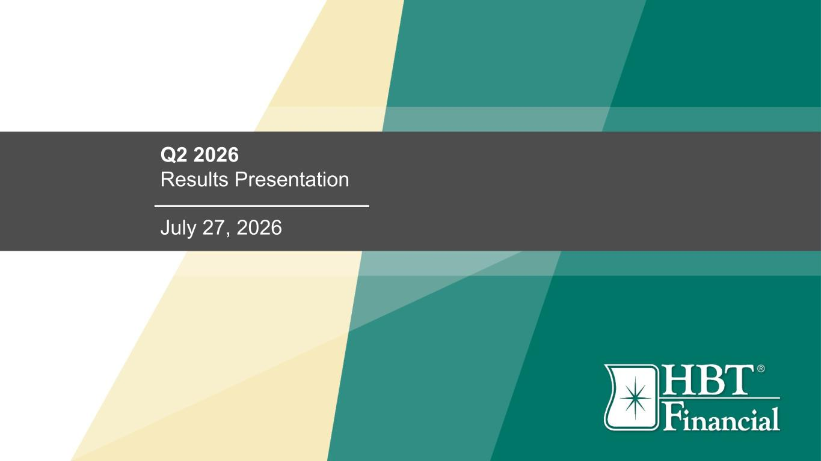

Q2 2026 Results Presentation July 27, 2026

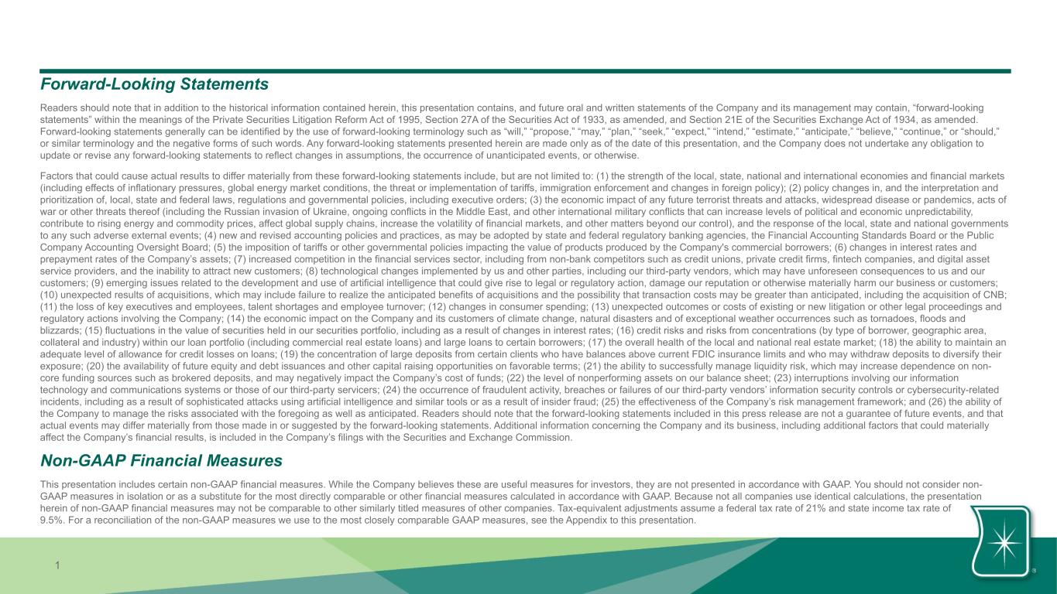
1 Forward-Looking Statements Readers should note that in addition to the historical information contained herein, this presentation contains, and future oral and written statements of the Company and its management may contain, “forward-looking statements” within the meanings of the Private Securities Litigation Reform Act of 1995, Section 27A of the Securities Act of 1933, as amended, and Section 21E of the Securities Exchange Act of 1934, as amended. Forward-looking statements generally can be identified by the use of forward-looking terminology such as “will,” “propose,” “may,” “plan,” “seek,” “expect,” “intend,” “estimate,” “anticipate,” “believe,” “continue,” or “should,” or similar terminology and the negative forms of such words. Any forward-looking statements presented herein are made only as of the date of this presentation, and the Company does not undertake any obligation to update or revise any forward-looking statements to reflect changes in assumptions, the occurrence of unanticipated events, or otherwise. Factors that could cause actual results to differ materially from these forward-looking statements include, but are not limited to: (1) the strength of the local, state, national and international economies and financial markets (including effects of inflationary pressures, global energy market conditions, the threat or implementation of tariffs, immigration enforcement and changes in foreign policy); (2) policy changes in, and the interpretation and prioritization of, local, state and federal laws, regulations and governmental policies, including executive orders; (3) the economic impact of any future terrorist threats and attacks, widespread disease or pandemics, acts of war or other threats thereof (including the Russian invasion of Ukraine, ongoing conflicts in the Middle East, and other international military conflicts that can increase levels of political and economic unpredictability, contribute to rising energy and commodity prices, affect global supply chains, increase the volatility of financial markets, and other matters beyond our control), and the response of the local, state and national governments to any such adverse external events; (4) new and revised accounting policies and practices, as may be adopted by state and federal regulatory banking agencies, the Financial Accounting Standards Board or the Public Company Accounting Oversight Board; (5) the imposition of tariffs or other governmental policies impacting the value of products produced by the Company's commercial borrowers; (6) changes in interest rates and prepayment rates of the Company’s assets; (7) increased competition in the financial services sector, including from non-bank competitors such as credit unions, private credit firms, fintech companies, and digital asset service providers, and the inability to attract new customers; (8) technological changes implemented by us and other parties, including our third-party vendors, which may have unforeseen consequences to us and our customers; (9) emerging issues related to the development and use of artificial intelligence that could give rise to legal or regulatory action, damage our reputation or otherwise materially harm our business or customers; (10) unexpected results of acquisitions, which may include failure to realize the anticipated benefits of acquisitions and the possibility that transaction costs may be greater than anticipated, including the acquisition of CNB; (11) the loss of key executives and employees, talent shortages and employee turnover; (12) changes in consumer spending; (13) unexpected outcomes or costs of existing or new litigation or other legal proceedings and regulatory actions involving the Company; (14) the economic impact on the Company and its customers of climate change, natural disasters and of exceptional weather occurrences such as tornadoes, floods and blizzards; (15) fluctuations in the value of securities held in our securities portfolio, including as a result of changes in interest rates; (16) credit risks and risks from concentrations (by type of borrower, geographic area, collateral and industry) within our loan portfolio (including commercial real estate loans) and large loans to certain borrowers; (17) the overall health of the local and national real estate market; (18) the ability to maintain an adequate level of allowance for credit losses on loans; (19) the concentration of large deposits from certain clients who have balances above current FDIC insurance limits and who may withdraw deposits to diversify their exposure; (20) the availability of future equity and debt issuances and other capital raising opportunities on favorable terms; (21) the ability to successfully manage liquidity risk, which may increase dependence on non- core funding sources such as brokered deposits, and may negatively impact the Company’s cost of funds; (22) the level of nonperforming assets on our balance sheet; (23) interruptions involving our information technology and communications systems or those of our third-party servicers; (24) the occurrence of fraudulent activity, breaches or failures of our third-party vendors’ information security controls or cybersecurity-related incidents, including as a result of sophisticated attacks using artificial intelligence and similar tools or as a result of insider fraud; (25) the effectiveness of the Company’s risk management framework; and (26) the ability of the Company to manage the risks associated with the foregoing as well as anticipated. Readers should note that the forward-looking statements included in this press release are not a guarantee of future events, and that actual events may differ materially from those made in or suggested by the forward-looking statements. Additional information concerning the Company and its business, including additional factors that could materially affect the Company’s financial results, is included in the Company’s filings with the Securities and Exchange Commission. Non-GAAP Financial Measures This presentation includes certain non-GAAP financial measures. While the Company believes these are useful measures for investors, they are not presented in accordance with GAAP. You should not consider non- GAAP measures in isolation or as a substitute for the most directly comparable or other financial measures calculated in accordance with GAAP. Because not all companies use identical calculations, the presentation herein of non-GAAP financial measures may not be comparable to other similarly titled measures of other companies. Tax-equivalent adjustments assume a federal tax rate of 21% and state income tax rate of 9.5%. For a reconciliation of the non-GAAP measures we use to the most closely comparable GAAP measures, see the Appendix to this presentation.

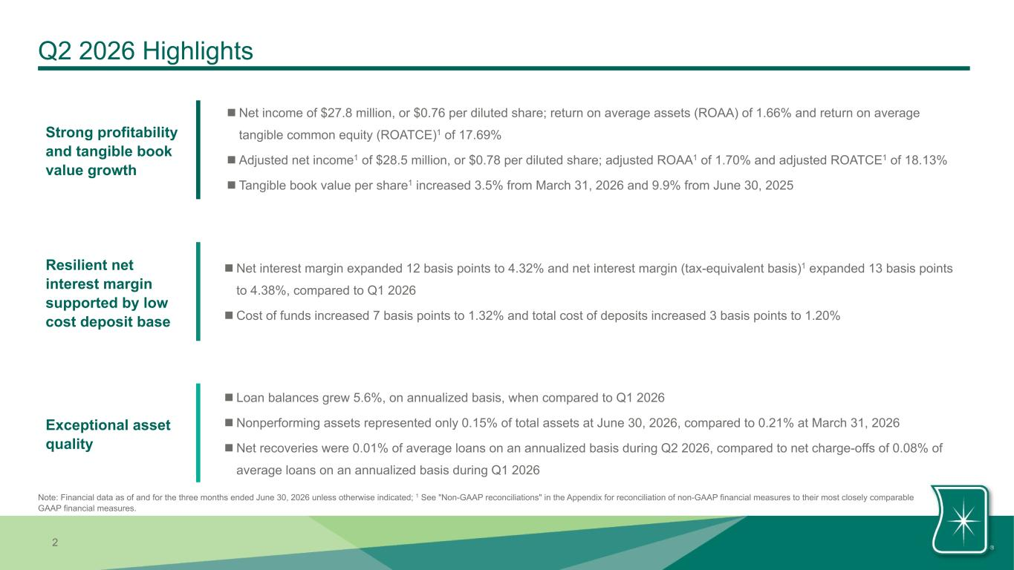
2 Exceptional asset quality Strong profitability and tangible book value growth Resilient net interest margin supported by low cost deposit base n Loan balances grew 5.6%, on annualized basis, when compared to Q1 2026 n Nonperforming assets represented only 0.15% of total assets at June 30, 2026, compared to 0.21% at March 31, 2026 n Net recoveries were 0.01% of average loans on an annualized basis during Q2 2026, compared to net charge-offs of 0.08% of average loans on an annualized basis during Q1 2026 n Net income of $27.8 million, or $0.76 per diluted share; return on average assets (ROAA) of 1.66% and return on average tangible common equity (ROATCE)1 of 17.69% n Adjusted net income1 of $28.5 million, or $0.78 per diluted share; adjusted ROAA1 of 1.70% and adjusted ROATCE1 of 18.13% n Tangible book value per share1 increased 3.5% from March 31, 2026 and 9.9% from June 30, 2025 Q2 2026 Highlights Note: Financial data as of and for the three months ended June 30, 2026 unless otherwise indicated; 1 See "Non-GAAP reconciliations" in the Appendix for reconciliation of non-GAAP financial measures to their most closely comparable GAAP financial measures. n Net interest margin expanded 12 basis points to 4.32% and net interest margin (tax-equivalent basis)1 expanded 13 basis points to 4.38%, compared to Q1 2026 n Cost of funds increased 7 basis points to 1.32% and total cost of deposits increased 3 basis points to 1.20%

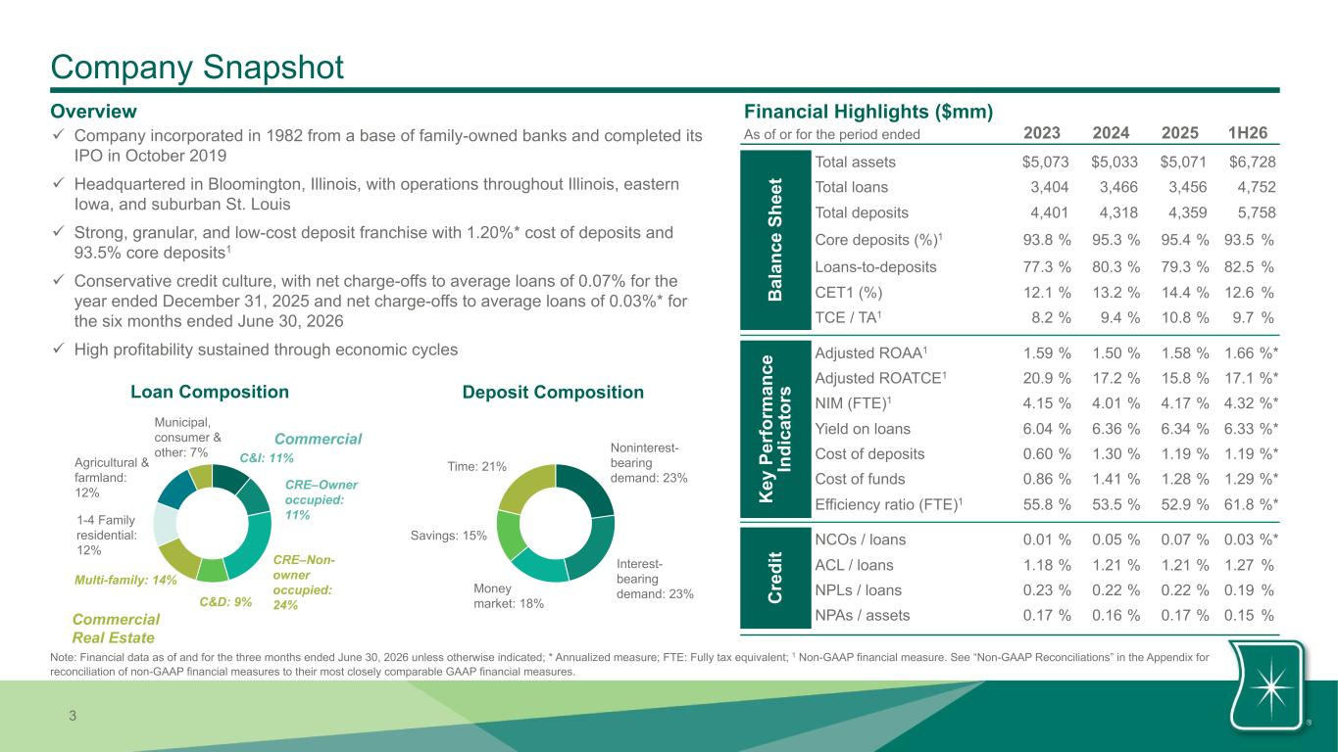
3 Company Snapshot Overview ü Company incorporated in 1982 from a base of family-owned banks and completed its IPO in October 2019 ü Headquartered in Bloomington, Illinois, with operations throughout Illinois, eastern Iowa, and suburban St. Louis ü Strong, granular, and low-cost deposit franchise with 1.20%* cost of deposits and 93.5% core deposits1 ü Conservative credit culture, with net charge-offs to average loans of 0.07% for the year ended December 31, 2025 and net charge-offs to average loans of 0.03%* for the six months ended June 30, 2026 ü High profitability sustained through economic cycles Loan Composition Deposit Composition Noninterest- bearing demand: 23% Interest- bearing demand: 23%Money market: 18% Savings: 15% Time: 21% C&I: 11% CRE–Owner occupied: 11% CRE–Non- owner occupied: 24%C&D: 9% Multi-family: 14% 1-4 Family residential: 12% Agricultural & farmland: 12% Municipal, consumer & other: 7% Commercial Real Estate Note: Financial data as of and for the three months ended June 30, 2026 unless otherwise indicated; * Annualized measure; FTE: Fully tax equivalent; 1 Non-GAAP financial measure. See “Non-GAAP Reconciliations” in the Appendix for reconciliation of non-GAAP financial measures to their most closely comparable GAAP financial measures. Commercial Financial Highlights ($mm) 2023 2024 2025 1H26As of or for the period ended B al an ce S he et Total assets $5,073 $5,033 $5,071 $6,728 Total loans 3,404 3,466 3,456 4,752 Total deposits 4,401 4,318 4,359 5,758 Core deposits (%)1 93.8 % 95.3 % 95.4 % 93.5 % Loans-to-deposits 77.3 % 80.3 % 79.3 % 82.5 % CET1 (%) 12.1 % 13.2 % 14.4 % 12.6 % TCE / TA1 8.2 % 9.4 % 10.8 % 9.7 % K ey P er fo rm an ce In di ca to rs Adjusted ROAA1 1.59 % 1.50 % 1.58 % 1.66 %* Adjusted ROATCE1 20.9 % 17.2 % 15.8 % 17.1 %* NIM (FTE)1 4.15 % 4.01 % 4.17 % 4.32 %* Yield on loans 6.04 % 6.36 % 6.34 % 6.33 %* Cost of deposits 0.60 % 1.30 % 1.19 % 1.19 %* Cost of funds 0.86 % 1.41 % 1.28 % 1.29 %* Efficiency ratio (FTE)1 55.8 % 53.5 % 52.9 % 61.8 %* C re di t NCOs / loans 0.01 % 0.05 % 0.07 % 0.03 %* ACL / loans 1.18 % 1.21 % 1.21 % 1.27 % NPLs / loans 0.23 % 0.22 % 0.22 % 0.19 % NPAs / assets 0.17 % 0.16 % 0.17 % 0.15 %

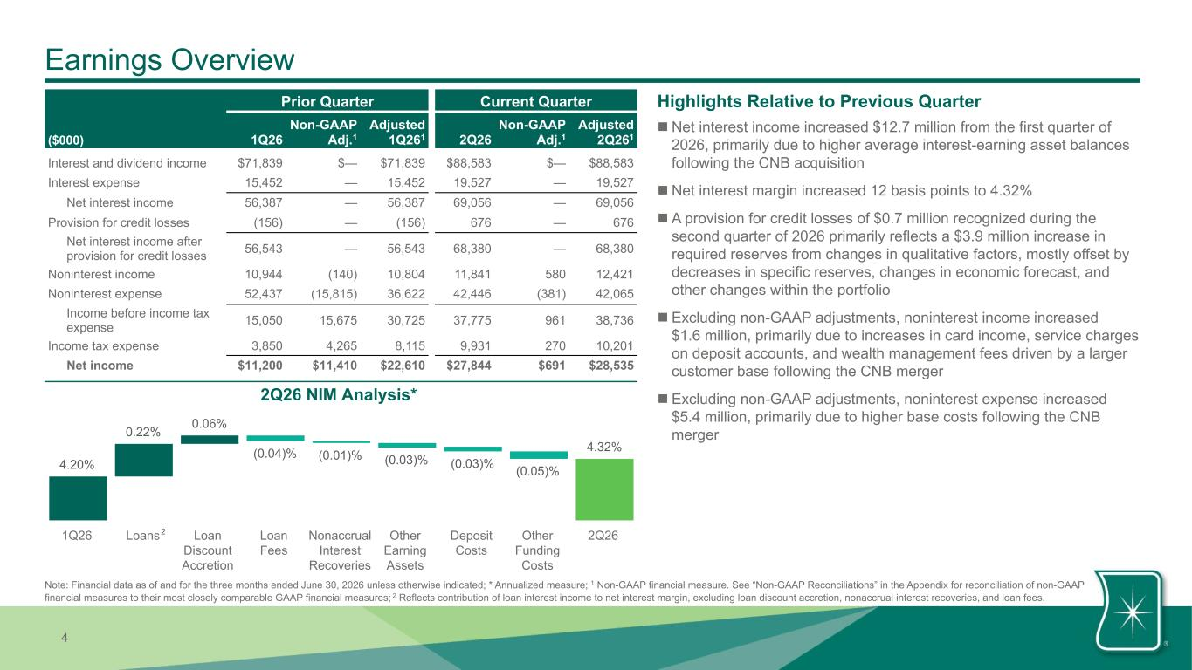
4 4.20% 0.22% 0.06% (0.04)% (0.01)% (0.03)% (0.03)% (0.05)% 4.32% 1Q26 Loans Loan Discount Accretion Loan Fees Nonaccrual Interest Recoveries Other Earning Assets Deposit Costs Other Funding Costs 2Q26 Earnings Overview Prior Quarter Current Quarter ($000) 1Q26 Non-GAAP Adj.1 Adjusted 1Q261 2Q26 Non-GAAP Adj.1 Adjusted 2Q261 Interest and dividend income $71,839 $— $71,839 $88,583 $— $88,583 Interest expense 15,452 — 15,452 19,527 — 19,527 Net interest income 56,387 — 56,387 69,056 — 69,056 Provision for credit losses (156) — (156) 676 — 676 Net interest income after provision for credit losses 56,543 — 56,543 68,380 — 68,380 Noninterest income 10,944 (140) 10,804 11,841 580 12,421 Noninterest expense 52,437 (15,815) 36,622 42,446 (381) 42,065 Income before income tax expense 15,050 15,675 30,725 37,775 961 38,736 Income tax expense 3,850 4,265 8,115 9,931 270 10,201 Net income $11,200 $11,410 $22,610 $27,844 $691 $28,535 Highlights Relative to Previous Quarter 2 n Net interest income increased $12.7 million from the first quarter of 2026, primarily due to higher average interest-earning asset balances following the CNB acquisition n Net interest margin increased 12 basis points to 4.32% n A provision for credit losses of $0.7 million recognized during the second quarter of 2026 primarily reflects a $3.9 million increase in required reserves from changes in qualitative factors, mostly offset by decreases in specific reserves, changes in economic forecast, and other changes within the portfolio n Excluding non-GAAP adjustments, noninterest income increased $1.6 million, primarily due to increases in card income, service charges on deposit accounts, and wealth management fees driven by a larger customer base following the CNB merger n Excluding non-GAAP adjustments, noninterest expense increased $5.4 million, primarily due to higher base costs following the CNB merger 2Q26 NIM Analysis* Note: Financial data as of and for the three months ended June 30, 2026 unless otherwise indicated; * Annualized measure; 1 Non-GAAP financial measure. See “Non-GAAP Reconciliations” in the Appendix for reconciliation of non-GAAP financial measures to their most closely comparable GAAP financial measures; 2 Reflects contribution of loan interest income to net interest margin, excluding loan discount accretion, nonaccrual interest recoveries, and loan fees.

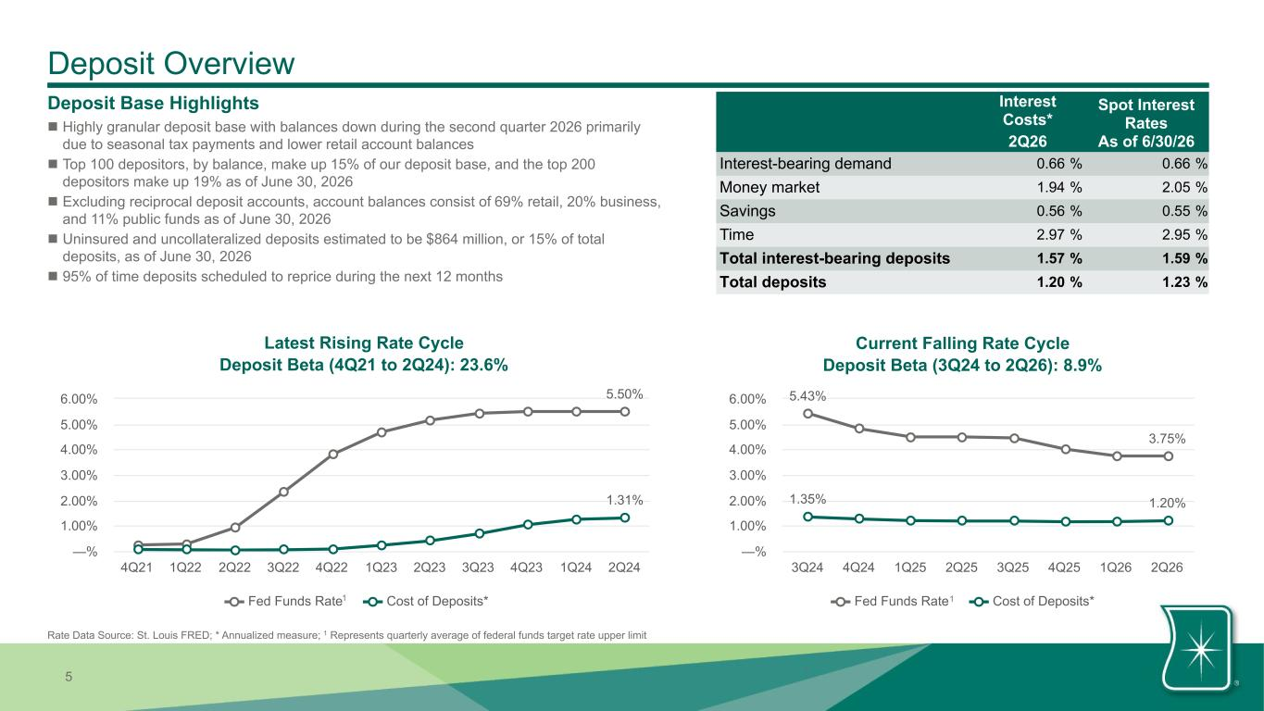
5 5.50% 1.31% Fed Funds Rate Cost of Deposits* 4Q21 1Q22 2Q22 3Q22 4Q22 1Q23 2Q23 3Q23 4Q23 1Q24 2Q24 —% 1.00% 2.00% 3.00% 4.00% 5.00% 6.00% Deposit Overview Deposit Base Highlights n Highly granular deposit base with balances down during the second quarter 2026 primarily due to seasonal tax payments and lower retail account balances n Top 100 depositors, by balance, make up 15% of our deposit base, and the top 200 depositors make up 19% as of June 30, 2026 n Excluding reciprocal deposit accounts, account balances consist of 69% retail, 20% business, and 11% public funds as of June 30, 2026 n Uninsured and uncollateralized deposits estimated to be $864 million, or 15% of total deposits, as of June 30, 2026 n 95% of time deposits scheduled to reprice during the next 12 months Interest Costs* 2Q26 Spot Interest Rates As of 6/30/26 Interest-bearing demand 0.66 % 0.66 % Money market 1.94 % 2.05 % Savings 0.56 % 0.55 % Time 2.97 % 2.95 % Total interest-bearing deposits 1.57 % 1.59 % Total deposits 1.20 % 1.23 % 1 Latest Rising Rate Cycle Deposit Beta (4Q21 to 2Q24): 23.6% 5.43% 3.75% 1.35% 1.20% Fed Funds Rate Cost of Deposits* 3Q24 4Q24 1Q25 2Q25 3Q25 4Q25 1Q26 2Q26 —% 1.00% 2.00% 3.00% 4.00% 5.00% 6.00% Current Falling Rate Cycle Deposit Beta (3Q24 to 2Q26): 8.9% 1 Rate Data Source: St. Louis FRED; * Annualized measure; 1 Represents quarterly average of federal funds target rate upper limit 1

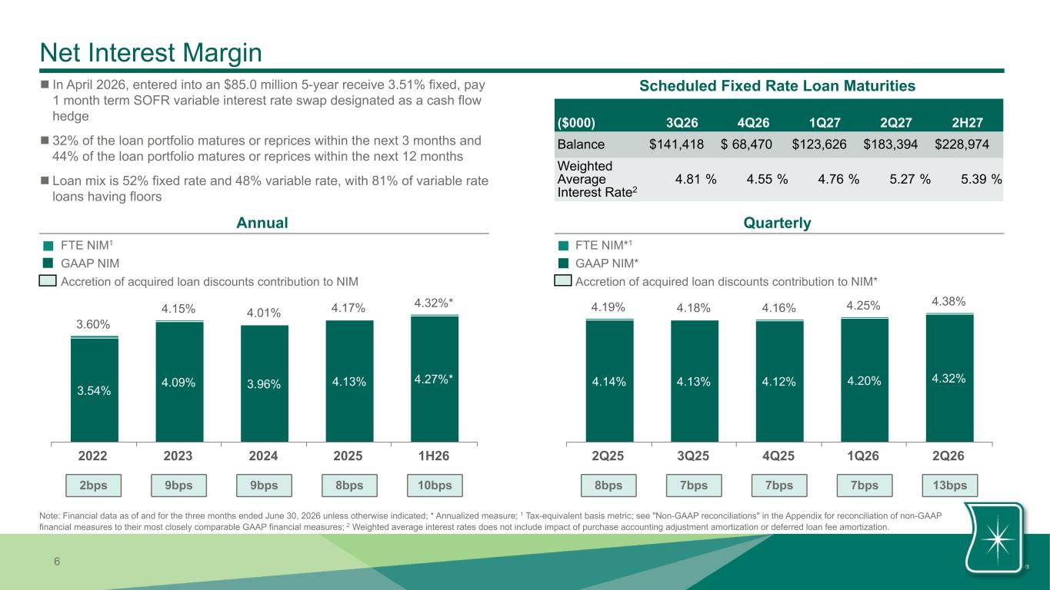
6 Net Interest Margin Annual Quarterly FTE NIM*1 GAAP NIM* Accretion of acquired loan discounts contribution to NIM* FTE NIM1 GAAP NIM Accretion of acquired loan discounts contribution to NIM 3.60% 4.15% 4.01% 4.17% 4.32%* 3.54% 4.09% 3.96% 4.13% 4.27%* 2022 2023 2024 2025 1H26 4.19% 4.18% 4.16% 4.25% 4.38% 4.14% 4.13% 4.12% 4.20% 4.32% 2Q25 3Q25 4Q25 1Q26 2Q26 n In April 2026, entered into an $85.0 million 5-year receive 3.51% fixed, pay 1 month term SOFR variable interest rate swap designated as a cash flow hedge n 32% of the loan portfolio matures or reprices within the next 3 months and 44% of the loan portfolio matures or reprices within the next 12 months n Loan mix is 52% fixed rate and 48% variable rate, with 81% of variable rate loans having floors Scheduled Fixed Rate Loan Maturities ($000) 3Q26 4Q26 1Q27 2Q27 2H27 Balance $ 141,418 $ 68,470 $ 123,626 $ 183,394 $ 228,974 Weighted Average Interest Rate2 4.81 % 4.55 % 4.76 % 5.27 % 5.39 % Note: Financial data as of and for the three months ended June 30, 2026 unless otherwise indicated; * Annualized measure; 1 Tax-equivalent basis metric; see "Non-GAAP reconciliations" in the Appendix for reconciliation of non-GAAP financial measures to their most closely comparable GAAP financial measures; 2 Weighted average interest rates does not include impact of purchase accounting adjustment amortization or deferred loan fee amortization. 2bps 9bps 9bps 8bps 10bps 8bps 7bps 7bps 7bps 13bps

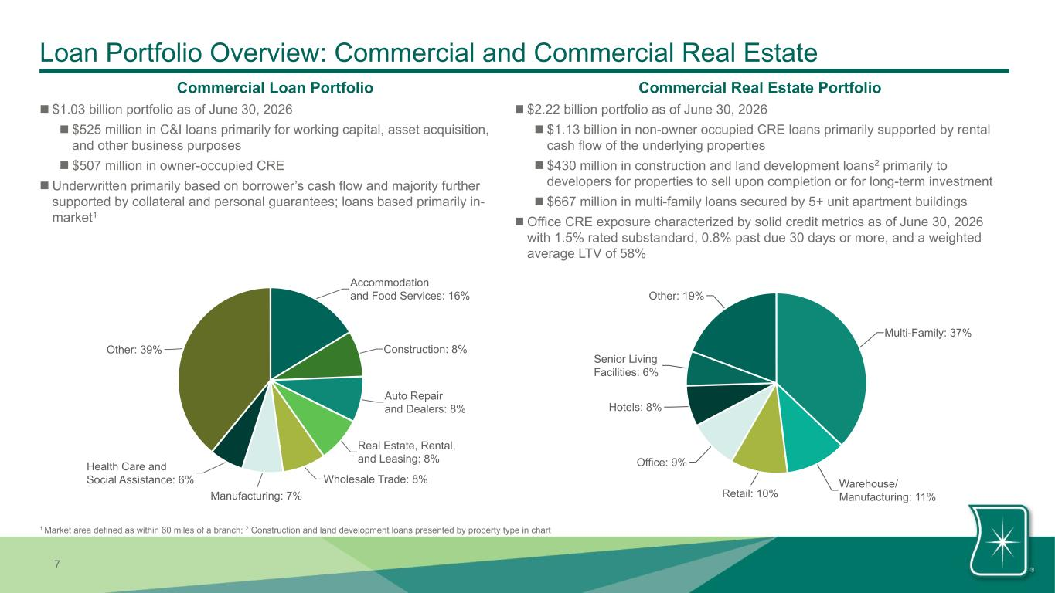
7 Loan Portfolio Overview: Commercial and Commercial Real Estate n $2.22 billion portfolio as of June 30, 2026 n $1.13 billion in non-owner occupied CRE loans primarily supported by rental cash flow of the underlying properties n $430 million in construction and land development loans2 primarily to developers for properties to sell upon completion or for long-term investment n $667 million in multi-family loans secured by 5+ unit apartment buildings n Office CRE exposure characterized by solid credit metrics as of June 30, 2026 with 1.5% rated substandard, 0.8% past due 30 days or more, and a weighted average LTV of 58% Commercial Real Estate PortfolioCommercial Loan Portfolio n $1.03 billion portfolio as of June 30, 2026 n $525 million in C&I loans primarily for working capital, asset acquisition, and other business purposes n $507 million in owner-occupied CRE n Underwritten primarily based on borrower’s cash flow and majority further supported by collateral and personal guarantees; loans based primarily in- market1 Accommodation and Food Services: 16% Construction: 8% Auto Repair and Dealers: 8% Real Estate, Rental, and Leasing: 8% Wholesale Trade: 8% Manufacturing: 7% Health Care and Social Assistance: 6% Other: 39% Multi-Family: 37% Warehouse/ Manufacturing: 11%Retail: 10% Office: 9% Hotels: 8% Senior Living Facilities: 6% Other: 19% 1 Market area defined as within 60 miles of a branch; 2 Construction and land development loans presented by property type in chart

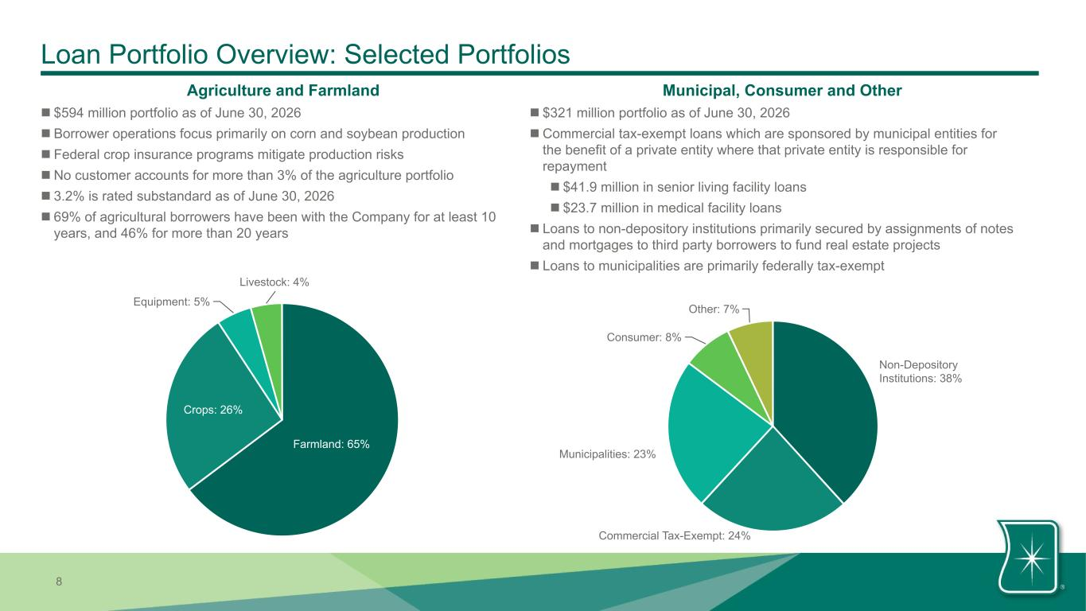
8 Loan Portfolio Overview: Selected Portfolios n $594 million portfolio as of June 30, 2026 n Borrower operations focus primarily on corn and soybean production n Federal crop insurance programs mitigate production risks n No customer accounts for more than 3% of the agriculture portfolio n 3.2% is rated substandard as of June 30, 2026 n 69% of agricultural borrowers have been with the Company for at least 10 years, and 46% for more than 20 years n $321 million portfolio as of June 30, 2026 n Commercial tax-exempt loans which are sponsored by municipal entities for the benefit of a private entity where that private entity is responsible for repayment n $41.9 million in senior living facility loans n $23.7 million in medical facility loans n Loans to non-depository institutions primarily secured by assignments of notes and mortgages to third party borrowers to fund real estate projects n Loans to municipalities are primarily federally tax-exempt Farmland: 65% Crops: 26% Equipment: 5% Livestock: 4% Non-Depository Institutions: 38% Commercial Tax-Exempt: 24% Municipalities: 23% Consumer: 8% Other: 7% Municipal, Consumer and OtherAgriculture and Farmland

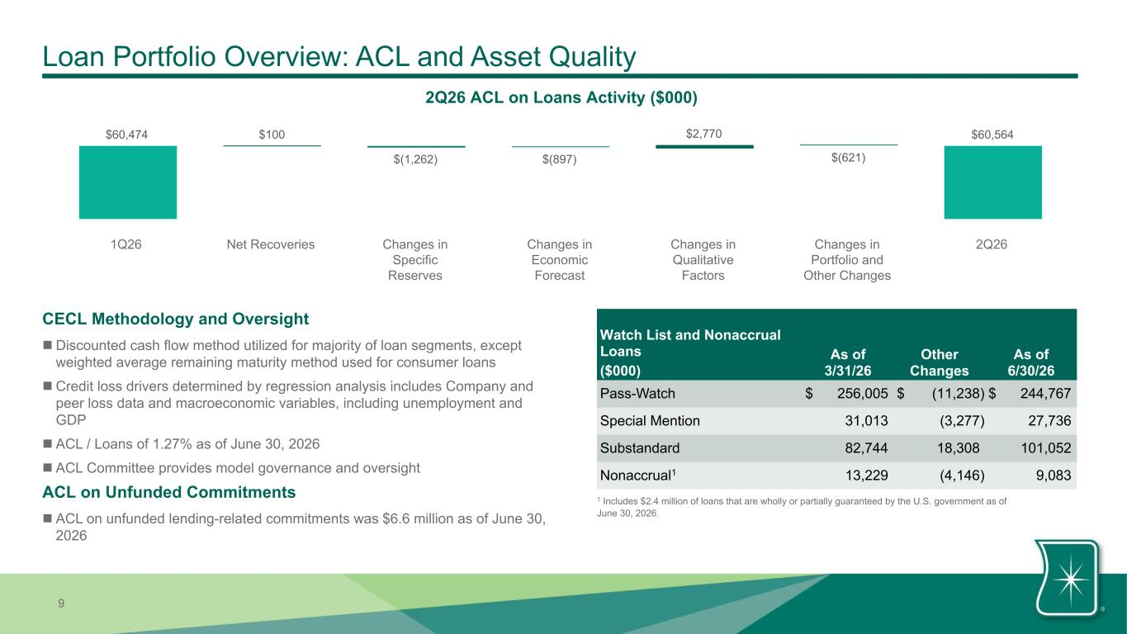
9 Loan Portfolio Overview: ACL and Asset Quality 2Q26 ACL on Loans Activity ($000) Watch List and Nonaccrual Loans ($000) As of 3/31/26 Other Changes As of 6/30/26 Pass-Watch $ 256,005 $ (11,238) $ 244,767 Special Mention 31,013 (3,277) 27,736 Substandard 82,744 18,308 101,052 Nonaccrual1 13,229 (4,146) 9,083 CECL Methodology and Oversight n Discounted cash flow method utilized for majority of loan segments, except weighted average remaining maturity method used for consumer loans n Credit loss drivers determined by regression analysis includes Company and peer loss data and macroeconomic variables, including unemployment and GDP n ACL / Loans of 1.27% as of June 30, 2026 n ACL Committee provides model governance and oversight ACL on Unfunded Commitments n ACL on unfunded lending-related commitments was $6.6 million as of June 30, 2026 1 Includes $2.4 million of loans that are wholly or partially guaranteed by the U.S. government as of June 30, 2026. $60,474 $100 $(1,262) $(897) $2,770 $(621) $60,564 1Q26 Net Recoveries Changes in Specific Reserves Changes in Economic Forecast Changes in Qualitative Factors Changes in Portfolio and Other Changes 2Q26

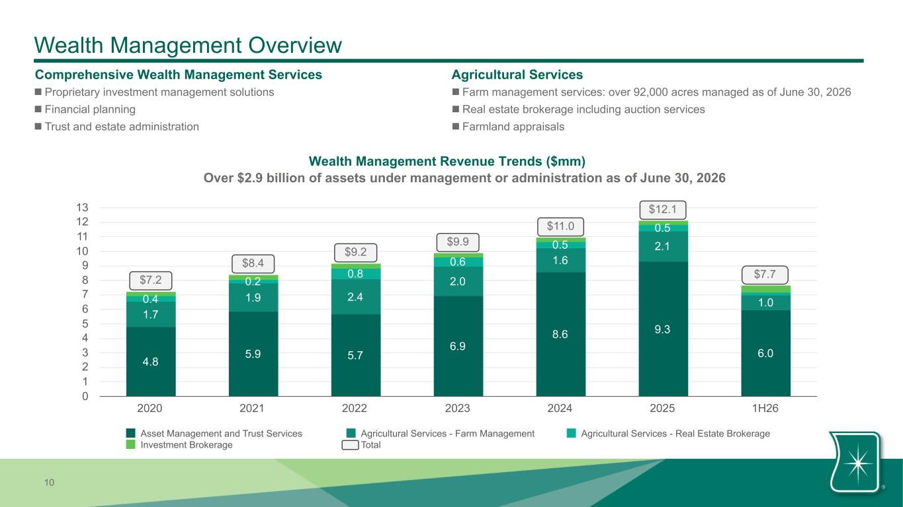
10 4.8 5.9 5.7 6.9 8.6 9.3 6.0 1.7 1.9 2.4 2.0 1.6 2.1 1.00.4 0.2 0.8 0.6 0.5 0.5 Asset Management and Trust Services Agricultural Services - Farm Management Agricultural Services - Real Estate Brokerage Investment Brokerage Total 2020 2021 2022 2023 2024 2025 1H26 0 1 2 3 4 5 6 7 8 9 10 11 12 13 Wealth Management Overview Comprehensive Wealth Management Services n Proprietary investment management solutions n Financial planning n Trust and estate administration Wealth Management Revenue Trends ($mm) Agricultural Services n Farm management services: over 92,000 acres managed as of June 30, 2026 n Real estate brokerage including auction services n Farmland appraisals $12.1 $7.2 $8.4 $9.2 $9.9 Over $2.9 billion of assets under management or administration as of June 30, 2026 $11.0 $7.7

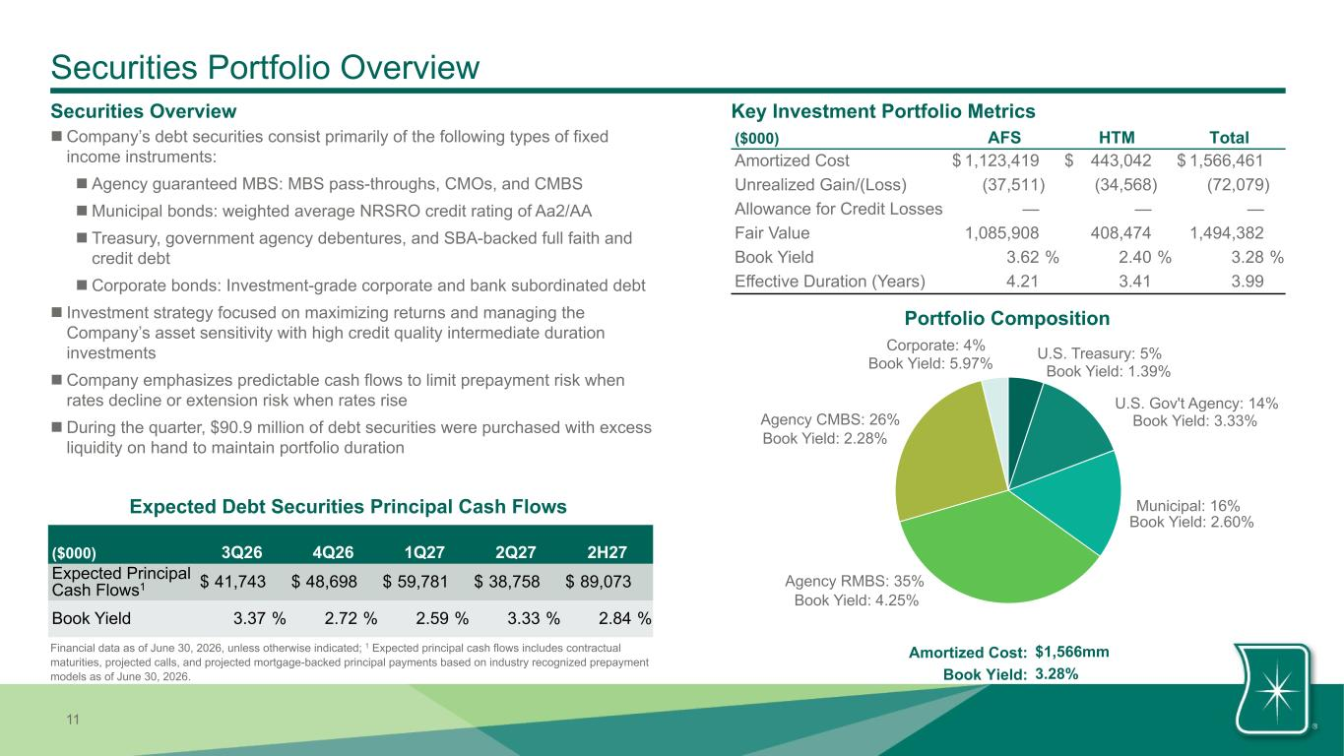
11 Securities Portfolio Overview Securities Overview Key Investment Portfolio Metrics ($000) AFS HTM Total Amortized Cost $ 1,123,419 $ 443,042 $ 1,566,461 Unrealized Gain/(Loss) (37,511) (34,568) (72,079) Allowance for Credit Losses — — — Fair Value 1,085,908 408,474 1,494,382 Book Yield 3.62 % 2.40 % 3.28 % Effective Duration (Years) 4.21 3.41 3.99 Portfolio Composition U.S. Treasury: 5% U.S. Gov't Agency: 14% Municipal: 16% Agency RMBS: 35% Agency CMBS: 26% Corporate: 4% Amortized Cost: $1,566mm Book Yield: 3.28% Book Yield: 3.33% Book Yield: 2.28% Book Yield: 1.39% Book Yield: 2.60% Book Yield: 4.25% Book Yield: 5.97% n Company’s debt securities consist primarily of the following types of fixed income instruments: n Agency guaranteed MBS: MBS pass-throughs, CMOs, and CMBS n Municipal bonds: weighted average NRSRO credit rating of Aa2/AA n Treasury, government agency debentures, and SBA-backed full faith and credit debt n Corporate bonds: Investment-grade corporate and bank subordinated debt n Investment strategy focused on maximizing returns and managing the Company’s asset sensitivity with high credit quality intermediate duration investments n Company emphasizes predictable cash flows to limit prepayment risk when rates decline or extension risk when rates rise n During the quarter, $90.9 million of debt securities were purchased with excess liquidity on hand to maintain portfolio duration Expected Debt Securities Principal Cash Flows ($000) 3Q26 4Q26 1Q27 2Q27 2H27 Expected Principal Cash Flows1 $ 41,743 $ 48,698 $ 59,781 $ 38,758 $ 89,073 Book Yield 3.37 % 2.72 % 2.59 % 3.33 % 2.84 % Financial data as of June 30, 2026, unless otherwise indicated; 1 Expected principal cash flows includes contractual maturities, projected calls, and projected mortgage-backed principal payments based on industry recognized prepayment models as of June 30, 2026.

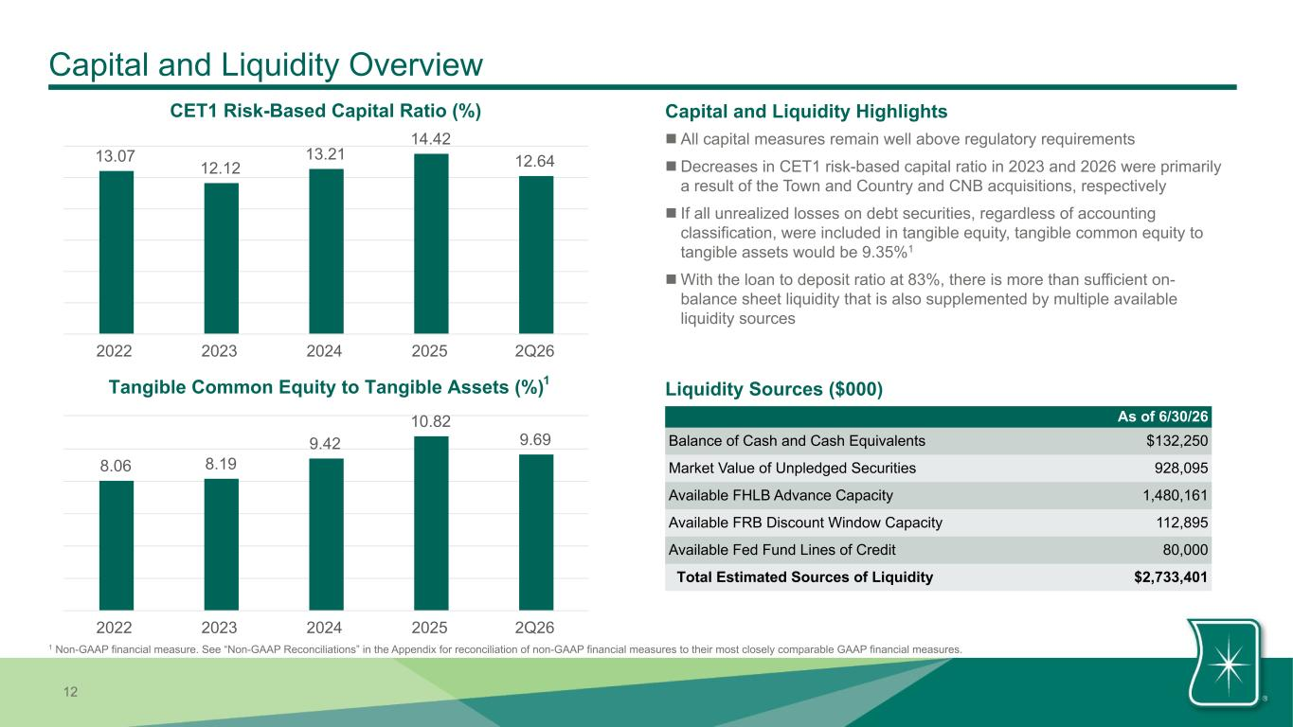
12 Capital and Liquidity Overview As of 6/30/26 Balance of Cash and Cash Equivalents $132,250 Market Value of Unpledged Securities 928,095 Available FHLB Advance Capacity 1,480,161 Available FRB Discount Window Capacity 112,895 Available Fed Fund Lines of Credit 80,000 Total Estimated Sources of Liquidity $2,733,401 Capital and Liquidity Highlights n All capital measures remain well above regulatory requirements n Decreases in CET1 risk-based capital ratio in 2023 and 2026 were primarily a result of the Town and Country and CNB acquisitions, respectively n If all unrealized losses on debt securities, regardless of accounting classification, were included in tangible equity, tangible common equity to tangible assets would be 9.35%1 n With the loan to deposit ratio at 83%, there is more than sufficient on- balance sheet liquidity that is also supplemented by multiple available liquidity sources CET1 Risk-Based Capital Ratio (%) 13.07 12.12 13.21 14.42 12.64 2022 2023 2024 2025 2Q26 Tangible Common Equity to Tangible Assets (%) 8.06 8.19 9.42 10.82 9.69 2022 2023 2024 2025 2Q26 1 1 Non-GAAP financial measure. See “Non-GAAP Reconciliations” in the Appendix for reconciliation of non-GAAP financial measures to their most closely comparable GAAP financial measures. Liquidity Sources ($000)

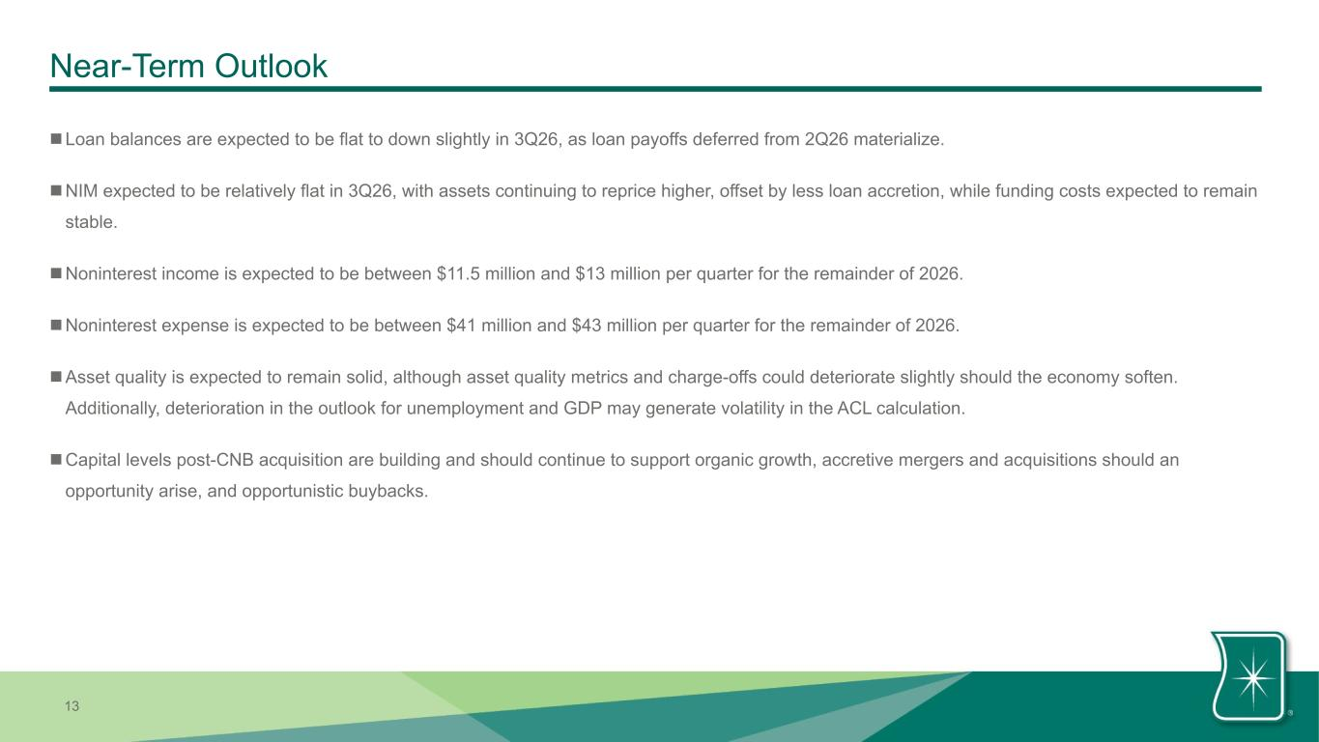
13 Near-Term Outlook nLoan balances are expected to be flat to down slightly in 3Q26, as loan payoffs deferred from 2Q26 materialize. nNIM expected to be relatively flat in 3Q26, with assets continuing to reprice higher, offset by less loan accretion, while funding costs expected to remain stable. nNoninterest income is expected to be between $11.5 million and $13 million per quarter for the remainder of 2026. nNoninterest expense is expected to be between $41 million and $43 million per quarter for the remainder of 2026. nAsset quality is expected to remain solid, although asset quality metrics and charge-offs could deteriorate slightly should the economy soften. Additionally, deterioration in the outlook for unemployment and GDP may generate volatility in the ACL calculation. nCapital levels post-CNB acquisition are building and should continue to support organic growth, accretive mergers and acquisitions should an opportunity arise, and opportunistic buybacks.

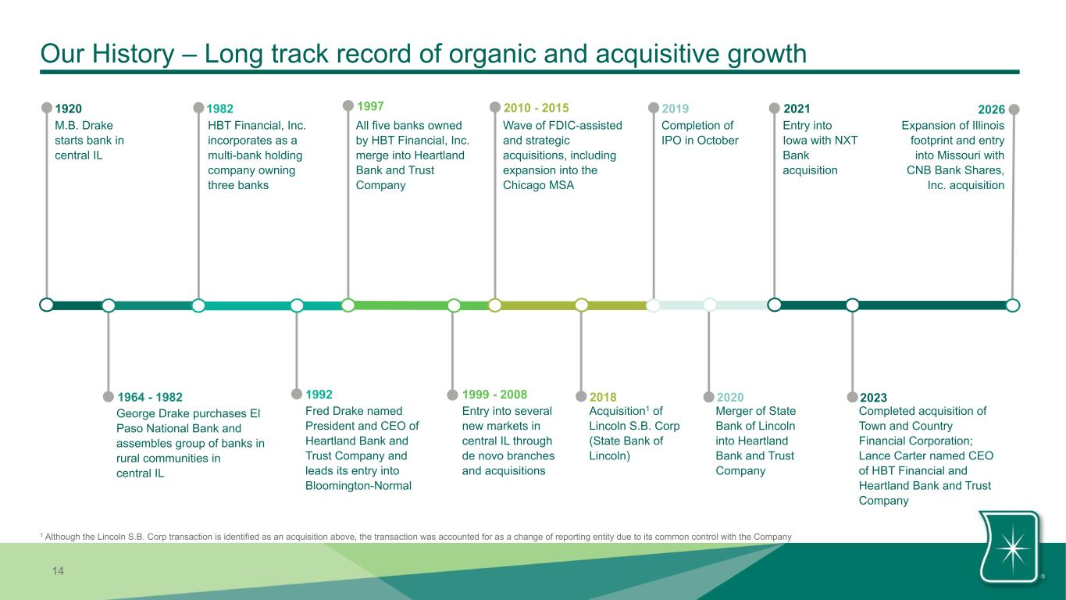
14 Our History – Long track record of organic and acquisitive growth All five banks owned by HBT Financial, Inc. merge into Heartland Bank and Trust Company 1997 1964 - 1982 George Drake purchases El Paso National Bank and assembles group of banks in rural communities in central IL M.B. Drake starts bank in central IL 1920 HBT Financial, Inc. incorporates as a multi-bank holding company owning three banks 1982 1992 Fred Drake named President and CEO of Heartland Bank and Trust Company and leads its entry into Bloomington-Normal Completion of IPO in October 2019 Acquisition1 of Lincoln S.B. Corp (State Bank of Lincoln) 2018 Entry into several new markets in central IL through de novo branches and acquisitions 1999 - 2008 2010 - 2015 Wave of FDIC-assisted and strategic acquisitions, including expansion into the Chicago MSA 2021 Entry into Iowa with NXT Bank acquisition 2020 Merger of State Bank of Lincoln into Heartland Bank and Trust Company 2026 Expansion of Illinois footprint and entry into Missouri with CNB Bank Shares, Inc. acquisition 1 Although the Lincoln S.B. Corp transaction is identified as an acquisition above, the transaction was accounted for as a change of reporting entity due to its common control with the Company Completed acquisition of Town and Country Financial Corporation; Lance Carter named CEO of HBT Financial and Heartland Bank and Trust Company 2023

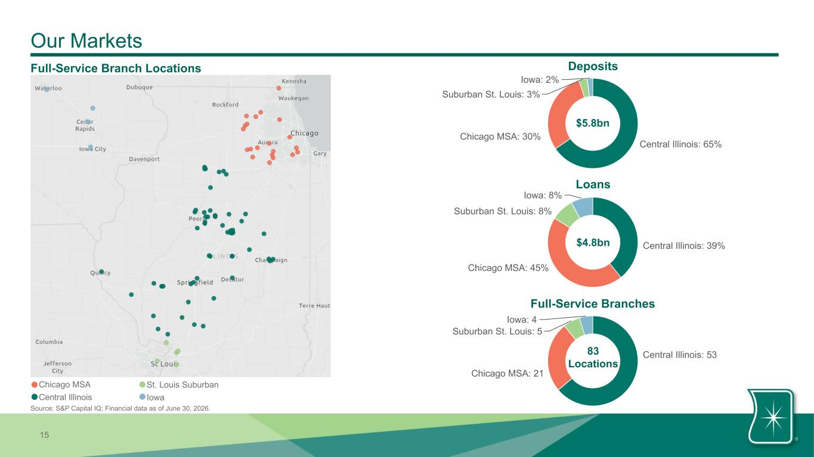
15 Central Illinois: 53 Chicago MSA: 21 Suburban St. Louis: 5 Iowa: 4 Our Markets Source: S&P Capital IQ; Financial data as of June 30, 2026. Full-Service Branch Locations Central Illinois: 65% Chicago MSA: 30% Suburban St. Louis: 3% Iowa: 2% $5.8bn Central Illinois: 39% Chicago MSA: 45% Suburban St. Louis: 8% Iowa: 8% $4.8bn 83 Locations Deposits Loans Full-Service Branches Chicago MSA Central Illinois St. Louis Suburban Iowa

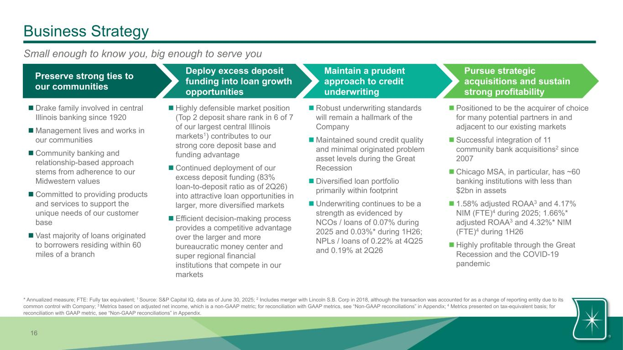
16 Business Strategy n Drake family involved in central Illinois banking since 1920 n Management lives and works in our communities n Community banking and relationship-based approach stems from adherence to our Midwestern values n Committed to providing products and services to support the unique needs of our customer base n Vast majority of loans originated to borrowers residing within 60 miles of a branch n Robust underwriting standards will remain a hallmark of the Company n Maintained sound credit quality and minimal originated problem asset levels during the Great Recession n Diversified loan portfolio primarily within footprint n Underwriting continues to be a strength as evidenced by NCOs / loans of 0.07% during 2025 and 0.03%* during 1H26; NPLs / loans of 0.22% at 4Q25 and 0.19% at 2Q26 n Positioned to be the acquirer of choice for many potential partners in and adjacent to our existing markets n Successful integration of 11 community bank acquisitions2 since 2007 n Chicago MSA, in particular, has ~60 banking institutions with less than $2bn in assets n 1.58% adjusted ROAA3 and 4.17% NIM (FTE)4 during 2025; 1.66%* adjusted ROAA3 and 4.32%* NIM (FTE)4 during 1H26 n Highly profitable through the Great Recession and the COVID-19 pandemic n Highly defensible market position (Top 2 deposit share rank in 6 of 7 of our largest central Illinois markets1) contributes to our strong core deposit base and funding advantage n Continued deployment of our excess deposit funding (83% loan-to-deposit ratio as of 2Q26) into attractive loan opportunities in larger, more diversified markets n Efficient decision-making process provides a competitive advantage over the larger and more bureaucratic money center and super regional financial institutions that compete in our markets Preserve strong ties to our communities Deploy excess deposit funding into loan growth opportunities Maintain a prudent approach to credit underwriting Pursue strategic acquisitions and sustain strong profitability Small enough to know you, big enough to serve you * Annualized measure; FTE: Fully tax equivalent; 1 Source: S&P Capital IQ, data as of June 30, 2025; 2 Includes merger with Lincoln S.B. Corp in 2018, although the transaction was accounted for as a change of reporting entity due to its common control with Company; 3 Metrics based on adjusted net income, which is a non-GAAP metric; for reconciliation with GAAP metrics, see “Non-GAAP reconciliations” in Appendix; 4 Metrics presented on tax-equivalent basis; for reconciliation with GAAP metric, see “Non-GAAP reconciliations” in Appendix.

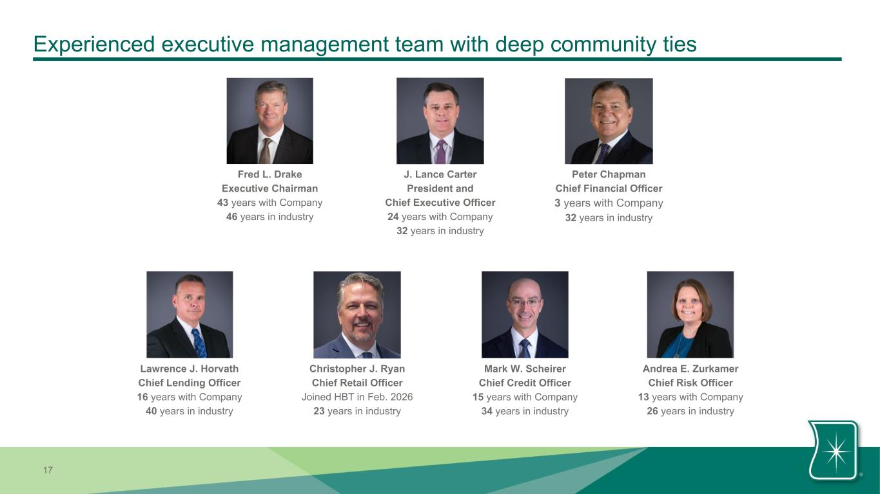
17 Experienced executive management team with deep community ties Fred L. Drake Executive Chairman 43 years with Company 46 years in industry J. Lance Carter President and Chief Executive Officer 24 years with Company 32 years in industry Lawrence J. Horvath Chief Lending Officer 16 years with Company 40 years in industry Mark W. Scheirer Chief Credit Officer 15 years with Company 34 years in industry Andrea E. Zurkamer Chief Risk Officer 13 years with Company 26 years in industry Christopher J. Ryan Chief Retail Officer Joined HBT in Feb. 2026 23 years in industry Peter Chapman Chief Financial Officer 3 years with Company 32 years in industry


18 Talented Board of Directors with deep financial services industry experience Fred L. Drake Executive Chairman • Director since 1984 • 43 years with Company • 46 years in industry J. Lance Carter Director • Director since 2011 • President & CEO of HBT Financial and Heartland Bank • 24 years with Company • 32 years in industry Patrick F. Busch Director • Director since 1998 • Vice Chairman of Heartland Bank • 31 years with Company • 48 years in industry Eric E. Burwell Director • Director since 2005 • Owner, Burwell Management Company Linda J. Koch Director • Director since 2020 • Former President & CEO of the Illinois Bankers Association • 36 years in industry Gerald E. Pfeiffer Director • Director since 2019 • Former Partner at CliftonLarsonAllen LLP • Over 50 years of industry experience Allen C. Drake Director • Director since 1981 • Retired EVP with 27 years of experience at Company Dr. C. Alvin Bowman Director • Director since 2019 • Former President of Illinois State University • 36 years in higher education Roger A. Baker Director • Director since 2022 • Former Chairman & President of NXT Bancorporation • 15 years in industry James T. Ashworth Director • Director since 2026 • Former President & Vice Chairman of CNB Bank Shares, Inc. • Over 47 years in industry Nancy L. Ruyle Director • Director since 2026 • Former Senior Partner at Ruyle & Sims • Over 40 years of legal experience Mike J. Morton Director • Director since 2026 • Former Vice Chair, U.S. Commercial Banking at Bank of Montreal • 39 years in industry

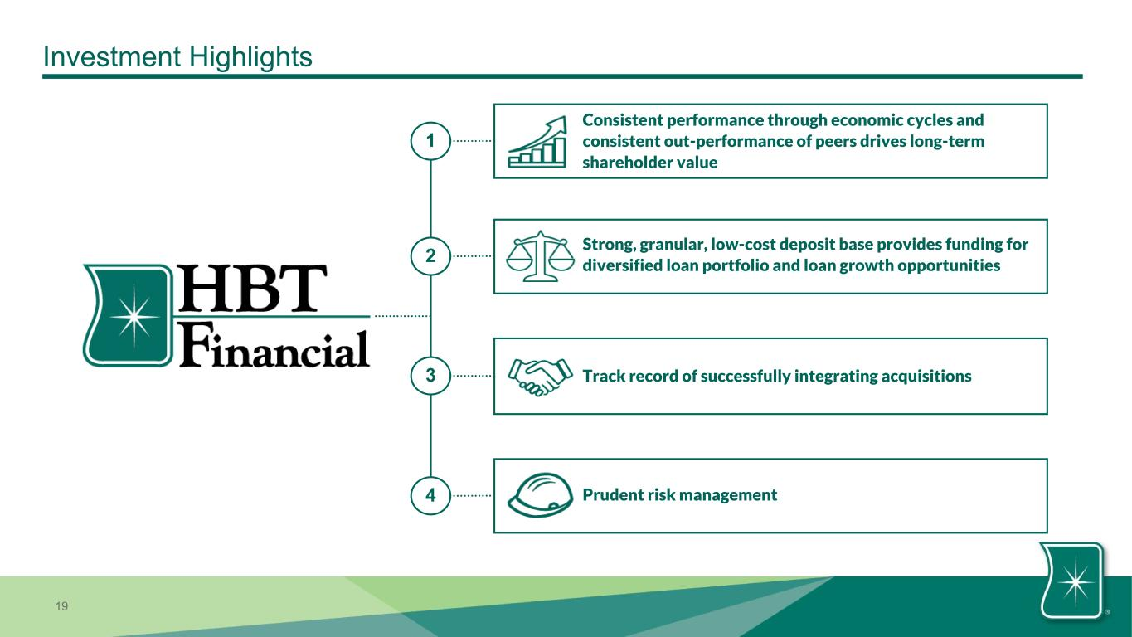
19 Investment Highlights 3 1 2 4 Track record of successfully integrating acquisitions Consistent performance through economic cycles and consistent out-performance of peers drives long-term shareholder value Strong, granular, low-cost deposit base provides funding for diversified loan portfolio and loan growth opportunities Prudent risk management

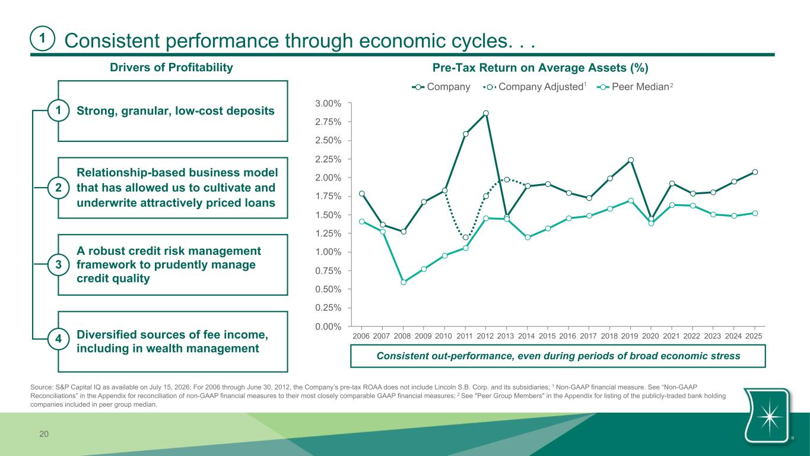
20 Consistent performance through economic cycles. . . Drivers of Profitability Strong, granular, low-cost deposits1 Relationship-based business model that has allowed us to cultivate and underwrite attractively priced loans A robust credit risk management framework to prudently manage credit quality Diversified sources of fee income, including in wealth management 4 Consistent out-performance, even during periods of broad economic stress 1 2 3 Pre-Tax Return on Average Assets (%) Company Company Adjusted Peer Median 2006 2007 2008 2009 2010 2011 2012 2013 2014 2015 2016 2017 2018 2019 2020 2021 2022 2023 2024 2025 0.00% 0.25% 0.50% 0.75% 1.00% 1.25% 1.50% 1.75% 2.00% 2.25% 2.50% 2.75% 3.00% 1 Source: S&P Capital IQ as available on July 15, 2026; For 2006 through June 30, 2012, the Company’s pre-tax ROAA does not include Lincoln S.B. Corp. and its subsidiaries; 1 Non-GAAP financial measure. See “Non-GAAP Reconciliations” in the Appendix for reconciliation of non-GAAP financial measures to their most closely comparable GAAP financial measures; 2 See "Peer Group Members" in the Appendix for listing of the publicly-traded bank holding companies included in peer group median. 2

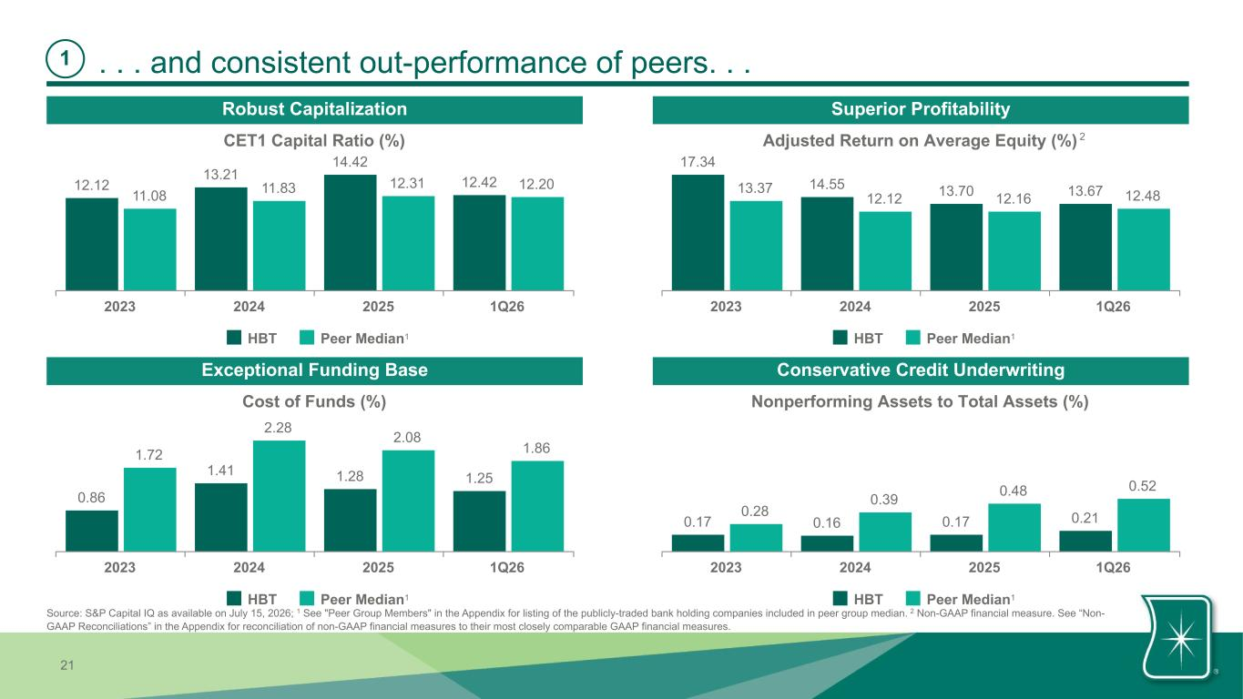
21 . . . and consistent out-performance of peers. . .1 CET1 Capital Ratio (%) 12.12 13.21 14.42 12.42 11.08 11.83 12.31 12.20 HBT Peer Median 2023 2024 2025 1Q26 Adjusted Return on Average Equity (%) 17.34 14.55 13.70 13.6713.37 12.12 12.16 12.48 HBT Peer Median 2023 2024 2025 1Q26 Cost of Funds (%) 0.86 1.41 1.28 1.25 1.72 2.28 2.08 1.86 HBT Peer Median 2023 2024 2025 1Q26 Nonperforming Assets to Total Assets (%) 0.17 0.16 0.17 0.210.28 0.39 0.48 0.52 HBT Peer Median 2023 2024 2025 1Q26 Robust Capitalization Superior Profitability Exceptional Funding Base Conservative Credit Underwriting 1 11 1 Source: S&P Capital IQ as available on July 15, 2026; 1 See "Peer Group Members" in the Appendix for listing of the publicly-traded bank holding companies included in peer group median. 2 Non-GAAP financial measure. See “Non- GAAP Reconciliations” in the Appendix for reconciliation of non-GAAP financial measures to their most closely comparable GAAP financial measures. 2

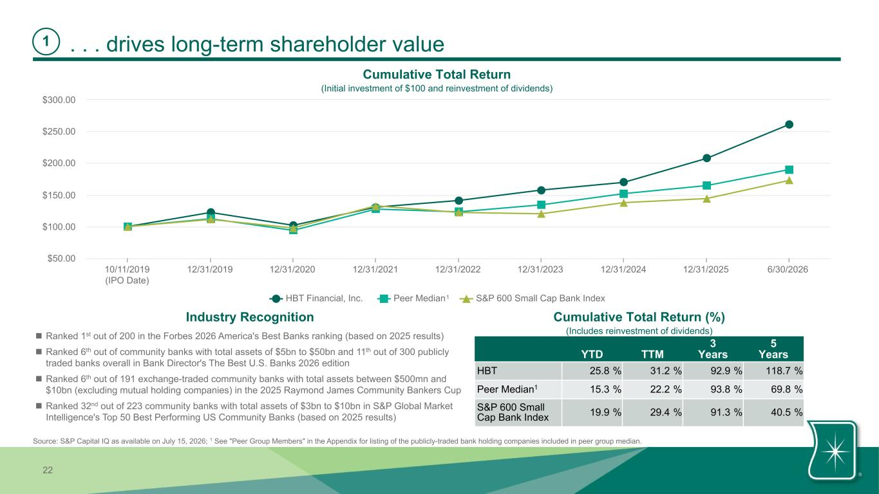
22 . . . drives long-term shareholder value1 HBT Financial, Inc. Peer Median S&P 600 Small Cap Bank Index 10/11/2019 (IPO Date) 12/31/2019 12/31/2020 12/31/2021 12/31/2022 12/31/2023 12/31/2024 12/31/2025 6/30/2026 $50.00 $100.00 $150.00 $200.00 $250.00 $300.00 Cumulative Total Return (Initial investment of $100 and reinvestment of dividends) 1 Source: S&P Capital IQ as available on July 15, 2026; 1 See "Peer Group Members" in the Appendix for listing of the publicly-traded bank holding companies included in peer group median. YTD TTM 3 Years 5 Years HBT 25.8 % 31.2 % 92.9 % 118.7 % Peer Median1 15.3 % 22.2 % 93.8 % 69.8 % S&P 600 Small Cap Bank Index 19.9 % 29.4 % 91.3 % 40.5 % Cumulative Total Return (%) (Includes reinvestment of dividends) Industry Recognition n Ranked 1st out of 200 in the Forbes 2026 America's Best Banks ranking (based on 2025 results) n Ranked 6th out of community banks with total assets of $5bn to $50bn and 11th out of 300 publicly traded banks overall in Bank Director's The Best U.S. Banks 2026 edition n Ranked 6th out of 191 exchange-traded community banks with total assets between $500mn and $10bn (excluding mutual holding companies) in the 2025 Raymond James Community Bankers Cup n Ranked 32nd out of 223 community banks with total assets of $3bn to $10bn in S&P Global Market Intelligence's Top 50 Best Performing US Community Banks (based on 2025 results)

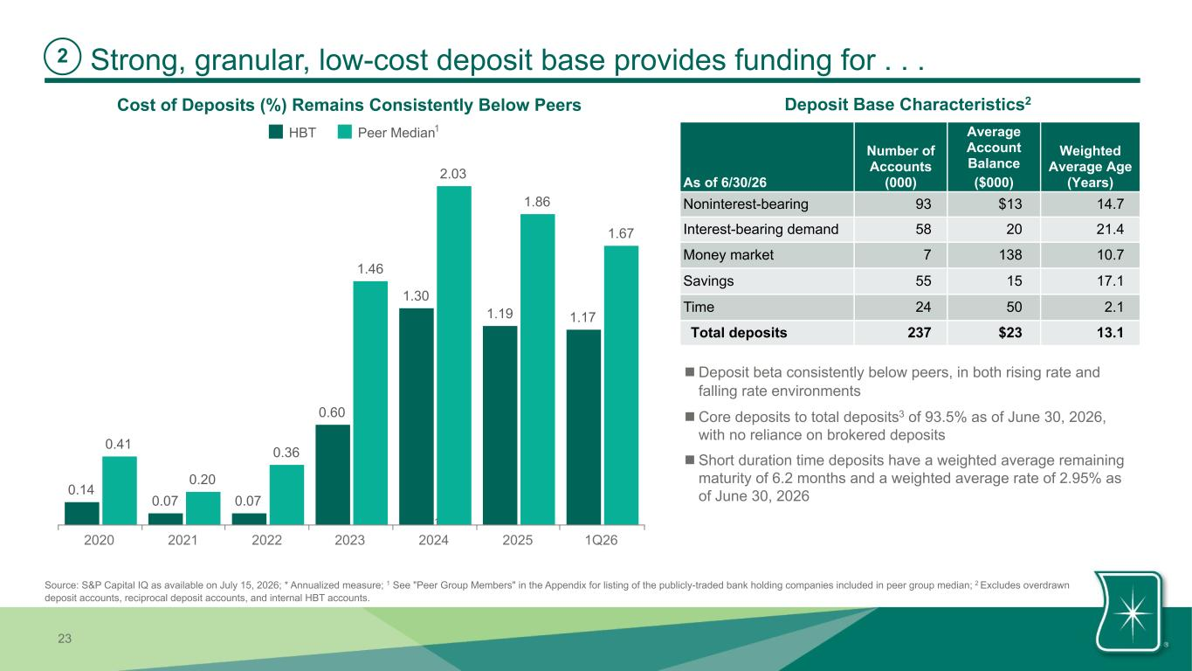
23 0.14 0.07 0.07 0.60 1.30 1.19 1.17 0.41 0.20 0.36 1.46 2.03 1.86 1.67 HBT Peer Median 2020 2021 2022 2023 2024 2025 1Q26 Strong, granular, low-cost deposit base provides funding for . . . Cost of Deposits (%) Remains Consistently Below Peers 1 2 As of 6/30/26 Number of Accounts (000) Average Account Balance ($000) Weighted Average Age (Years) Noninterest-bearing 93 $13 14.7 Interest-bearing demand 58 20 21.4 Money market 7 138 10.7 Savings 55 15 17.1 Time 24 50 2.1 Total deposits 237 $23 13.1 Deposit Base Characteristics2 1 Source: S&P Capital IQ as available on July 15, 2026; * Annualized measure; 1 See "Peer Group Members" in the Appendix for listing of the publicly-traded bank holding companies included in peer group median; 2 Excludes overdrawn deposit accounts, reciprocal deposit accounts, and internal HBT accounts. n Deposit beta consistently below peers, in both rising rate and falling rate environments n Core deposits to total deposits3 of 93.5% as of June 30, 2026, with no reliance on brokered deposits n Short duration time deposits have a weighted average remaining maturity of 6.2 months and a weighted average rate of 2.95% as of June 30, 2026 1

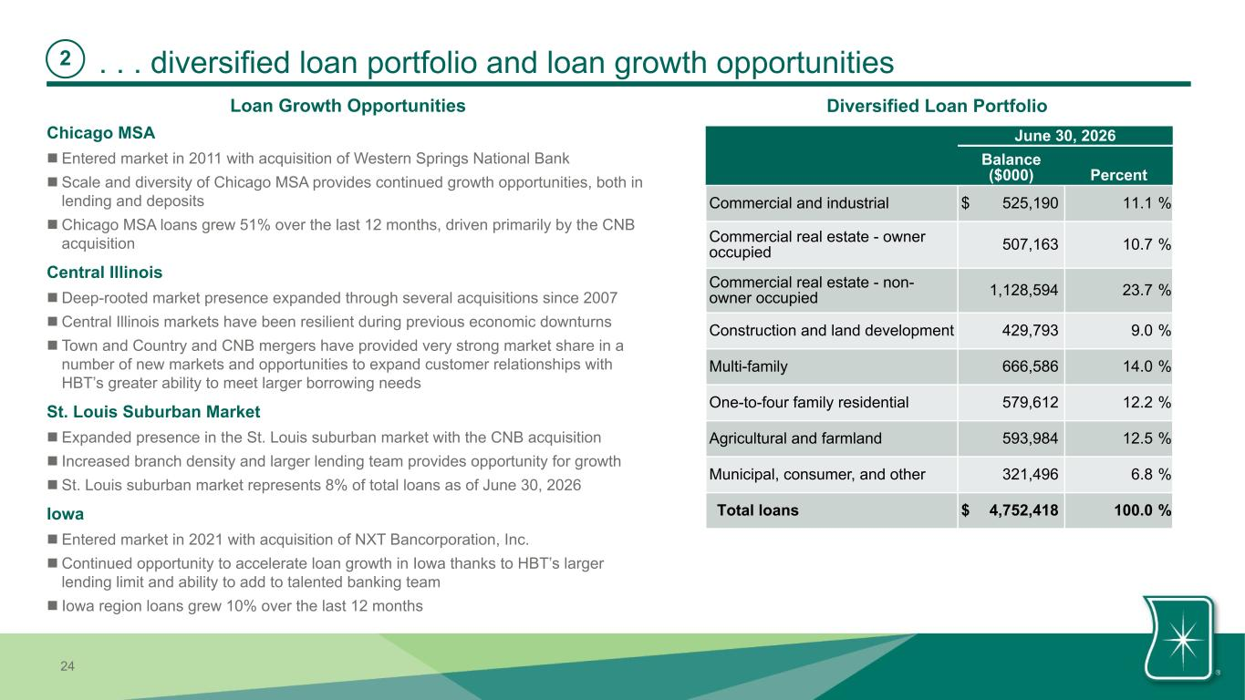
24 . . . diversified loan portfolio and loan growth opportunities2 June 30, 2026 Balance ($000) Percent Commercial and industrial $ 525,190 11.1 % Commercial real estate - owner occupied 507,163 10.7 % Commercial real estate - non- owner occupied 1,128,594 23.7 % Construction and land development 429,793 9.0 % Multi-family 666,586 14.0 % One-to-four family residential 579,612 12.2 % Agricultural and farmland 593,984 12.5 % Municipal, consumer, and other 321,496 6.8 % Total loans $ 4,752,418 100.0 % Diversified Loan Portfolio Chicago MSA n Entered market in 2011 with acquisition of Western Springs National Bank n Scale and diversity of Chicago MSA provides continued growth opportunities, both in lending and deposits n Chicago MSA loans grew 51% over the last 12 months, driven primarily by the CNB acquisition Central Illinois n Deep-rooted market presence expanded through several acquisitions since 2007 n Central Illinois markets have been resilient during previous economic downturns n Town and Country and CNB mergers have provided very strong market share in a number of new markets and opportunities to expand customer relationships with HBT’s greater ability to meet larger borrowing needs St. Louis Suburban Market n Expanded presence in the St. Louis suburban market with the CNB acquisition n Increased branch density and larger lending team provides opportunity for growth n St. Louis suburban market represents 8% of total loans as of June 30, 2026 Iowa n Entered market in 2021 with acquisition of NXT Bancorporation, Inc. n Continued opportunity to accelerate loan growth in Iowa thanks to HBT’s larger lending limit and ability to add to talented banking team n Iowa region loans grew 10% over the last 12 months Loan Growth Opportunities

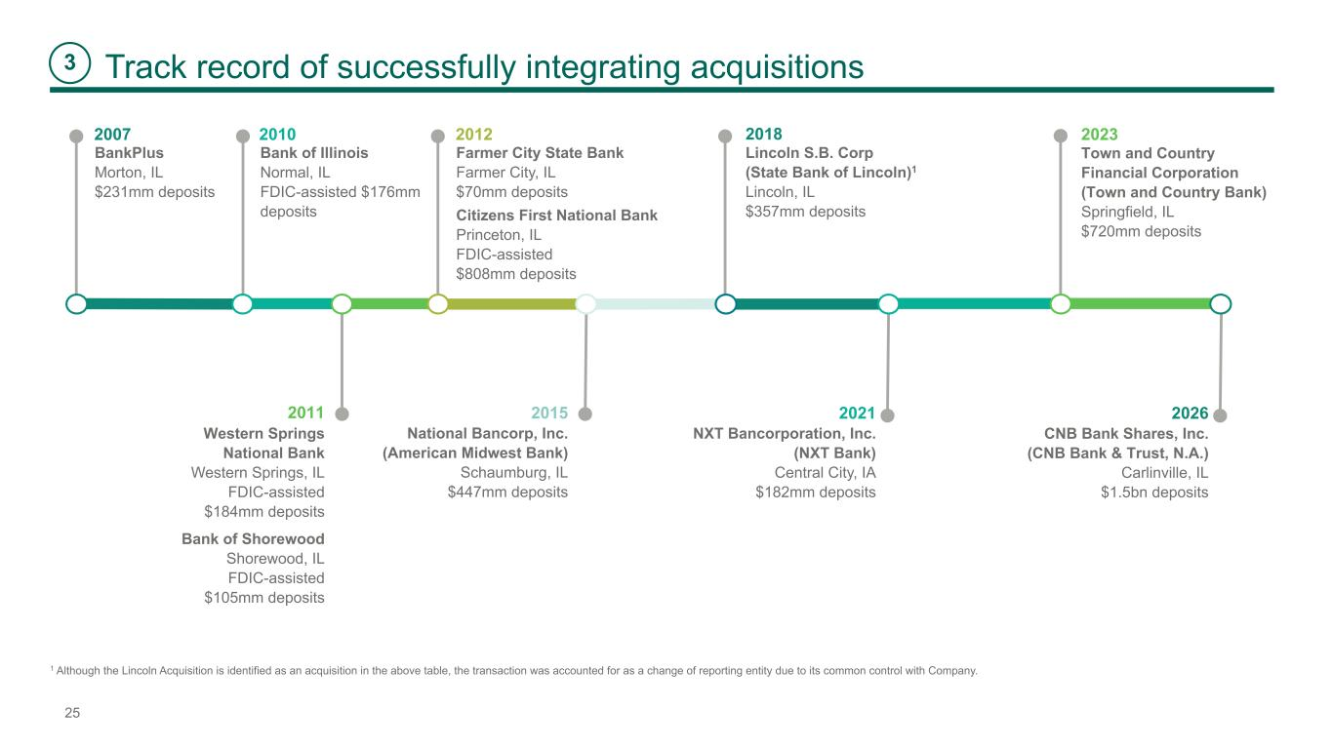
25 2026 CNB Bank Shares, Inc. (CNB Bank & Trust, N.A.) Carlinville, IL $1.5bn deposits Track record of successfully integrating acquisitions BankPlus Morton, IL $231mm deposits 2007 2012 Bank of Illinois Normal, IL FDIC-assisted $176mm deposits Western Springs National Bank Western Springs, IL FDIC-assisted $184mm deposits 2011 Citizens First National Bank Princeton, IL FDIC-assisted $808mm deposits Farmer City State Bank Farmer City, IL $70mm deposits 20182010 Bank of Shorewood Shorewood, IL FDIC-assisted $105mm deposits Lincoln S.B. Corp (State Bank of Lincoln)1 Lincoln, IL $357mm deposits 2021 NXT Bancorporation, Inc. (NXT Bank) Central City, IA $182mm deposits 2015 National Bancorp, Inc. (American Midwest Bank) Schaumburg, IL $447mm deposits 2023 Town and Country Financial Corporation (Town and Country Bank) Springfield, IL $720mm deposits 3 1 Although the Lincoln Acquisition is identified as an acquisition in the above table, the transaction was accounted for as a change of reporting entity due to its common control with Company.

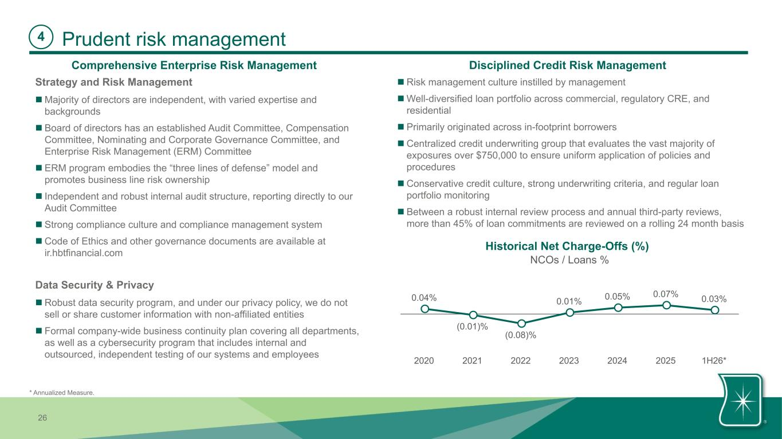
26 Prudent risk management n Risk management culture instilled by management n Well-diversified loan portfolio across commercial, regulatory CRE, and residential n Primarily originated across in-footprint borrowers n Centralized credit underwriting group that evaluates the vast majority of exposures over $750,000 to ensure uniform application of policies and procedures n Conservative credit culture, strong underwriting criteria, and regular loan portfolio monitoring n Between a robust internal review process and annual third-party reviews, more than 45% of loan commitments are reviewed on a rolling 24 month basis Strategy and Risk Management n Majority of directors are independent, with varied expertise and backgrounds n Board of directors has an established Audit Committee, Compensation Committee, Nominating and Corporate Governance Committee, and Enterprise Risk Management (ERM) Committee n ERM program embodies the “three lines of defense” model and promotes business line risk ownership n Independent and robust internal audit structure, reporting directly to our Audit Committee n Strong compliance culture and compliance management system n Code of Ethics and other governance documents are available at ir.hbtfinancial.com Data Security & Privacy n Robust data security program, and under our privacy policy, we do not sell or share customer information with non-affiliated entities n Formal company-wide business continuity plan covering all departments, as well as a cybersecurity program that includes internal and outsourced, independent testing of our systems and employees Comprehensive Enterprise Risk Management Disciplined Credit Risk Management Historical Net Charge-Offs (%) 4 NCOs / Loans % 0.04% (0.01)% (0.08)% 0.01% 0.05% 0.07% 0.03% 2020 2021 2022 2023 2024 2025 1H26* * Annualized Measure.

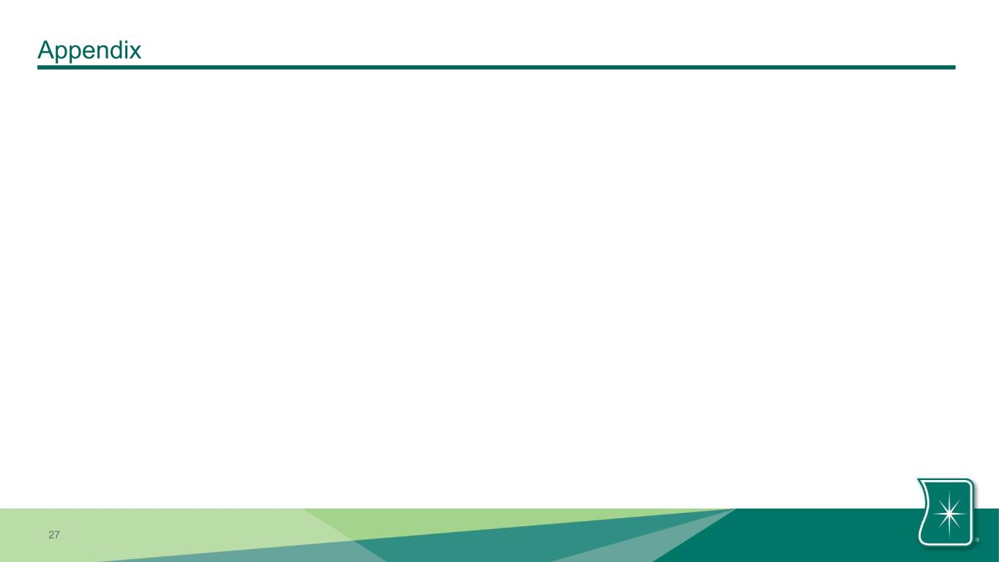
27 Appendix

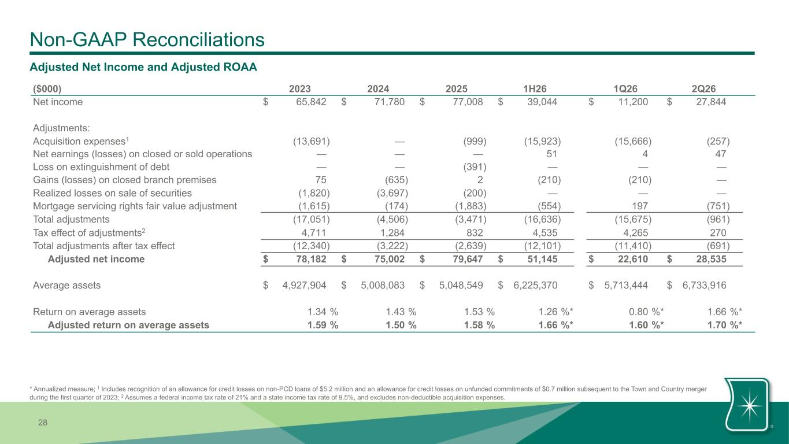
28 Non-GAAP Reconciliations Adjusted Net Income and Adjusted ROAA ($000) 2023 2024 2025 1H26 1Q26 2Q26 Net income $ 65,842 $ 71,780 $ 77,008 $ 39,044 $ 11,200 $ 27,844 Adjustments: Acquisition expenses1 (13,691) — (999) (15,923) (15,666) (257) Net earnings (losses) on closed or sold operations — — — 51 4 47 Loss on extinguishment of debt — — (391) — — — Gains (losses) on closed branch premises 75 (635) 2 (210) (210) — Realized losses on sale of securities (1,820) (3,697) (200) — — — Mortgage servicing rights fair value adjustment (1,615) (174) (1,883) (554) 197 (751) Total adjustments (17,051) (4,506) (3,471) (16,636) (15,675) (961) Tax effect of adjustments2 4,711 1,284 832 4,535 4,265 270 Total adjustments after tax effect (12,340) (3,222) (2,639) (12,101) (11,410) (691) Adjusted net income $ 78,182 $ 75,002 $ 79,647 $ 51,145 $ 22,610 $ 28,535 Average assets $ 4,927,904 $ 5,008,083 $ 5,048,549 $ 6,225,370 $ 5,713,444 $ 6,733,916 Return on average assets 1.34 % 1.43 % 1.53 % 1.26 %* 0.80 %* 1.66 %* Adjusted return on average assets 1.59 % 1.50 % 1.58 % 1.66 %* 1.60 %* 1.70 %* * Annualized measure; 1 Includes recognition of an allowance for credit losses on non-PCD loans of $5.2 million and an allowance for credit losses on unfunded commitments of $0.7 million subsequent to the Town and Country merger during the first quarter of 2023; 2 Assumes a federal income tax rate of 21% and a state income tax rate of 9.5%, and excludes non-deductible acquisition expenses.

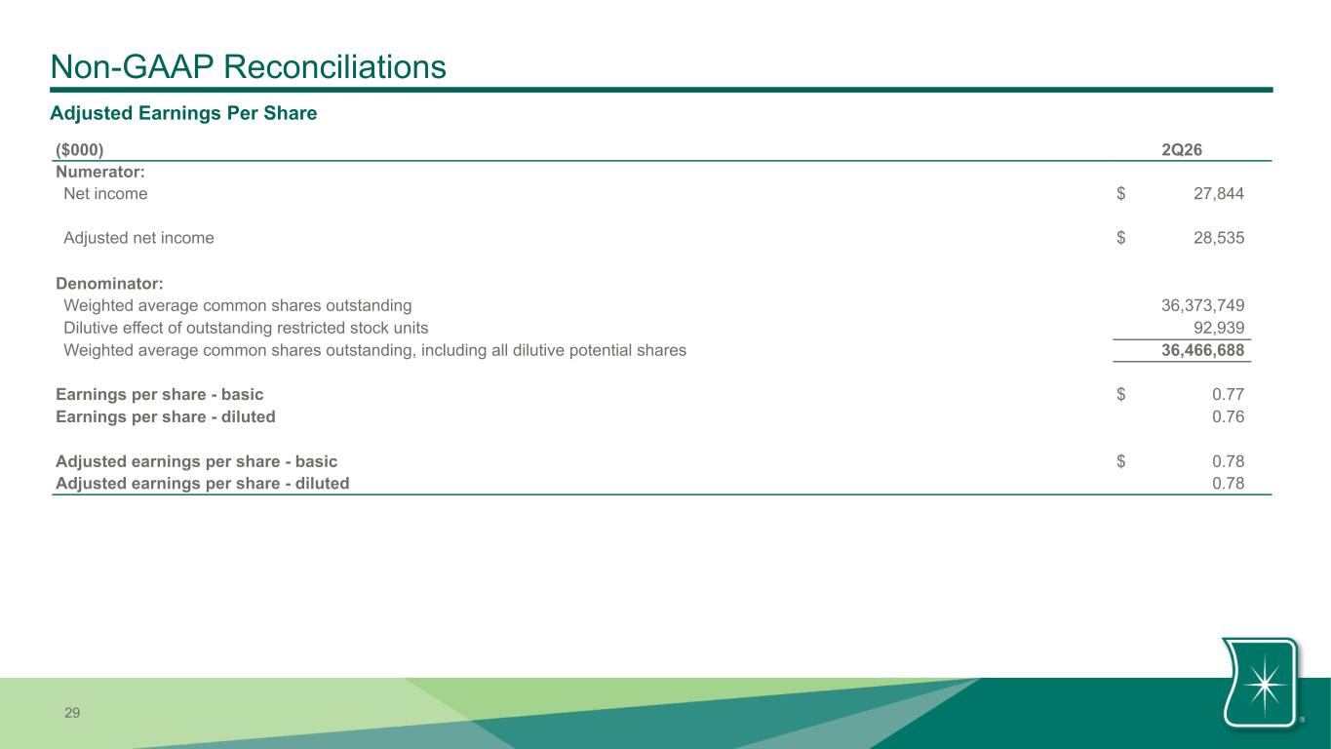
29 Non-GAAP Reconciliations Adjusted Earnings Per Share ($000) 2Q26 Numerator: Net income $ 27,844 Adjusted net income $ 28,535 Denominator: Weighted average common shares outstanding 36,373,749 Dilutive effect of outstanding restricted stock units 92,939 Weighted average common shares outstanding, including all dilutive potential shares 36,466,688 Earnings per share - basic $ 0.77 Earnings per share - diluted 0.76 Adjusted earnings per share - basic $ 0.78 Adjusted earnings per share - diluted 0.78

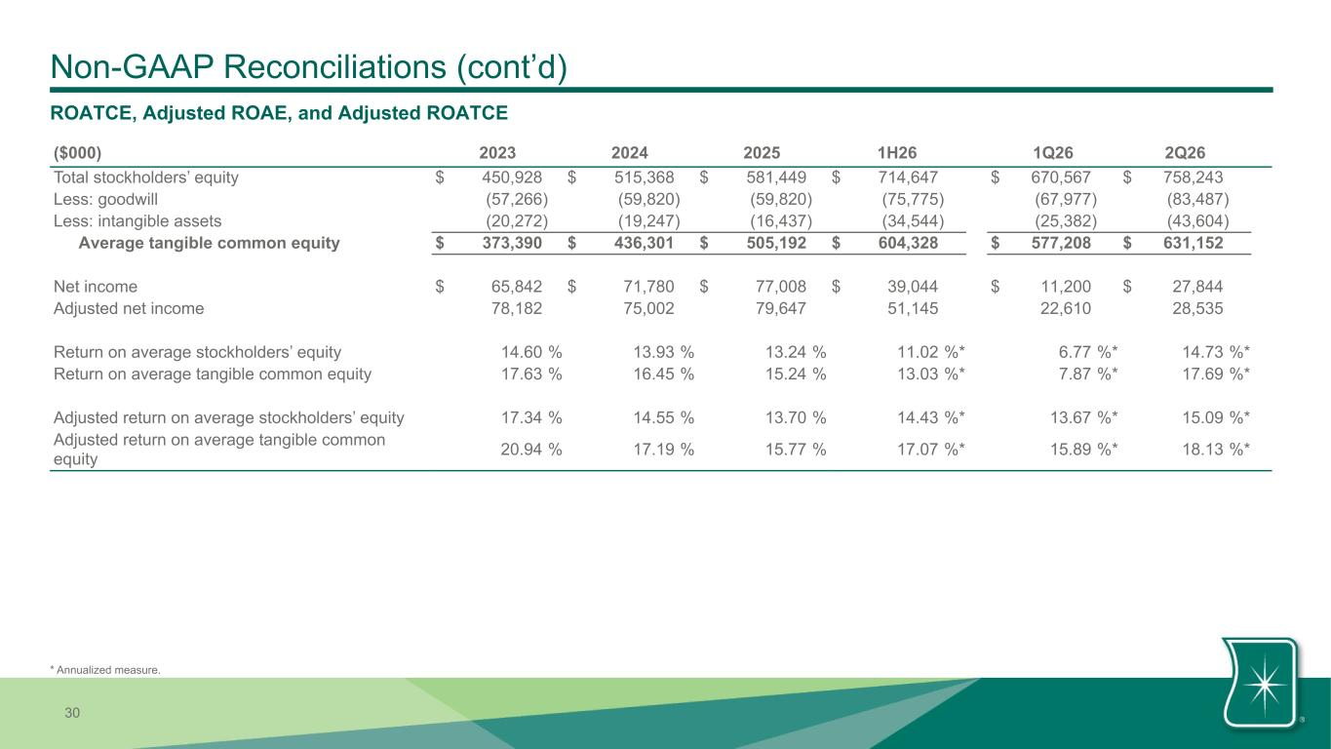
30 Non-GAAP Reconciliations (cont’d) ROATCE, Adjusted ROAE, and Adjusted ROATCE ($000) 2023 2024 2025 1H26 1Q26 2Q26 Total stockholders’ equity $ 450,928 $ 515,368 $ 581,449 $ 714,647 $ 670,567 $ 758,243 Less: goodwill (57,266) (59,820) (59,820) (75,775) (67,977) (83,487) Less: intangible assets (20,272) (19,247) (16,437) (34,544) (25,382) (43,604) Average tangible common equity $ 373,390 $ 436,301 $ 505,192 $ 604,328 $ 577,208 $ 631,152 Net income $ 65,842 $ 71,780 $ 77,008 $ 39,044 $ 11,200 $ 27,844 Adjusted net income 78,182 75,002 79,647 51,145 22,610 28,535 Return on average stockholders’ equity 14.60 % 13.93 % 13.24 % 11.02 %* 6.77 %* 14.73 %* Return on average tangible common equity 17.63 % 16.45 % 15.24 % 13.03 %* 7.87 %* 17.69 %* Adjusted return on average stockholders’ equity 17.34 % 14.55 % 13.70 % 14.43 %* 13.67 %* 15.09 %* Adjusted return on average tangible common equity 20.94 % 17.19 % 15.77 % 17.07 %* 15.89 %* 18.13 %* * Annualized measure.

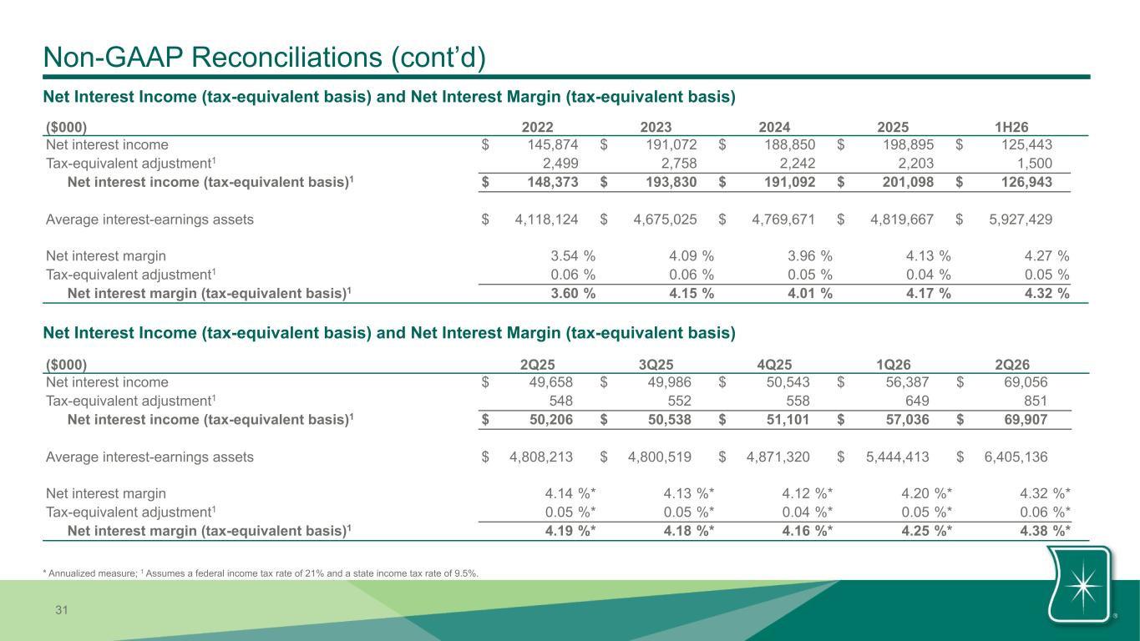
31 Non-GAAP Reconciliations (cont’d) ($000) 2022 2023 2024 2025 1H26 Net interest income $ 145,874 $ 191,072 $ 188,850 $ 198,895 $ 125,443 Tax-equivalent adjustment1 2,499 2,758 2,242 2,203 1,500 Net interest income (tax-equivalent basis)1 $ 148,373 $ 193,830 $ 191,092 $ 201,098 $ 126,943 Average interest-earnings assets $ 4,118,124 $ 4,675,025 $ 4,769,671 $ 4,819,667 $ 5,927,429 Net interest margin 3.54 % 4.09 % 3.96 % 4.13 % 4.27 % Tax-equivalent adjustment1 0.06 % 0.06 % 0.05 % 0.04 % 0.05 % Net interest margin (tax-equivalent basis)1 3.60 % 4.15 % 4.01 % 4.17 % 4.32 % Net Interest Income (tax-equivalent basis) and Net Interest Margin (tax-equivalent basis) Net Interest Income (tax-equivalent basis) and Net Interest Margin (tax-equivalent basis) ($000) 2Q25 3Q25 4Q25 1Q26 2Q26 Net interest income $ 49,658 $ 49,986 $ 50,543 $ 56,387 $ 69,056 Tax-equivalent adjustment1 548 552 558 649 851 Net interest income (tax-equivalent basis)1 $ 50,206 $ 50,538 $ 51,101 $ 57,036 $ 69,907 Average interest-earnings assets $ 4,808,213 $ 4,800,519 $ 4,871,320 $ 5,444,413 $ 6,405,136 Net interest margin 4.14 %* 4.13 %* 4.12 %* 4.20 %* 4.32 %* Tax-equivalent adjustment1 0.05 %* 0.05 %* 0.04 %* 0.05 %* 0.06 %* Net interest margin (tax-equivalent basis)1 4.19 %* 4.18 %* 4.16 %* 4.25 %* 4.38 %* * Annualized measure; 1 Assumes a federal income tax rate of 21% and a state income tax rate of 9.5%.

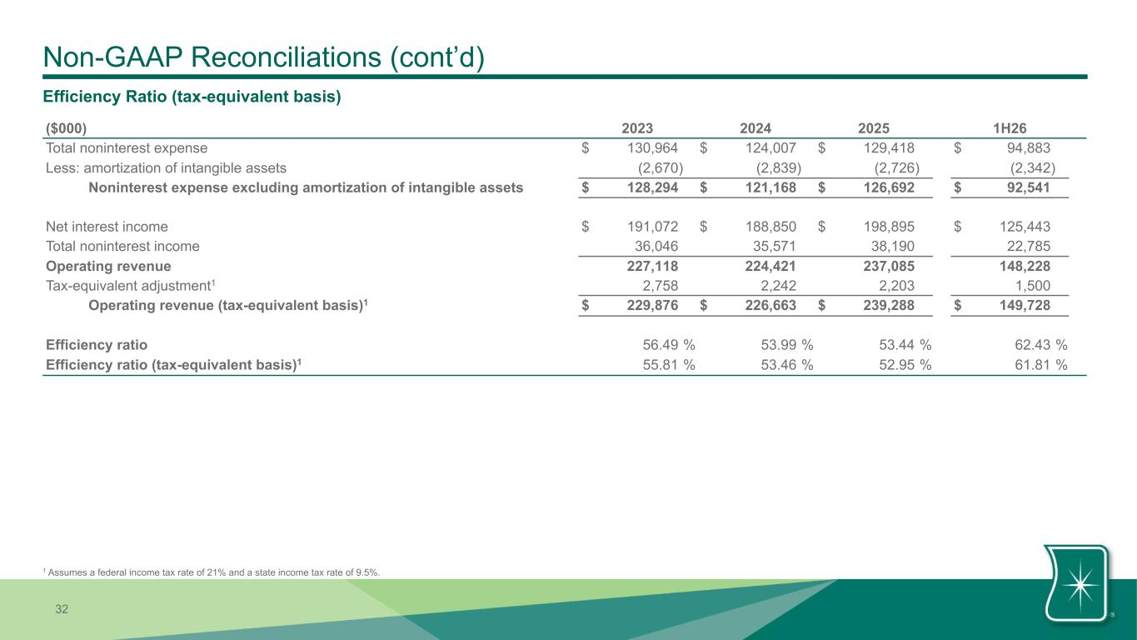
32 Non-GAAP Reconciliations (cont’d) Efficiency Ratio (tax-equivalent basis) ($000) 2023 2024 2025 1H26 Total noninterest expense $ 130,964 $ 124,007 $ 129,418 $ 94,883 Less: amortization of intangible assets (2,670) (2,839) (2,726) (2,342) Noninterest expense excluding amortization of intangible assets $ 128,294 $ 121,168 $ 126,692 $ 92,541 Net interest income $ 191,072 $ 188,850 $ 198,895 $ 125,443 Total noninterest income 36,046 35,571 38,190 22,785 Operating revenue 227,118 224,421 237,085 148,228 Tax-equivalent adjustment1 2,758 2,242 2,203 1,500 Operating revenue (tax-equivalent basis)1 $ 229,876 $ 226,663 $ 239,288 $ 149,728 Efficiency ratio 56.49 % 53.99 % 53.44 % 62.43 % Efficiency ratio (tax-equivalent basis)1 55.81 % 53.46 % 52.95 % 61.81 % 1 Assumes a federal income tax rate of 21% and a state income tax rate of 9.5%.

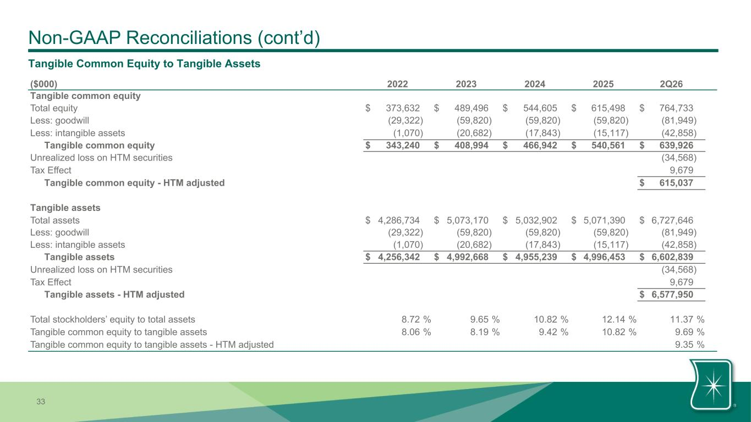
33 Non-GAAP Reconciliations (cont’d) ($000) 2022 2023 2024 2025 2Q26 Tangible common equity Total equity $ 373,632 $ 489,496 $ 544,605 $ 615,498 $ 764,733 Less: goodwill (29,322) (59,820) (59,820) (59,820) (81,949) Less: intangible assets (1,070) (20,682) (17,843) (15,117) (42,858) Tangible common equity $ 343,240 $ 408,994 $ 466,942 $ 540,561 $ 639,926 Unrealized loss on HTM securities (34,568) Tax Effect 9,679 Tangible common equity - HTM adjusted $ 615,037 Tangible assets Total assets $ 4,286,734 $ 5,073,170 $ 5,032,902 $ 5,071,390 $ 6,727,646 Less: goodwill (29,322) (59,820) (59,820) (59,820) (81,949) Less: intangible assets (1,070) (20,682) (17,843) (15,117) (42,858) Tangible assets $ 4,256,342 $ 4,992,668 $ 4,955,239 $ 4,996,453 $ 6,602,839 Unrealized loss on HTM securities (34,568) Tax Effect 9,679 Tangible assets - HTM adjusted $ 6,577,950 Total stockholders’ equity to total assets 8.72 % 9.65 % 10.82 % 12.14 % 11.37 % Tangible common equity to tangible assets 8.06 % 8.19 % 9.42 % 10.82 % 9.69 % Tangible common equity to tangible assets - HTM adjusted 9.35 % Tangible Common Equity to Tangible Assets

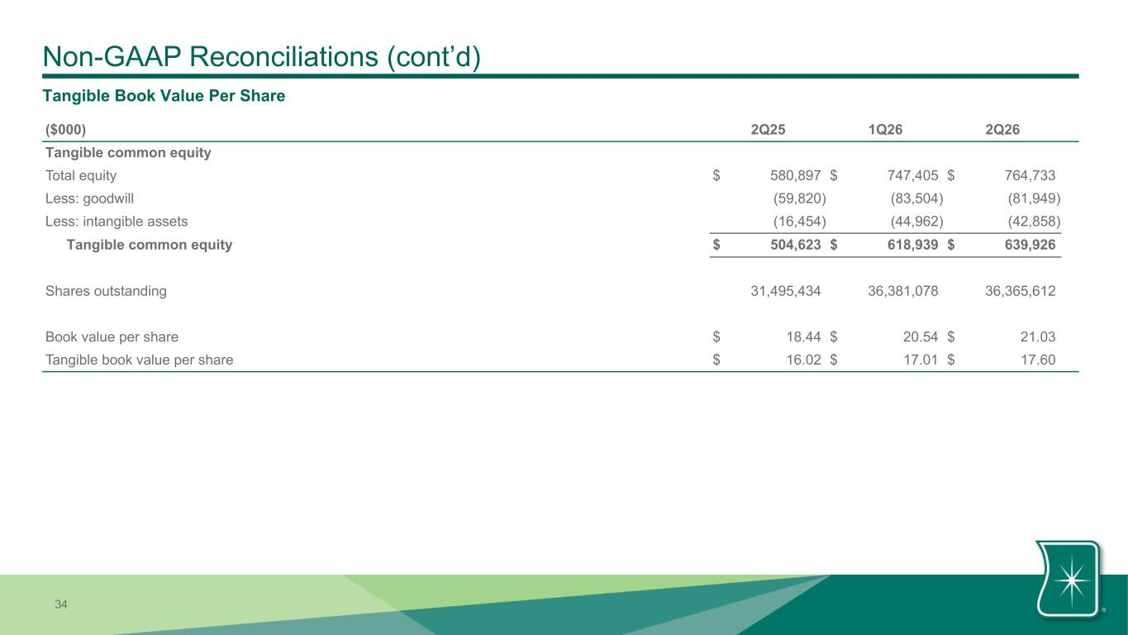
34 Non-GAAP Reconciliations (cont’d) ($000) 2Q25 1Q26 2Q26 Tangible common equity Total equity $ 580,897 $ 747,405 $ 764,733 Less: goodwill (59,820) (83,504) (81,949) Less: intangible assets (16,454) (44,962) (42,858) Tangible common equity $ 504,623 $ 618,939 $ 639,926 Shares outstanding 31,495,434 36,381,078 36,365,612 Book value per share $ 18.44 $ 20.54 $ 21.03 Tangible book value per share $ 16.02 $ 17.01 $ 17.60 Tangible Book Value Per Share

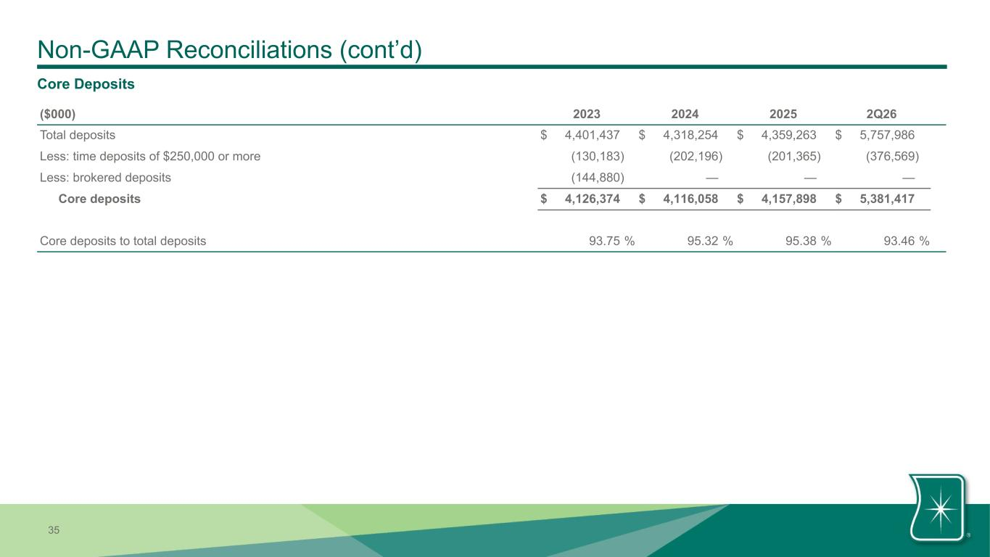
35 Non-GAAP Reconciliations (cont’d) ($000) 2023 2024 2025 2Q26 Total deposits $ 4,401,437 $ 4,318,254 $ 4,359,263 $ 5,757,986 Less: time deposits of $250,000 or more (130,183) (202,196) (201,365) (376,569) Less: brokered deposits (144,880) — — — Core deposits $ 4,126,374 $ 4,116,058 $ 4,157,898 $ 5,381,417 Core deposits to total deposits 93.75 % 95.32 % 95.38 % 93.46 % Core Deposits

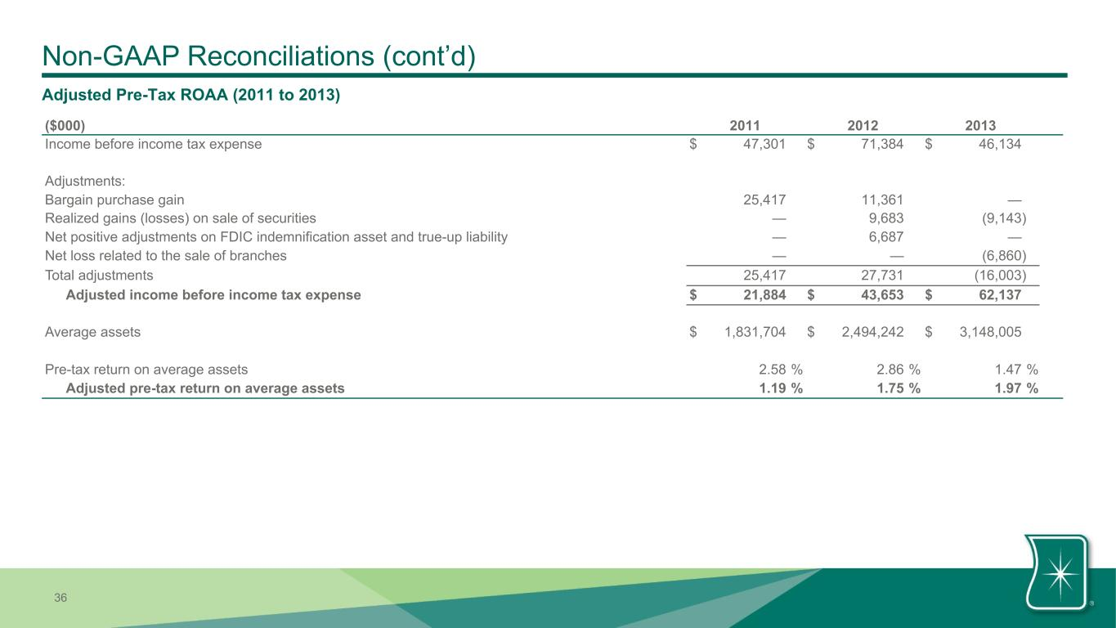
36 Non-GAAP Reconciliations (cont’d) ($000) 2011 2012 2013 Income before income tax expense $ 47,301 $ 71,384 $ 46,134 Adjustments: Bargain purchase gain 25,417 11,361 — Realized gains (losses) on sale of securities — 9,683 (9,143) Net positive adjustments on FDIC indemnification asset and true-up liability — 6,687 — Net loss related to the sale of branches — — (6,860) Total adjustments 25,417 27,731 (16,003) Adjusted income before income tax expense $ 21,884 $ 43,653 $ 62,137 Average assets $ 1,831,704 $ 2,494,242 $ 3,148,005 Pre-tax return on average assets 2.58 % 2.86 % 1.47 % Adjusted pre-tax return on average assets 1.19 % 1.75 % 1.97 % Adjusted Pre-Tax ROAA (2011 to 2013)

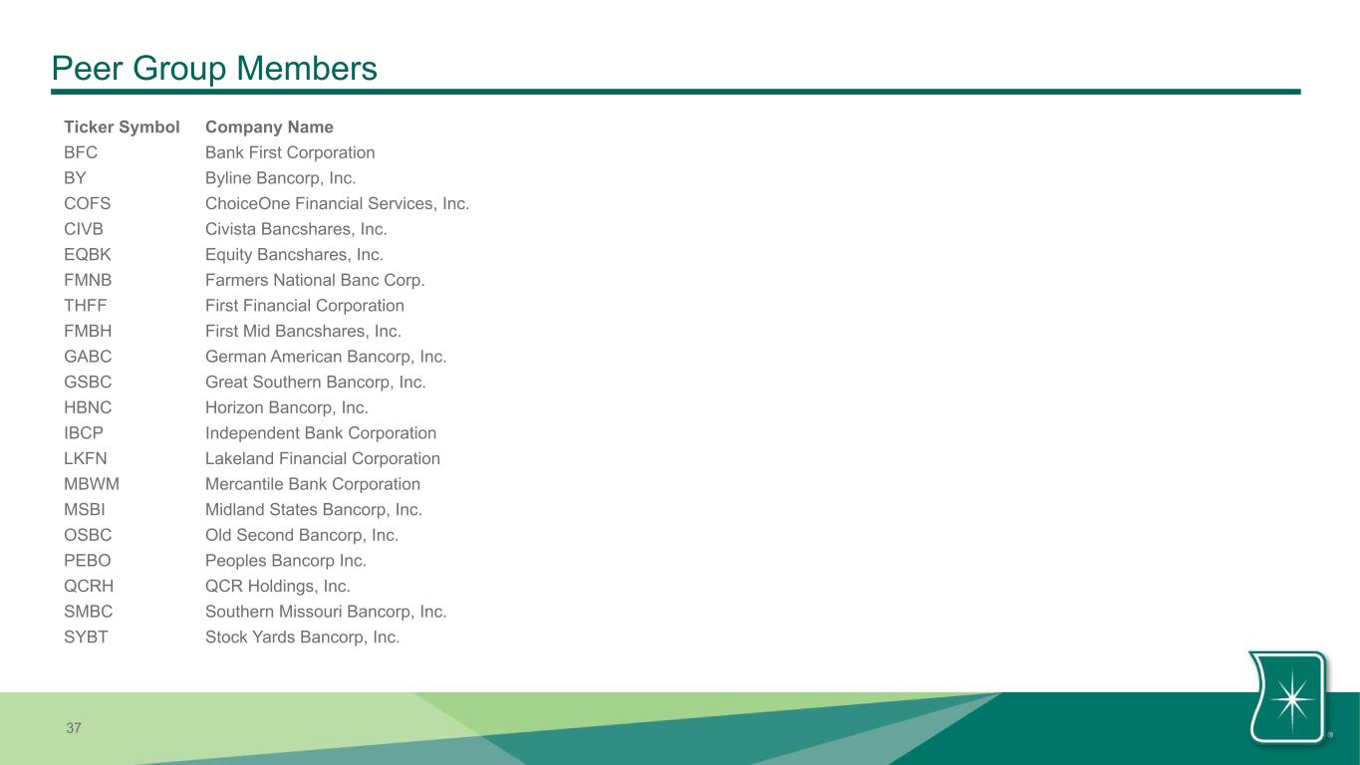
37 Peer Group Members Ticker Symbol Company Name BFC Bank First Corporation BY Byline Bancorp, Inc. COFS ChoiceOne Financial Services, Inc. CIVB Civista Bancshares, Inc. EQBK Equity Bancshares, Inc. FMNB Farmers National Banc Corp. THFF First Financial Corporation FMBH First Mid Bancshares, Inc. GABC German American Bancorp, Inc. GSBC Great Southern Bancorp, Inc. HBNC Horizon Bancorp, Inc. IBCP Independent Bank Corporation LKFN Lakeland Financial Corporation MBWM Mercantile Bank Corporation MSBI Midland States Bancorp, Inc. OSBC Old Second Bancorp, Inc. PEBO Peoples Bancorp Inc. QCRH QCR Holdings, Inc. SMBC Southern Missouri Bancorp, Inc. SYBT Stock Yards Bancorp, Inc.


0 118 104 0 118 104 0 118 104 165 211 142 165 211 142 245 230 168 245 230 168 255 255 255

